CHINHOYI UNIVERSITY OF TECHNOLOGY
School of Engineering Science and Technology
Department of ICT & Electronics


WaitLess: A Digital Queue Management System for Zimbabwean Public Hospitals
Case Study: Chinhoyi Provincial Hospital

Team Member | Email Address
Shadreck Mapuranga | mapurangashadreck03@gmail.com
Norris Marava | norrismarava44@gmail.com
Kelvin Ncube | kevincube19@gmail.com

Supervisor: H. Musabayeka
Date: June 2026

A PROJECT SUBMITTED IN PARTIAL FULFILMENT OF THE REQUIREMENTS FOR THE BACHELOR OF SCIENCE HONOURS DEGREE IN INFORMATION TECHNOLOGY

Table of Contents
CHAPTER 1: INTRODUCTION 5
1.0 Introduction 5
1.1 Background of the study 6
1.2 Problem Statement 8
1.2.1 Ideal Situation 8
1.2.2 Reality 8
1.2.3 Consequences 9
1.2.4 Proposed Solution 9
1.3 Project Aims and Objectives 10
1.3.1 Aim 10
1.3.2 Objectives 10
1.4 Significance of the Study 11
1.5 Limitations and Delimitations of the Study 12
1.5.1 Limitations of the Study 12
1.5.2 Delimitations of the Study 12
1.6 Definition of terms 13
1.7 Conclusion 15
CHAPTER 2: LITERATURE REVIEW 17
2.0 Introduction 17
2.1 Queue Management Theory in Healthcare 17
2.2 Digital Queue Management Systems in Hospitals 18
2.3 Patient Notification Systems in Healthcare 20
2.4 Digital Health Adoption in Zimbabwe and Sub-Saharan Africa 21
2.5 Design Science Research as a Methodological Foundation 22
2.6 Technology Frameworks for Real-Time Web Applications 22
2.7 Review of Commercial Queue Management Systems 23
2.8 Identified Gaps in the Literature 24
2.9 Conclusion 25
CHAPTER 3: METHODOLOGY 26
3.0 Introduction 26
3.1 Research Philosophy and Approach 27
3.2 Research Design 27
3.3 Design Science Research Method 28
3.3.1 Problem Identification 28
3.3.2 Objectives of the Artefact 29
3.3.3 Design and Development 29
3.3.4 Demonstration and Evaluation 29
3.4 Case Study and Unit of Analysis 30
3.5 Data Sources and Collection Methods 31
3.5.1 Direct Workflow Observation 31
3.5.2 Hospital Workflow Artefacts 31
3.5.3 Literature and Policy Review 31
3.5.4 Existing-System and Code Evidence 32
3.6 Requirements Analysis Procedure 32
3.7 System Development Method 33
3.8 Technology Selection Procedure 34
3.9 Evaluation Strategy 34
3.9.1 Functional Testing 35
3.9.2 Usability Evaluation 35
3.9.3 Performance and Reliability Evaluation 35
3.9.4 Security Evaluation 35
3.10 Data Analysis 36
3.11 Validity, Reliability, and Trustworthiness 36
3.12 Ethical and Privacy Considerations 37
3.13 Implementation Plan and Milestones 37
3.14 Methodological Limitations 38
3.15 Chapter Summary 38
CHAPTER 4: SYSTEM DESIGN AND IMPLEMENTATION 42
4.0 Introduction 42
4.1 Requirements Analysis 42
4.1.1 Functional Requirements 42
4.1.2 Non-Functional Requirements 46
4.1.3 User Requirements by Stakeholder Role 47
4.2 Use Case Diagrams 48
4.2.1 System-Wide Use Case Diagram 48
4.2.2 Patient Registration Use Case Diagram 49
4.2.3 Triage Use Case Diagram 50
4.2.4 Queue Management Use Case Diagram 51
4.2.5 Notification Use Case Diagram 52
4.3 Use Case Descriptions 52
4.3.1 Use Case UC-01: Register New Patient 52
4.3.2 Use Case UC-02: Triage Assessment 53
4.3.3 Use Case UC-03: Call Next Patient 54
4.3.4 Use Case UC-04: Missed Turn and Recall 54
4.3.5 Use Case UC-05: Queue Transfer 55
4.3.6 Use Case UC-06: Patient Self-Tracking 55
4.3.7 Use Case UC-07: Kiosk Self-Check-in 56
4.3.8 Use Case UC-08: Send WhatsApp Notification 57
4.3.9 Use Case UC-09: View Reports 57
4.3.10 Use Case UC-10: View Audit Trail 58
4.4 System Architecture 58
4.4.1 High-Level Architecture 58
4.4.2 Layered Architecture Description 59
4.4.3 Technology Architecture 60
4.4.4 Deployment Architecture 61
4.5 Data Design 62
4.5.1 Entity-Relationship Diagram 62
4.5.2 Data Dictionary 63
4.5.3 Data Flow Diagrams 68
4.6 Process Design 71
4.6.1 Sequence Diagram: Patient Registration 71
4.6.2 Sequence Diagram: Triage Assessment 72
4.6.3 Sequence Diagram: Call Next Patient 73
4.6.4 Sequence Diagram: Notification Dispatch with Retry 74
4.6.5 Activity Diagram: Patient Journey 75
4.6.6 Activity Diagram: Triage Workflow 76
4.6.7 Activity Diagram: Notification Retry Lifecycle 77
4.7 User Interface Design 77
4.7.1 UI Design Principles 77
4.7.2 Colour Palette 78
4.7.3 Typography 78
4.7.4 Navigation Structure 79
4.7.5 Key Page Descriptions 80
4.8 Security Design 82
4.8.1 Authentication Model 82
4.8.2 Role-Based Access Control Matrix 82
4.8.3 Audit Trail Design 83
4.8.4 Privacy Measures 83
4.9 Implementation Plan and Milestones 84
4.10 Technology Stack 84
4.10.1 Frontend Technologies 84
4.10.2 Backend Technologies 84
4.10.3 Development Tools 85
4.10.4 Architecture Decision Records 85
4.11 System Structure 86
4.11.1 Project Directory Structure 86
4.11.2 Backend Module Map 89
4.11.3 Frontend Component Hierarchy 90
4.12 Backend Implementation 91
4.12.1 Custom HTTP Router 91
4.12.2 Repository Pattern — Dual-Mode Data Access 91
4.12.3 Queue Service — Core Business Logic 92
4.12.4 Triage Assessment 94
4.12.5 Notification System 94
4.12.6 Authentication and Security 95
4.12.7 Real-Time Updates (SSE) 97
4.12.8 Reporting Endpoints 97
4.13 Frontend Implementation 98
4.13.1 Application Architecture 98
4.13.2 State Management 98
4.13.3 API Layer 99
4.13.4 Real-Time Integration 99
4.13.5 Key Page Implementations 100
4.13.6 UI Component Library 102
4.14 Database Implementation 103
4.14.1 Schema Implementation 103
4.14.2 Indexing Strategy 104
4.14.3 Initialisation and Seeding 104
4.14.4 Dual-Mode Storage 105
4.15 Integration Implementation 105
4.15.1 WhatsApp Cloud API Integration 105
4.15.2 QR Code Generation and Scanning 106
4.15.3 Audit Trail Implementation 106
4.16 Deployment Configuration 107
4.16.1 Environment Variables 107
4.16.2 Backend Startup 107
4.16.3 Frontend Build 108
4.16.4 LAN Deployment 108
4.17 Summary 109

CHAPTER 1: INTRODUCTION

1.0 Introduction
Healthcare delivery in public hospitals is significantly impacted by the efficiency of patient management systems. In Zimbabwe, many public health facilities continue to rely on manual, paper-based processes for patient registration, triage, and queue management. These outdated processes result in long waiting times, patient congestion, poor service delivery, and increased risk of adverse health outcomes. As Zimbabwe pursues its Vision 2030 agenda and seeks to modernise public service delivery, there is an urgent need to integrate digital technologies into the healthcare system.
This chapter presents the development of WaitLess, a digital queue management system designed specifically for Zimbabwean public hospitals. The system is informed by a physical case study conducted at Chinhoyi Provincial Hospital, where patient flow processes, triage protocols, departmental workflows, and patient origin patterns were documented and analysed. The case study revealed critical inefficiencies in the hospital's outpatient department (OPD) flow, casualty department triaging, and opportunistic infection clinic management.
A key feature of WaitLess is its integrated patient notification system, which will alert patients when their turn is approaching through two channels: WhatsApp notifications for patients who provide a contact number at registration, and real-time web push notifications for patients who registered through the web application. This addresses a critical gap identified during site observations: patients who leave the hospital premises while waiting have no way of being notified, leading to no-shows and queue disruption. The WhatsApp channel is designed to operate at no cost to the hospital by leveraging Meta's service conversation policy, whereby a patient who sends an initiating message to the system's WhatsApp Business number at registration opens a free 24-hour messaging window within which all subsequent queue notifications are delivered without charge.
This chapter is organised as follows: Section 1.1 presents the background to the study, outlining the broader context of queue management in healthcare and the specific challenges observed in the Zimbabwean setting. Section 1.2 articulates the problem statement, contrasting the ideal situation with the reality observed at Chinhoyi Provincial Hospital and the resulting consequences. Section 1.3 states the aim and objectives of the project. Section 1.4 discusses the significance of the study, while Section 1.5 outlines its limitations and delimitations. Section 1.6 defines key terms used throughout the chapter, and Section 1.7 concludes with a summary and a preview of the next chapter.

1.1 Background of the study
Queue management in healthcare is defined as the systematic process of controlling the flow of patients from entry to exit within a healthcare facility (Preater, 2002). Effective queue management is critical to the functioning of any hospital, as it directly influences patient satisfaction, clinical outcomes, and staff productivity. In high-income countries, digital queue management systems (DQMS) are widely deployed, incorporating features such as electronic patient registration, automated triage prioritisation, real-time wait-time displays, and digital notifications to patients (Cayirli & Veral, 2003).
In Sub-Saharan Africa, including Zimbabwe, the healthcare system faces unique challenges. According to the World Health Organization (2019), the African region bears over 24% of the global disease burden while having access to only 3% of health workers and less than 1% of world health expenditure. The resulting strain manifests in overcrowded outpatient departments, inefficient manual patient registration, and chaotic queuing that can endanger critically ill patients who do not receive timely care.
Zimbabwe's public hospitals have historically operated with paper-based patient records and manual queue management. Research in comparable Sub-Saharan African contexts has found that patients at public hospitals spend several hours waiting for outpatient consultations, with the majority of this time spent in unmanaged queues (Egbunu et al., 2020). This is consistent with findings from other low- and middle-income countries where manual queuing systems lead to inequitable service delivery, with vulnerable and critically ill patients sometimes being overlooked (Bidari et al., 2021).
The case study conducted at Chinhoyi Provincial Hospital corroborated these findings. The hospital operates a colour-coded triage system categorised into four priority levels: Priority I (Red) for critically ill patients such as those with respiratory arrest or severe burns, directed to the Casualty Resuscitation Room; Priority II (Yellow) for seriously ill but non-life-threatening cases directed to the Casualty Observation Ward; Priority III (Green) for ambulant patients with minor injuries directed to the Casualty Waiting Area; and Priority IV (Black) for deceased patients held until transfer to the mortuary. Despite this structured triage framework, the absence of a digital system to support these processes means that patient sorting relies entirely on manual observation and handwritten records.
The hospital's OPD Patient Flow Map revealed a structured but entirely paper-based pathway: patients began at registration (5 minutes), proceeded to nurse observation (5 minutes) and nurse consultation (10 minutes), waited at the doctor's queue line (10 minutes), then underwent doctor's consultation (10 minutes) before branching to laboratory (20 minutes), radiology (30 minutes), or direct admission. Results were then reviewed by a doctor (5 minutes), followed by pharmacy (10 minutes), the treatment room (10 minutes), and departure. The total expected journey time for a straightforward OPD visit was thus approximately 80 minutes under ideal conditions. In practice, the absence of digital tracking means bottlenecks are invisible to management and cannot be proactively addressed.
The hospital also operates an Opportunistic Infection (OI) Clinic, which serves HIV/AIDS patients requiring TB services, antiretroviral therapy (ART) resupply, viral load testing, cervical cancer screening, and counselling. Managing these multiple parallel service streams without a digital system creates confusion, missed appointments, and inequitable service distribution.
Digital queue management systems have been successfully implemented in hospitals across Sub-Saharan Africa. Mboya et al. (2024) reported that digital healthcare interventions, including electronic medical records and workflow optimisation strategies, significantly reduced outpatient waiting times at Kilimanjaro Christian Medical Centre in Tanzania. In South Africa, the Chris Hani Baragwanath Hospital implemented a hybrid digital-physical queue system in its outpatient pharmacy, reporting significant improvements in patient satisfaction scores (Coetzee et al., 2020). These precedents demonstrate the feasibility and impact of digital queue management implementations in resource-constrained African hospital settings.
Despite the availability of such technologies, their adoption in Zimbabwe's public hospitals has been negligible. A key barrier is the lack of locally developed, context-appropriate solutions that account for infrastructural realities such as intermittent internet connectivity, limited patient digital literacy, and constrained hospital IT budgets (Gombe et al., 2019). This project seeks to address this gap by designing WaitLess specifically tailored to the operational context of Chinhoyi Provincial Hospital and, by extension, other Zimbabwean public hospitals.

1.2 Problem Statement

1.2.1 Ideal Situation
In an ideal healthcare environment, every patient who enters a public hospital should be swiftly registered, electronically triaged according to the severity of their condition, and directed to the appropriate service area with minimal waiting time. Real-time digital dashboards should enable clinical staff and hospital administrators to monitor patient flow across all departments, identify bottlenecks instantly, and dynamically reallocate resources to prevent congestion. Patients should be notified when their turn is approaching via WhatsApp or web notification, even if they have temporarily left the hospital premises. Critically ill patients should be automatically flagged and fast-tracked, and all patient journey data should be recorded digitally for reporting, quality improvement, and health system planning.

1.2.2 Reality
The current reality at Chinhoyi Provincial Hospital, as evidenced by the case study, is significantly different. Patient registration, triage classification, and queue management are entirely manual and paper-based. There is no system to digitally track a patient's journey from the point of entry through triage, consultation, investigations, pharmacy, and discharge. Triage officers rely on visual assessment and handwritten records to assign patients to the colour-coded priority categories (Red, Yellow, Green, Black), with no digital support to flag deteriorating patients or compute waiting times.
The OPD flow map, while conceptually well-designed, is not supported by any digital infrastructure. Queue bottlenecks, such as delays at the laboratory (20 minutes) or radiology (30 minutes), cannot be monitored in real time. The OI Clinic manages multiple complex patient streams through paper-based files with no automated scheduling or queue prioritisation. Patient sources include both unreferred walk-in cases and referred cases from clinics, peripheral hospitals, and private practitioners, adding further complexity to patient flow management. Critically, patients who leave the hospital premises while waiting have no way of being notified when it is their turn, leading to no-shows and further disruption of the queue.

1.2.3 Consequences
The consequences of the current manual system include:
- Prolonged patient waiting times that regularly exceed 3-5 hours for a standard OPD visit, far beyond the expected 80 minutes under ideal conditions.
- Unmanaged congestion in OPD and casualty areas, with risk of adverse clinical outcomes when critically ill patients are not prioritised.
- Staff burnout due to manual administrative burden, including physical movement between departments to coordinate patient referrals.
- Inability to generate real-time or historical performance reports, preventing evidence-based staffing and resource decisions.
- Loss of institutional data due to paper records being misfiled or damaged.
- No-shows caused by patients who leave the premises without knowing when their turn will come, as there is no notification mechanism.
- Patients from referred facilities who arrive without prior digital notification experience additional, avoidable delays.

1.2.4 Proposed Solution
This project proposes the development of WaitLess, a web-based digital queue management system tailored for Zimbabwean public hospitals. The system will digitise patient registration and triage, automate patient-to-department routing based on triage priority, provide real-time queue dashboards for clinical and administrative staff, generate waiting time estimates, and notify patients when their turn is approaching via WhatsApp or web push notification. It will also produce automated reports for hospital management. The system will be designed to function on low-bandwidth networks using locally hosted infrastructure, making it suitable for resource-constrained hospital settings.

Problem Statement: Chinhoyi Provincial Hospital, like most public hospitals in Zimbabwe, manages patient registration, triage, and queue flow using entirely manual, paper-based processes. No digital system exists to track patient movement from entry through triage, consultation, investigations, and discharge, nor to monitor waiting times, alert staff to congestion, or notify patients of their queue status. This results in inequitable service delivery, preventable delays in care, and loss of operational data. A web-based digital queue management system tailored to Zimbabwe's triage protocols and hospital workflows would enable real-time patient tracking, automated priority routing, patient notifications via WhatsApp and web push, and data-driven hospital management.

1.3 Project Aims and Objectives

1.3.1 Aim
The aim of this project is to design, develop, and evaluate a web-based digital queue management system for Zimbabwean public hospitals, using Chinhoyi Provincial Hospital as the primary case study.

1.3.2 Objectives
The following objectives have been defined to guide the achievement of the project aim:
- To analyse current patient flow, triage, and queue management processes at Chinhoyi Provincial Hospital and identify key system requirements, including the need for a patient notification mechanism, by May 2026.
- To design and develop a web-based digital queue management system that supports colour-coded triage prioritisation, multi-department patient routing, real-time queue monitoring, and a WhatsApp and web push patient notification engine, by August 2026.
- To evaluate the system's usability, efficiency, and suitability for deployment in low bandwidth, resource-limited Zimbabwean hospital settings, including patient satisfaction with the notification system, by October 2026.

1.4 Significance of the Study
This study is significant in terms of societal impact, healthcare service improvement, academic contribution, and alignment with national digital health objectives.
- Societal Impact: Long patient waiting times in Zimbabwean public hospitals remain a major healthcare challenge. By digitising and streamlining queue management processes at Chinhoyi Provincial Hospital, the proposed system has the potential to improve patient experience and reduce congestion in waiting areas. The integration of patient notifications further allows patients to temporarily leave waiting areas without losing their queue position.
- Healthcare Worker Efficiency: The automation of queue coordination tasks reduces the administrative burden currently placed on nurses and hospital staff. This allows healthcare personnel to focus more on clinical responsibilities, thereby improving operational efficiency and potentially enhancing job satisfaction.
- Evidence-Based Management: The system generates both real-time and historical data relating to patient flow, waiting times, and departmental throughput. Such information can support hospital management in making informed decisions regarding staffing, scheduling, and resource allocation.
- Reduction of Missed Queue Turns: The integration of WhatsApp and web push notifications addresses the common problem of patients missing their queue turn after temporarily leaving the hospital premises. By notifying patients when their turn is approaching, the system improves queue continuity and reduces service disruptions.
- Academic Contribution: The study contributes to the growing body of knowledge in digital healthcare systems within sub-Saharan Africa, particularly in Zimbabwe. The project may serve as a reference model for similar queue management implementations in other public healthcare institutions.
- Alignment with National Health Objectives: The project aligns with Zimbabwe’s National Health Strategy 2021–2025 and the Digital Economy Blueprint, both of which encourage the adoption of digital technologies to improve healthcare service delivery and patient experience in public institutions.

1.5 Limitations and Delimitations of the Study

1.5.1 Limitations of the Study
The following limitations are acknowledged in this study:
- The case study was conducted at a single hospital, Chinhoyi Provincial Hospital, which may not fully represent the diversity of patient flow processes and infrastructure conditions across all Zimbabwean public hospitals.
- Intermittent internet connectivity at Chinhoyi Provincial Hospital may affect the WhatsApp notification and web push features of the system. However, the core queue management system is designed to function offline within the hospital local area network, with notifications queued for delivery once internet connectivity is restored.
- Variations in patient and staff digital literacy levels may affect system usability, thereby necessitating simple user interfaces and staff orientation sessions.
- Access to hospital records and patient flow data for baseline comparison may be limited due to the manual nature of existing systems and data privacy considerations.
- Intermittent power supply and limited hardware resources at the hospital may affect system deployment and testing activities.
- The limited timeframe allocated for the final-year project may restrict the depth of user acceptance testing and system evaluation conducted.

1.5.2 Delimitations of the Study
The study is delimited as follows:
- The system focuses exclusively on Chinhoyi Provincial Hospital as the case study institution. Generalisation to other hospitals is proposed but falls outside the scope of this project.
- The system covers five departments: Outpatient Department (OPD), Casualty/Triage, Pharmacy, Laboratory/Radiology, and Opportunistic Infection (OI) Clinic. Inpatient ward management and theatre scheduling are excluded from the scope of the project.
- Patient notifications are limited to WhatsApp Business API notifications and web push notifications only. SMS notifications and dedicated mobile applications are not included in this phase of the project.
- Queue display monitors for waiting areas are identified as possible future enhancements but are not part of the current project deliverables.
- The system does not integrate with existing Hospital Information Systems (HIS) or Electronic Health Records (EHR) platforms in this phase.
- The project focuses on prototype development and pilot evaluation rather than full scale production deployment.

1.6 Definition of terms
Queue Management System:
A digital system used to organise, monitor, and manage the flow of patients waiting for healthcare services in order to improve efficiency and reduce waiting times.
Triage:
The process of prioritising patients according to the severity and urgency of their medical condition to ensure timely medical attention.
Outpatient Department (OPD):
A hospital department that provides registration, consultation, and treatment services to patients who do not require overnight admission.
Casualty Department:
The hospital department responsible for the initial reception, triage, and emergency treatment of patients requiring urgent medical attention.
Opportunistic Infection (OI) Clinic:
A specialised hospital clinic that provides care for HIV/AIDS patients, including antiretroviral therapy resupply, TB services, viral load testing, cervical cancer screening, and counselling.
Digital Health System:
A technology-based healthcare solution designed to improve healthcare service delivery, patient management, and operational efficiency through the use of digital tools and platforms.
Web Push Notification:
A browser-based notification sent from a web application to a user’s device to provide alerts or updates, even when the application is not actively open.
WhatsApp Business API:
A communication platform provided by Meta that enables businesses and organisations to send automated messages and notifications to users through WhatsApp.
Local Area Network (LAN):
A computer network that connects devices within a limited geographical area such as a hospital, office, or campus to enable communication and resource sharing.
Patient Flow:
The movement of patients through different stages of healthcare service delivery, from registration and triage to consultation, treatment, and discharge.
Real-Time System:
A system capable of processing and updating information immediately or with minimal delay as events occur.
Hospital Information System (HIS):
An integrated digital system used by healthcare institutions to manage administrative, financial, and clinical operations.
Electronic Health Record (EHR):
A digital version of a patient’s medical history and health information maintained over time by healthcare providers.
WebSocket:
A communication protocol that enables continuous two-way communication between a client application and a server in real time.
Prototype:
An initial working version of a system developed for testing, evaluation, and demonstration purposes before full deployment.
Application Programming Interface (API):
A set of rules and protocols that allows different software applications or system components to communicate and exchange data with each other.
Departmental Queue:
A queue assigned to a specific hospital department where patients wait to receive services related to that department.
Patient Notification System:
A subsystem responsible for sending alerts and updates to patients regarding their queue status, appointment status, or service availability.

1.7 Conclusion
This chapter introduced the development of WaitLess, a digital queue management system designed for Zimbabwean public hospitals, with Chinhoyi Provincial Hospital serving as the case study institution. The chapter discussed the existing manual patient flow and triage processes currently used at the hospital and identified key inefficiencies associated with the absence of a digital queue management system.
The chapter further highlighted the significance of integrating digital queue coordination and patient notification mechanisms into public healthcare service delivery. Particular emphasis was placed on the use of WhatsApp Business API notifications and web push notifications to improve patient convenience and reduce missed queue turns without introducing recurring messaging costs to the hospital.
The aim, objectives, significance, limitations, and delimitations of the study were also presented to establish the boundaries and direction of the project. Collectively, these elements provide the foundation for the design and development of an affordable, scalable, and contextually appropriate queue management solution for Zimbabwean public healthcare institutions.
The next chapter reviews related literature and existing digital healthcare solutions relevant to queue management systems, patient flow optimisation, and healthcare digitalisation.

CHAPTER 2: LITERATURE REVIEW

2.0 Introduction
This chapter presents a review of literature relevant to the development of WaitLess. It examines existing scholarship on queue management theory in healthcare, digital queue management system implementations in hospital settings, patient notification mechanisms, digital health adoption in Zimbabwe and the wider Sub-Saharan African region, design science research as a methodological foundation for information systems projects, and the technology frameworks suited to real-time web applications. The chapter closes by synthesising the gaps that emerge from this body of work and explaining how WaitLess is positioned to address them.
The chapter is organised thematically. Section 2.1 begins with the theoretical foundations of queue management. Section 2.2 reviews specific digital queue management system implementations in hospital contexts, both globally and within Sub-Saharan Africa. Section 2.3 focuses on patient notification systems, a central feature of WaitLess. Section 2.4 examines digital health adoption in Zimbabwe. Section 2.5 discusses design science research as the methodological foundation adopted for this project, and Section 2.6 reviews the technology frameworks relevant to its implementation. Section 2.7 reviews existing commercial queue management systems, and Section 2.8 synthesises the gaps identified across the reviewed literature. Section 2.9 concludes the chapter.

2.1 Queue Management Theory in Healthcare
Queue management, as a field of academic enquiry, draws on queuing theory, a branch of operations research concerned with the mathematical study of waiting lines. Preater (2002) traced the growing application of queuing theory within healthcare and medicine, arguing that queue modelling provides a foundational analytical tool for understanding and managing patient flow within hospitals. This early framing established queue management not merely as an operational inconvenience to be minimised, but as a legitimate object of systematic study with direct implications for clinical safety and service quality.
Building on this foundation, Cayirli and Veral (2003) conducted a comprehensive review of outpatient scheduling and appointment systems literature. Their review concluded that the primary drivers of patient waiting time were unpredictable patient arrival patterns, variable service durations, and the absence of real-time monitoring tools, and argued that digital scheduling and queue management systems were essential tools for addressing these inefficiencies.
Fomundam and Herrmann (2007) extended this line of enquiry through a broader survey of queuing theory applications across the healthcare sector. Their survey concluded that the primary barriers to effective queue management in public hospitals were the lack of real-time data visibility and the absence of coordinated patient tracking systems spanning multiple departments. This finding mirrors the conditions documented during the case study conducted at Chinhoyi Provincial Hospital, where patient movement between the OPD, laboratory, radiology, and pharmacy is coordinated entirely through handwritten records with no shared visibility across departments.
Taken together, these three works establish queue management as a well-theorised problem domain, but one whose proposed solutions have historically remained largely conceptual or confined to high-income, well-resourced healthcare settings. None of the three studies reviewed in this section report on an implemented system evaluated in a low-resource, Sub-Saharan African hospital, a gap addressed by the empirical implementations reviewed in the following section.

2.2 Digital Queue Management Systems in Hospitals
Where Section 2.1 established the theoretical case for digital queue management, a growing body of empirical literature has evaluated implemented systems directly. Egbunu et al. (2020) developed a web-based centralised queue control system for non-tertiary hospitals in Nigeria, a healthcare and infrastructural context closely comparable to Zimbabwe. Their system was built using ASP.NET and Microsoft SQL Server and was evaluated using operational data drawn from hospitals in Benue State, Nigeria. The evaluation reported a reduced number of patients present in the hospital at any given time, reduced physical crowding, and improved overall service delivery. However, the Egbunu et al. system did not incorporate a formal triage prioritisation module aligned with colour-coded severity classification, nor did it include a patient notification component; patients were still required to remain physically present within the facility to retain their place in the queue. Both of these are core features of WaitLess, and their absence from the Egbunu et al. system represents a direct gap that this project addresses.
Bidari et al. (2021) provided some of the strongest causal evidence available in this literature through a prospective randomised controlled trial evaluating the effect of a queue management system on patient satisfaction in a hospital emergency department. The trial involved 236 patients allocated to intervention and control groups. The results showed that both actual and perceived waiting times were significantly lower in the intervention group, and that patient satisfaction improved markedly with the introduction of the queue management system. The randomised design of this study lends particular methodological weight to the broader claim, made throughout this literature, that queue management interventions produce measurable improvements in patient experience rather than merely a perception of improvement.
Wijeratne et al. (2019) evaluated a token-based electronic queue system implemented at a government hospital in Sri Lanka, reporting a 35% reduction in average patient waiting time alongside a significant improvement in patient satisfaction scores. Notably, the system evaluated by Wijeratne et al. incorporated automated patient notifications as a core design component rather than an optional add-on, offering evidence that patient-facing alerts are integral to the effectiveness of a queue management system rather than a peripheral convenience feature. This finding directly supports the architectural decision, central to WaitLess, to treat the notification engine as a first-class system component.
Within the African context specifically, an evaluation of technical and workflow interventions at Kilimanjaro Christian Medical Centre (KCMC) in Tanzania, reported by Mboya et al. (2024), found that KCMC had historically recorded the longest outpatient waiting times among Tanzania’s zonal and national referral hospitals, with patients waiting an average of six hours to receive OPD services. In response, the hospital implemented a multi-year programme of interventions, including the expansion of physical infrastructure, the streamlining of patient flow processes, the deployment of patient ushers, and increases in clinical staffing, which together produced a substantial and sustained reduction in patient waiting times. This case is instructive for the present study in two respects: first, it confirms that resource-constrained East African referral hospitals can achieve measurable waiting-time reductions through deliberate intervention; second, it demonstrates that the most effective intervention documented in a comparable regional setting relied primarily on process redesign and staffing changes rather than on a dedicated, purpose-built digital queue management platform of the kind proposed in this project.
Collectively, these four studies demonstrate that digital and process-based queue management interventions are both feasible and effective across a range of healthcare settings, from high income emergency departments to resource-constrained African referral hospitals. However, only Wijeratne et al. (2019) explicitly integrated patient notifications, and none of the four studies combined patient notification with a colour-coded triage prioritisation model of the kind required by Zimbabwean public hospitals. This combination represents a specific, unaddressed gap in the reviewed literature.

2.3 Patient Notification Systems in Healthcare
A recurring theme across the queue management literature reviewed in Section 2.2 is the growing recognition that patient notification is not a peripheral feature but a core determinant of system effectiveness. Despite this, the specific mechanism of notification varies considerably across implementations, and few studies address notification design in a manner appropriate to a resource-constrained, low-connectivity environment such as Chinhoyi Provincial Hospital.
The case study conducted at Chinhoyi Provincial Hospital identified the complete absence of any mechanism to notify patients of their queue status, particularly patients who leave hospital premises while waiting, as a critical gap in the existing manual process. WaitLess addresses this gap through two complementary notification channels selected specifically to minimise or eliminate ongoing cost to the hospital.
The primary channel is the WhatsApp Business API. According to Meta (2024), the WhatsApp Business Platform’s service conversation pricing model allows a business or organisation to reply to a patient-initiated message free of charge for a 24-hour window following that message. Applied to a hospital queue context, this means that if a patient sends an initiating message to the hospital’s WhatsApp Business number at the point of registration, all subsequent queue status notifications sent to that patient during a single-day visit fall within the free service window. Since a typical OPD visit at Chinhoyi Provincial Hospital is completed within a single day, this pricing structure allows WaitLess to deliver WhatsApp notifications at no recurring cost to the hospital, directly addressing one of the key adoption barriers identified by Gombe et al. (2019) in relation to digital health tools in Zimbabwe, namely constrained hospital IT budgets.
The secondary channel, web push notification, operates entirely within the system’s own infrastructure and therefore incurs no third-party messaging costs at all. This channel is particularly suited to patients who register in advance through the web application, or who access the system from a personal device while on the hospital premises.
A further design consideration, raised but placed outside the current project scope, is the use of physical queue display monitors positioned at departmental waiting areas. Such displays are already common in Zimbabwean retail and banking environments and would extend queue visibility to patients without phone access. Because this feature requires only a browser-capable display device rather than new backend infrastructure, it is identified as a natural next-phase enhancement following a successful pilot of the notification engine, rather than as a limitation of the underlying system design.
The design of the WaitLess notification engine therefore responds directly to two distinct gaps identified elsewhere in this chapter: the general under-prioritisation of patient notification observed in Section 2.2, and the specific absence of any notification mechanism documented in the Chinhoyi Provincial Hospital case study.

2.4 Digital Health Adoption in Zimbabwe and Sub-Saharan Africa
Despite the demonstrated benefits of digital queue management systems reviewed in Section 2.2, adoption of digital health tools more broadly across Sub-Saharan Africa, and within Zimbabwe specifically, remains uneven. Gombe et al. (2019) conducted a mixed-methods study analysing the barriers to health information system adoption in Zimbabwe. Their study identified three primary obstacles: inadequate infrastructure, limited information technology skills among healthcare workers, and a lack of locally developed, context-appropriate solutions.
This last barrier is of particular relevance to the present study. Much of the digital queue management literature reviewed in Section 2.2, and the commercial systems reviewed in Section 2.7, originates from or is designed for higher-resource contexts. Systems built for reliable broadband connectivity, well-staffed IT departments, or predictable electricity supply are not necessarily transferable, without substantial redesign, to a Zimbabwean provincial hospital operating under intermittent connectivity and constrained infrastructure. Gombe et al.’s finding therefore provides direct empirical support for the project’s core methodological decision to base system requirements on a physical case study conducted at Chinhoyi Provincial Hospital, rather than adapting an existing solution designed elsewhere.
The infrastructural barriers identified by Gombe et al. also align closely with the operating conditions documented at Chinhoyi Provincial Hospital, where intermittent internet connectivity and constrained hardware resources were identified as limitations that WaitLess must accommodate by design, rather than as edge cases to be handled separately.

2.5 Design Science Research as a Methodological Foundation
Beyond the substantive literature on queue management and digital health, this project also draws on methodological literature to justify its choice of research approach, which is elaborated fully in Chapter 3. Hevner et al. (2004) established a foundational framework for design science research (DSR) within the information systems discipline. They argued that DSR involves the creation of purposeful artefacts, such as software systems, models, or methods, that address specific, real-world organisational problems, and that the utility, quality, and efficacy of such artefacts must be rigorously and iteratively evaluated rather than simply asserted.
Bisandu (2019) further contextualised design science research specifically within computer science and information systems research, emphasising its particular relevance for projects that both develop and evaluate a software artefact as a direct response to a documented organisational problem. This framing maps closely onto the structure of the present project: the physical case study conducted at Chinhoyi Provincial Hospital documents a specific organisational problem, and the WaitLess system constitutes the designed artefact proposed as its solution.
The relevance of DSR to this project lies not only in its theoretical fit but in the explicit emphasis both Hevner et al. (2004) and Bisandu (2019) place on iterative evaluation. This has directly informed the decision to structure system development around distinct, evaluable phases, namely requirements analysis, design, implementation, testing, and evaluation, as detailed in Chapter 3, rather than pursuing a single-pass build with no structured evaluation checkpoint.

2.6 Technology Frameworks for Real-Time Web Applications
The implementation of WaitLess depends on technology choices capable of supporting realtime, concurrent updates across multiple hospital departments simultaneously. React and Node.js have emerged as a widely adopted full-stack combination for building this class of application. Aggarwal (2018) demonstrated that React’s component-based architecture is particularly well suited to building live dashboard interfaces that must reflect dynamic, frequently changing data, a requirement central to the WaitLess staff dashboard, which must reflect queue state changes across the OPD, Casualty, Pharmacy, Laboratory/Radiology, and OI Clinic departments in near real time.
On the server side, Tilkov and Vinoski (2010) argued that Node.js’s event-driven, non-blocking input/output model makes it well suited to handling large numbers of concurrent, lightweight updates of the kind generated by multiple hospital departments simultaneously reporting queue state changes. This architectural characteristic directly informs the choice of Node.js with Express.js and WebSocket support as the backend foundation for WaitLess, since a traditional synchronous, thread-per-request server architecture would be comparatively poorly suited to sustaining many simultaneous, low-latency department-to-dashboard update streams on the modest server hardware available within a hospital local area network.
While Aggarwal (2018) and Tilkov and Vinoski (2010) establish the general suitability of this stack for real-time applications, neither study addresses deployment within a low-bandwidth, intermittently connected environment of the kind found at Chinhoyi Provincial Hospital. This is not a shortcoming of either work, both of which concern general web application architecture rather than healthcare deployment specifically, but it does mean that the low-bandwidth, offline-tolerant configuration of WaitLess’s technology stack, detailed in Chapter 3, extends beyond what either source directly evaluates.

2.7 Review of Commercial Queue Management Systems
Beyond the academic literature reviewed above, a review of existing commercial queue management systems provides additional context for the gap this project addresses. Established commercial platforms such as Qmatic, Qtrac, and Wavetec are feature-rich, mature products with a strong track record of deployment in high-income country settings, including retail, banking, and some private healthcare environments. However, three characteristics limit their suitability for a Zimbabwean public hospital context. First, licensing and deployment costs are typically structured for well-resourced private or high-income public institutions, placing them outside the budget of a Zimbabwean public hospital such as Chinhoyi Provincial Hospital. Second, these platforms generally assume consistent, high-bandwidth internet connectivity, an assumption that does not hold reliably at Chinhoyi Provincial Hospital. Third, and most significantly for this project, none of these commercial platforms are designed around the specific colour-coded triage protocols (Red, Yellow, Green, Black) or the multi-department referral workflows that characterise Zimbabwean public hospital operations; their prioritisation and routing logic is generic rather than aligned to this clinical context.
This review of commercial systems is necessarily limited to publicly available product information rather than independent, peer-reviewed evaluation, and should be read as market context rather than as literature in the academic sense. Even accounting for this limitation, the pattern is consistent with the academic literature reviewed in Sections 2.1 and 2.2: mature, well-resourced solutions exist, but none combine affordability, offline tolerance, and Zimbabwean-triage-aware routing in a single system.

2.8 Identified Gaps in the Literature
The literature reviewed in this chapter establishes that queue management is a well-theorised problem (Section 2.1), that digital and process-based interventions have been implemented and evaluated with measurable success across a range of healthcare settings (Section 2.2), that patient notification is increasingly recognised as a core rather than peripheral system feature (Section 2.3), and that infrastructural and contextual barriers continue to limit digital health adoption specifically within Zimbabwe (Section 2.4). Read together, this body of work reveals a specific combination of gaps that no single reviewed source addresses simultaneously.
First, none of the digital queue management implementations reviewed in Section 2.2, including Egbunu et al.’s (2020) Nigerian system and the KCMC intervention reported by Mboya et al. (2024), combine automated patient notification with colour-coded triage prioritisation aligned to a four-tier severity classification of the kind used at Chinhoyi Provincial Hospital. Wijeratne et al. (2019) incorporated notifications but not triage-aware routing; Egbunu et al. (2020) addressed multi-department routing but not notifications.
Second, no reviewed implementation was explicitly designed for zero-recurring-cost patient notification in a low-resource public hospital setting. The token-based and application-based notification approaches described in the literature generally assume either dedicated hardware or standard messaging costs; none leverage a patient-initiated messaging-platform pricing structure, of the kind Meta’s (2024) WhatsApp Business service conversation policy makes possible, to eliminate recurring notification costs.
Third, the commercial systems reviewed in Section 2.7 demonstrate that feature-complete queue management platforms exist, but at a cost and connectivity requirement that places them outside the reach of Zimbabwean public hospitals, while the academic literature on affordable, locally developed digital health tools (Section 2.4) has not, to date, produced a queue management system specifically aligned to Zimbabwean triage protocols.
Fourth, and more generally, the reviewed African implementations (Egbunu et al., 2020; Mboya et al., 2024) demonstrate that digital and process interventions can succeed in resource-constrained regional hospital settings, but neither combines this feasibility with the specific notification architecture WaitLess proposes.
WaitLess is positioned directly within this combined gap: a web-based digital queue management system that integrates colour-coded triage-aware routing, real-time multidepartment queue visibility, and a zero-recurring-cost patient notification engine, purpose-built for the infrastructural and budgetary realities of a Zimbabwean public hospital.

2.9 Conclusion
This chapter has reviewed literature across six interconnected areas: the theoretical foundations of queue management in healthcare, empirical implementations of digital queue management systems in hospital settings, patient notification mechanisms, digital health adoption within Zimbabwe and the wider Sub-Saharan African region, design science research as a methodological foundation, and the technology frameworks suited to real-time web application development. A review of existing commercial queue management platforms provided additional market context.
Across this literature, a consistent pattern emerged: digital interventions in queue management are both feasible and effective, but no single reviewed system combines triage-aware patient routing, real-time multi-department visibility, and a zero-recurring-cost patient notification engine within a system designed for the infrastructural and budgetary constraints of a Zimbabwean public hospital. This combination of gaps, detailed in Section 2.8, defines the specific contribution WaitLess is intended to make.
The following chapter presents the methodology adopted to design, develop, and evaluate WaitLess, structured according to the design science research framework established by Hevner et al. (2004) and discussed in Section 2.5 of this chapter.

CHAPTER 3: METHODOLOGY

3.0 Introduction
This chapter explains how the WaitLess project was investigated, designed, built, and evaluated. The work combined a single-site case study with design science research because the project had two connected goals: to understand a practical patient-flow problem in its real setting and to produce a working software artefact that responded to that problem. The methodology was deliberately iterative. Requirements were refined as hospital workflows became clearer, and each implemented module was checked against the problem it was intended to solve.
The chapter describes the research design, case selection, data sources, requirements-analysis procedure, development method, evaluation strategy, ethical safeguards, and limitations of the approach. It also distinguishes evidence gathered from the hospital context from results generated through prototype testing. This distinction was important because the project did not claim a full clinical deployment or a large-scale patient trial.

3.1 Research Philosophy and Approach
The project adopted a pragmatic research position. The central question was not whether one research tradition was universally preferable, but which combination of methods could produce a useful and defensible response to the queue-management problem. Qualitative evidence was used to understand workflow, roles, constraints, and exceptions. Quantitative measures were used where the prototype could be tested objectively, including automated-test results, build status, API behaviour, queue metrics, and response-time observations.
The overall approach was therefore an applied, mixed-evidence design rather than a statistical population study. The case-study evidence explained the local problem; design science guided the construction of the artefact; and software evaluation established what the prototype could and could not do.

3.2 Research Design
The research design combined three mutually supporting methods.

Table 3.1: Research Design
Method | Purpose in the project | Main output
Single-site case study | To understand patient movement, triage, departmental hand-offs, and infrastructure constraints at Chinhoyi Provincial Hospital | Context-specific problem definition and workflow requirements
Design science research | To design and construct a useful software artefact in response to the observed problem | WaitLess web application, data model, queue logic, and notification workflow
Software-system evaluation | To test functional correctness, usability characteristics, security controls, build quality, and deployment suitability | Test results, requirements traceability, limitations, and recommendations

The stages were connected rather than strictly linear. A workflow observation could lead to a revised requirement; a failed test could lead to an implementation change; and an implementation constraint could require a more realistic interpretation of the original requirement.

Functional and technical evaluation
Incremental implementation
Architecture and interface design
Requirements analysis
Workflow and document review
Problem context at Chinhoyi Provincial Hospital
Architecture and interface design
Incremental implementation
Functional and technical evaluation

Requirement satisfied?
No
Yes
Document prototype and recommendations

Figure 3.1: Research Design

3.3 Design Science Research Method
Design science research was selected because the principal outcome was a software artefact designed to solve an identified organisational problem. Hevner et al. (2004) described design science as the creation and evaluation of purposeful artefacts, while Peffers et al. (2007) organised the method around problem identification, objectives, design and development, demonstration, evaluation, and communication. These stages closely matched the work carried out in WaitLess.

3.3.1 Problem Identification
The initial problem was expressed broadly as long and poorly coordinated queues. Case-study analysis refined it into several connected issues: registration and triage records were disconnected; queue position was not visible across departments; clinical urgency and arrival order had to be reconciled; patients could miss turns when they left a waiting area; and management lacked dependable operational data.

3.3.2 Objectives of the Artefact
The artefact was expected to provide one traceable patient-flow record from registration through triage and departmental service. It also had to preserve clinical priority, support anonymous public queue displays, provide role-appropriate staff controls, communicate queue events, and remain usable on an ordinary hospital local-area network.

3.3.3 Design and Development
The design was expressed through use cases, data-flow diagrams, an entity-relationship model, sequence diagrams, activity diagrams, access-control rules, and interface specifications. Development then proceeded by module, beginning with the queue core and extending into triage, dashboards, notifications, reporting, appointments, laboratory and pharmacy workflows, and administrative controls.

3.3.4 Demonstration and Evaluation
The prototype was demonstrated through realistic but non-identifying test records. Evaluation combined automated backend tests, manual end-to-end scenarios, production-build verification, API checks, interface review, requirements traceability, and a security-control review. Findings were used to separate completed behaviour from partially implemented or deployment-dependent behaviour.

Identify the operational problem

Define solution objectives

Design the WaitLess artefact

Yes
Implement an increment

Demonstrate with realistic test flows
Refinement required?
No
Communicate findings and limitations
Evaluate against requirements

Figure 3.2: Demonstration and Evaluation

3.4 Case Study and Unit of Analysis
Chinhoyi Provincial Hospital was selected purposively because it provided a realistic public-hospital setting with outpatient, casualty, diagnostic, pharmacy, and OI service streams. The hospital was not treated as a statistically representative sample of every Zimbabwean health facility. It was treated as a bounded case

through which a context-appropriate artefact could be developed.

The main unit of analysis was the patient journey through the queue-management process. Supporting units included the registration desk, triage point, departmental queue, public display, notification event, staff action, and management report. This framing kept the project focused on coordination and waiting flow rather than attempting to replace a complete electronic health-record system.

3.5 Data Sources and Collection Methods

3.5.1 Direct Workflow Observation
Non-participant observation was used to understand how patients entered the hospital, moved between service points, and waited for the next action. Attention was given to hand-offs, decision points, repeated data entry, visible bottlenecks, and the difference between ordinary and urgent cases. Notes from this process informed the problem statement and the early use cases.

3.5.2 Hospital Workflow Artefacts
Available workflow artefacts were reviewed, including the OPD patient-flow map, colour-coded casualty triage categories, service-time indications, referral routes, and OI Clinic streams. These materials helped translate a general idea of a queue into concrete system states, department names, routing rules, and safety thresholds.

3.5.3 Literature and Policy Review
Published work on queueing theory, patient satisfaction, hospital waiting time, design science, electronic records, and e-health adoption was reviewed. Zimbabwe’s National Health Strategy 2021-2025 was also considered to place the project within the wider direction of digital health and service improvement. Literature was used both to justify the problem and to challenge assumptions made during design.

3.5.4 Existing-System and Code Evidence
During implementation, evidence was also drawn from the system itself. API responses, audit events, test fixtures, queue-state transitions, notification attempts, production-build output, and source-code structure were examined. These sources supported technical evaluation but were not presented as clinical outcome data.

Table 3.2: Existing-System and Code Evidence
Evidence source | Information extracted Use in the project
Direct observation |  | Patient movement, waiting points, staff hand-offs |  | Problem definition and workflow modelling
OPD and triage artefacts |  | Stages, departments, priority categories, indicative times |  | Requirements and routing rules
OI service-flow information |  | ART, TB, viral-load, counselling, and screening streams |  | Confidential routing and module scope
Academic literature |  | Prior findings, research gap, evaluation approaches |  | Literature synthesis and methodological justification
Source code and API output |  | Implemented behaviour and constraints |  | Verification and traceability
Automated and manual tests |  | Pass/fail evidence and observed defects |  | Presentation of results

3.6 Requirements Analysis Procedure
Requirements were derived through a traceable sequence. Observed workflow needs were first written as plain-language problems. Each problem was converted into a user or system requirement, assigned a priority, and mapped to one or more use cases. The corresponding design model was then linked to an implementation module and a test case.
For example, the observation that a critically ill patient could not be represented safely by a simple first-in- first-out line became a requirement for four-level triage priority. That requirement was reflected in the triage use case, queue-ordering rule, priority data field, dashboard presentation, and tests for call-next behaviour. This chain reduced the risk of adding attractive features that did not address the hospital problem.

Architecture data rule
Use case
Requirement
Observed need

Status and limitation
Test evidence
Implemented module

Figure 3.3: Requirements Analysis Procedure

Requirements were classified as functional or non-functional and prioritised as high, medium, or low. High- priority work covered registration, triage, queue ordering, staff authentication, anonymous public display, and operational traceability. Lower-priority analytics and deployment enhancements were implemented only after the core patient-flow path was stable.

3.7 System Development Method
An iterative and incremental development method was used. A rigid single-pass process would have been poorly suited to a project in which queue rules, interface behaviour, and deployment assumptions were clarified during construction. Work was organised into short feature increments, each of which passed through clarification, design, implementation, verification, and review.
The main increments were:
1. Patient registration, ticket generation, and basic queue state.
2. Digital triage and priority-aware queue ordering.
3. Staff dashboard, call-next actions, missed turns, recall, and transfer.
4. Patient tracking, public queue boards, and department displays.
5. Notification logging, retry handling, and delivery analytics.
6. Reports, audit history, appointments, pharmacy, laboratory, and OI support.
7. Authentication hardening, profile management, navigation, and deployment preparation.

Version control was used to preserve implementation history. Reusable components and service boundaries were preferred so that changes to one workflow did not require unrelated pages to be rewritten. Defects found during testing were corrected within the same increment where practical; unresolved work was recorded as a limitation or future recommendation.

3.8 Technology Selection Procedure
Technology choices were judged against the project context rather than popularity alone. The frontend required responsive, component-based interfaces capable of frequent state updates. The backend required lightweight concurrent connections, structured APIs, and real-time event delivery. Data storage had to support a production relational database while retaining a simple development mode. The selected React, Node.js, Express, Server-Sent Events, and MySQL-oriented architecture met these needs and matched the skills and hardware available to the project team.
Other criteria included maintainability, licence cost, local development support, browser compatibility, and the ability to deploy on a hospital LAN. The detailed justification and resulting architecture are presented in Chapter 4.

3.9 Evaluation Strategy
Evaluation was structured around the three project objectives.

Table 3.3: Evaluation Strategy
Objective | Evaluation question | Evidence used
Analyse the existing workflow | Were the important actors, stages, priorities, and constraints represented? | Case-study notes, workflow artefacts, requirements catalogue, use cases
Design and develop the system | Did the prototype implement the required patient-flow and staff-control behaviour? | Source-code inspection, API verification, automated tests, manual scenarios, build output
Evaluate suitability | Was the prototype understandable, responsive, secure enough for demonstration, and realistic for constrained deployment? | Interface review, task scenarios, performance observations, security checklist, limitation analysis

3.9.1 Functional Testing
Backend unit tests checked queue ordering, registration, status transitions, notification retries, authentication- related behaviour, and report calculations. Manual tests exercised cross-page journeys such as registration to triage, call-next to patient tracking, missed turn to recall, and notification failure to retry.

3.9.2 Usability Evaluation
Usability was examined through task-based walkthroughs and responsive interface inspection. The System Usability Scale questionnaire was prepared as a repeatable instrument for pilot users; however, the documentation did not present an invented population score where a formal sample had not been completed. Interface findings were therefore reported as prototype evidence rather than as a hospital-wide usability claim.

3.9.3 Performance and Reliability Evaluation
The frontend production build, API response behaviour, real-time update path, and persistence modes were checked. Low-bandwidth suitability was considered through asset size, browser-based deployment, local- network operation, and graceful notification failure. Full production load testing with hospital-scale concurrent users remained future work.

3.9.4 Security Evaluation
The evaluation reviewed password hashing, session handling, role checks, audit logging, public-display privacy, consent, input validation, and configuration risks. Security findings were documented honestly: prototype controls that were present were distinguished from deployment controls that still required production secrets, hardened hosting, rate limiting, backup procedures, and operational monitoring.

3.10 Data Analysis
Qualitative evidence was analysed thematically. Observations and workflow materials were grouped into recurring concerns such as registration delay, triage safety, department hand-off, missed turns, visibility, reporting, confidentiality, and infrastructure. These themes became requirement groups and later provided categories for evaluating the prototype.
Quantitative prototype evidence was summarised descriptively. Counts, percentages, waiting-time calculations, test pass rates, build sizes, and notification statuses were reported without implying statistical generalisation beyond the tested data. Where real hospital baseline data were unavailable, the report stated that limitation instead of constructing unsupported before-and-after claims.

3.11 Validity, Reliability, and Trustworthiness
Several measures were used to strengthen the study. Requirements were triangulated across observation, hospital workflow artefacts, literature, and the implemented system. A requirements-traceability matrix connected needs to tests. Repeatable automated tests reduced dependence on a single manual demonstration. Diagrams, API contracts, and data definitions made design decisions inspectable by another developer or supervisor.
Threats remained. The single-case design limited generalisation, observation could miss infrequent events, and prototype test data could not reproduce every clinical or organisational condition. These limitations were mitigated by avoiding claims of clinical effectiveness and by presenting future pilot evaluation as a necessary next step.

3.12 Ethical and Privacy Considerations
The project dealt with healthcare workflows and therefore applied privacy-by-design principles even though it remained a prototype. Demonstration records used synthetic identities. Public queue boards displayed ticket numbers rather than patient names. Staff actions were attributed through authenticated accounts, sensitive routes were role-protected, notification consent was recorded, and OI-related information was treated as confidential.
No diagnosis or treatment decision was delegated to the software. Triage logic supported authorised staff and provided escalation cues; it did not replace clinical judgement. Formal hospital approval, production data- governance agreements, and patient-participant consent would be required before live clinical deployment or a patient outcome study.

3.13 Implementation Plan and Milestones
The implementation plan was organised around observable deliverables and completion criteria, as required by the project guide.

Table 3.4: Implementation Plan and Milestones
Milestone | Deliverable | Completion criterion | Target period
Problem analysis | Case-study notes and problem statement | Core workflow and constraints documented | March-April 2026
Requirements | Prioritised functional and non-functional requirements | Requirements reviewed and mapped to actors | April-May 2026
System design | Architecture, ERD, DFDs, use cases, sequences, and activity models | Major workflows represented consistently | May-June 2026
Core implementation | Registration, triage, queues, dashboards, tracking | End-to-end patient flow demonstrable | June-July 2026
Extended implementation | Notifications, reports, appointments, department modules | Priority features integrated with the queue core | July-August 2026
Verification | Automated tests, manual scenarios, build and security review | Critical test paths pass and limitations are recorded | August 2026
Documentation | Dissertation, diagrams, user guides, and deployment notes | Submission package generated and reviewed | August 2026
Pilot preparation | UAT plan, deployment checklist, training material | Ready for authorised hospital pilot | Post- submission

Project deliverables included the frontend and backend source code, database schema, environment templates, automated tests, system diagrams, deployment guidance, patient and staff user manuals, and the completed dissertation.

3.14 Methodological Limitations
The methodology produced a well-documented prototype, but it did not substitute for a controlled clinical evaluation. The project did not have a sufficiently large verified dataset to measure a statistically reliable reduction in hospital waiting time. It also did not complete a representative survey of patients and staff. External services such as WhatsApp and web push required production credentials and provider configuration that could not be fully validated in an offline demonstration environment.
These limitations shaped the conclusions. The project could demonstrate functional feasibility, traceable design, and readiness for pilot preparation; it could not yet claim population-level patient satisfaction, long- term operational savings, or improved clinical outcomes.

3.15 Chapter Summary
This chapter described the pragmatic case-study and design science methodology used to develop WaitLess. The method connected observed workflow problems to requirements, design models, implementation modules, and test evidence. It also established the boundaries of the evaluation so that the final claims remained proportional to the evidence. Chapter 4 presents the resulting system design and implementation in detail.

CHAPTER 4: SYSTEM DESIGN AND IMPLEMENTATION

4.0 Introduction
This chapter translates the requirements identified in Chapters 1 and 2, and the methodology described in Chapter 3, into the design and implementation of the WaitLess prototype. It first presents the requirements, use cases, architecture, data structures, process flows, interface approach, and security model. It then explains how those decisions were implemented in the frontend, backend, storage, real-time update, notification, reporting, and deployment layers. The chapter deliberately distinguishes a feature represented in the prototype from a control that still requires production configuration or hospital acceptance.

4.1 Requirements Analysis
The status values in this section describe the prototype at the documentation freeze on 10 August 2026. A status of Complete means that the feature was represented in the prototype and available for controlled verification; it does not by itself indicate production accreditation or completion of a live hospital pilot. Partial identifies a usable foundation that still depended on provider configuration, broader acceptance testing, infrastructure hardening, or another stated control.

4.1.1 Functional Requirements
The functional requirements are organised by module, with each requirement assigned a unique identifier consistent with the project’s amendments and traceability audit.

Module 1: Patient Registration
Table 4.1: Module 1: Patient Registration
ID | Requirement | Priority | Status
1.1 | The system shall allow staff to electronically register patients with demographics, national ID, phone, address, category, next of kin, chief complaint, department, and notification consent. | High | Complete
1.2 | The system shall support returning-patient search by name, phone, national ID, patient number, previous ticket, or scanned QR code, and reuse existing records without duplication. | High | Complete
1.3 | The system shall generate a unique, immutable queue token (e.g., OPD-205, LAB-206) consistent across print, phone, WhatsApp, and display board. | High | Complete
1.4 | The system shall generate a QR patient card for self-service identification and reception lookup. | Medium | Partial
1.5 | The system shall classify patients by category: walk-in, referred, emergency, elderly, pregnant, child, disabled, and chronic-care. | Medium | Complete

Module 2: Patient Self-Service
Table 4.2: Module 2: Patient Self-Service
ID | Requirement | Priority | Status
2.1 | The system shall allow online pre-registration with arrival activation by reception staff. | Medium | Partial
2.2 | The system shall provide a self-service kiosk for check-in by QR code scan or phone number lookup, collecting department and visit reason, and issuing a queue token. | High | Complete
2.3 | The system shall provide a live patient queue-status tracking page showing token, department, position, patients ahead, ETA, progress, directions, and notification history. | High | Complete
2.4 | The system shall provide a patient feedback form for satisfaction, cleanliness, communication, and wait- time feedback. | Low | Complete

Module 3: Triage
Table 4.3: Module 3: Triage
ID | Requirement | Priority | Status
3.1 | The system shall support digital triage assessment capturing chief complaint, symptoms, vitals (oxygen saturation, heart rate, blood pressure, temperature, respiratory rate), pain score, and severity. | High | Complete
3.2 | The system shall classify patients into four priority levels: Red (Critical), Yellow (Serious), Green (Ambulant), and Black (Deceased). | High | Complete
3.3 | The system shall automatically fast-track Red priority cases based on emergency vital thresholds and trigger escalation alerts. | High | Complete
3.4 | The system shall generate reassessment alerts for Red and Yellow patients who have been waiting beyond defined thresholds. | High | Complete
3.5 | The system shall allow authorised triage staff to manually override the priority assignment, recording the before/after priority and the staff actor. | High | Complete

Module 4: Queue Management
Table 4.4: Module 4: Queue Management
ID | Requirement | Priority | Status
4.1 | The system shall automatically assign patients to a department queue after registration or triage. | High | Partial
4.2 | The system shall maintain department-specific queues for OPD, Casualty/Triage, Pharmacy, Laboratory, Radiology, and OI Clinic. | High | Complete
4.3 | The system shall call the next patient by priority (Red > Yellow > Green > Black), then by arrival time, within a selected department. | High | Complete
4.4 | The system shall mark a called patient as missed if they do not present for service. | High | Complete
4.5 | The system shall support fair recall of missed patients with configurable reinsertion rules. | Medium | Partial
4.6 | The system shall support queue transfer of a patient to another department with patient notification. | High | Complete
4.7 | The system shall calculate dynamic estimated waiting time based on historical service time and queue position. | Medium | Partial
4.8 | The system shall detect and display queue bottlenecks based on department load and thresholds. | Medium | Partial

Module 5: Department Routing
Table 4.5: Module 5: Department Routing
ID | Requirement | Priority | Status
5.1 | The system shall support automatic department routing based on chief complaint keyword matching. | Medium | Partial
5.2 | The system shall support doctor-to-laboratory test order workflow with lifecycle states (ordered, sample- collected, in-progress, completed, result-ready). | Medium | Complete
5.3 | The system shall support doctor-to-pharmacy prescription workflow with lifecycle states (prescribed, dispensing, ready, collected). | Medium | Complete
5.4 | The system shall support OI Clinic service streams (ART, TB, viral load, counselling, screening). | Low | Complete

Module 6: Staff Dashboard
Table 4.6: Module 6: Staff Dashboard
ID | Requirement | Priority | Status
6.1 | The system shall provide a live queue dashboard with real-time metrics, queue tables, patient actions, alerts, and automatic refresh. | High | Complete
6.2 | The system shall provide department-scoped dashboards that filter data by staff department assignment. | Medium | Complete
6.3 | The system shall provide an administrator dashboard with staff management, audit trail, queue overview, reports, and settings. | High | Complete
6.4 | The system shall display operational alerts including critical metrics, reassessment alerts, and notification failures. | Medium | Complete

Module 7: Notifications
Table 4.7: Module 7: Notifications
ID | Requirement | Priority | Status
7.1 | The system shall send WhatsApp notifications for registration, turn readiness, call, missed turn, and transfer events. | High | Partial
7.2 | The system shall support web push notifications. | Low | Partial
7.3 | The system shall provide automatic and manual notification retry with configurable retry delays and attempt limits. | High | Complete
7.4 | The system shall maintain a notification delivery log with status, timestamps, provider message ID, and error details. | High | Complete
7.5 | The system shall send a missed-turn notification when a called ticket is marked missed. | High | Complete

Module 8: Queue Display Screens
Table 4.8: Module 8: Queue Display Screens
ID | Requirement | Priority | Status
8.1 | The system shall provide a public waiting-area display board showing now-serving, waiting, and missed token numbers without patient names. | High | Complete
8.2 | The system shall provide department-specific display boards accessible via URL with department query parameter. | Medium | Complete
8.3 | The system shall support audio calling of token numbers. | Low | Complete

Module 9: Reporting
Table 4.9: Module 9: Reporting
ID | Requirement | Priority | Status
9.1 | The system shall generate a daily report by department, service, gender, age, and triage priority. | Medium | Complete
9.2 | The system shall generate an average waiting time report by department with date filtering. | High | Complete
9.3 | The system shall generate a department performance report with throughput, missed rate, and priority breakdown. | High | Complete
9.4 | The system shall generate a no-show report with notification delivery correlation per missed ticket. | High | Complete
9.5 | The system shall generate a triage report with triage rate, timing, outcomes, overrides, and trends. | High | Complete
9.6 | The system shall support PDF, Excel, and CSV export of reports. | Low | Complete

Module 10: Analytics
Table 4.10: Module 10: Analytics
ID | Requirement | Priority | Status
10.1 | The system shall provide peak-hours analysis of patient arrivals and service patterns. | Low | Complete
10.2 | The system shall provide queue-congestion prediction. | Low | Partial
10.3 | The system shall provide resource-allocation suggestions based on current load. | Low | Partial

Module 11: Security and Access Control
Table 4.11: Module 11: Security and Access Control
ID | Requirement | Priority | Status
11.1 | The system shall enforce role-based access control with roles: admin, reception, triage, and clinician. | High | Complete
11.2 | The system shall provide secure individual login with bcrypt password hashing and action attribution. | High | Complete
11.3 | The system shall maintain an immutable, hash-chained audit trail of all operational actions. | High | Complete
11.4 | The system shall implement automatic idle logout with inactivity timeout. | Medium | Complete

Module 12: Privacy and Confidentiality
Table 4.12: Module 12: Privacy and Confidentiality
ID | Requirement | Priority | Status
12.1 | The system shall display anonymous token numbers on public displays, never patient names. | High | Complete
12.2 | The system shall capture and honour notification consent preferences. | High | Complete
12.3 | The system shall provide confidential OI mode with masked routing and restricted data views. | Low | Partial

Module 13: Offline and Connectivity
Table 4.13: Module 13: Offline and Connectivity
ID | Requirement | Priority | Status
13.1 | The system shall support local-network hosting within a hospital LAN. | Medium | Partial
13.2 | The system shall maintain core queue operation without internet connectivity. | Medium | Partial
13.3 | The system shall queue notifications for delivery when internet connectivity returns. | Medium | Partial
13.4 | The system shall provide local form auto-save with IndexedDB draft recovery. | Low | Complete

Module 14–21: Additional Modules
Additional modules covering Appointment Management, OI Clinic, Pharmacy, Laboratory/Radiology, Staff Management, Patient Experience, Global System Features, and AI/Smart Assistance are defined in the project amendments. Their current implementation status is documented in the traceability matrix (Section 3.2.3).

4.1.2 Non-Functional Requirements
Table 4.14: Non-Functional Requirements
ID | Category | Requirement
NFR-01 | Performance | The system shall load the public queue board within 3 seconds on a standard hospital LAN connection.
NFR-02 | Performance | The system shall deliver real-time queue updates to connected clients within 2 seconds of a state change via Server-Sent Events.
NFR-03 | Performance | The frontend production JavaScript output shall remain below 3 MB uncompressed and shall use lazy-loaded chunks for major routes.
NFR-04 | Security | All passwords shall be hashed using bcrypt with a minimum cost factor of 12.
NFR-05 | Security | Staff sessions shall expire after 8 hours of inactivity.
NFR-06 | Security | The audit trail shall be tamper-evident using SHA-256 hash chaining.
NFR-07 | Security | Public displays shall never expose patient names or personally identifiable information.
NFR-08 | Usability | The system shall be usable on desktop, tablet, and mobile devices with responsive design.
NFR-09 | Usability | The system shall use a consistent visual language with medical teal (#0F766E) as the primary brand colour.
NFR-10 | Reliability | The system shall persist all queue state to the database, surviving server restarts without data loss.
NFR-11 | Reliability | The system shall support dual-mode storage (MySQL or file-based JSON) for deployment flexibility.
NFR-12 | Scalability | The system shall support concurrent connections from at least 50 staff and display board clients.
NFR-13 | Maintainability | The system shall use a modular architecture with clear separation of concerns (controller, service, repository layers).
NFR-14 | Maintainability | The system shall use a component-based frontend architecture with reusable UI components.
NFR-15 | Compatibility | The system shall run on Node.js v18+ and modern browsers (Chrome, Firefox, Edge, Safari).

4.1.3 User Requirements by Stakeholder Role
Table 4.15: User Requirements by Stakeholder Role
Role | Key Requirements
Patient | Register online or at kiosk; receive a queue token; track queue status in real-time; receive WhatsApp notifications; view estimated wait time; leave and return without losing position.
Reception Staff | Register new and returning patients; search patient records; scan QR codes; manage queue tokens; transfer patients between departments; view department-scoped queue.
Triage Nurse | Conduct digital triage assessments; assign priority levels; override automatic classifications; view reassessment alerts; fast-track emergency cases.
Clinician/Doctor | Call next patient by priority; mark patients as in-service or completed; prescribe medications; order laboratory tests; transfer patients; view department dashboard.
Administrator | Manage staff accounts and roles; view system-wide audit trail; access all reports and analytics; configure system settings; manage departments.
Hospital Manager | View department performance reports; monitor waiting times and no-show rates; review triage outcomes; assess notification delivery effectiveness.

4.2 Use Case Diagrams

4.2.1 System-Wide Use Case Diagram
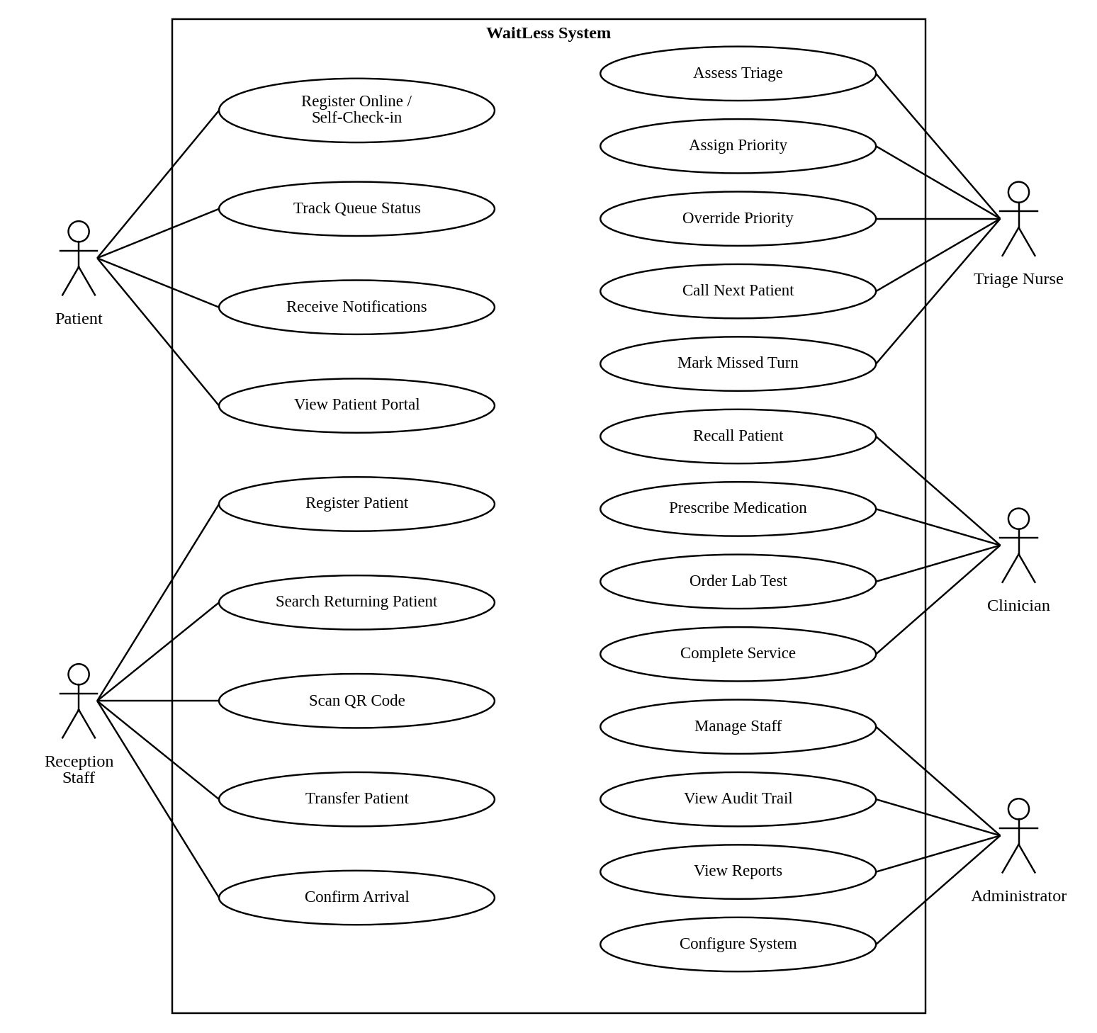
Figure 4.1: System-Wide Use Case Diagram

4.2.2 Patient Registration Use Case Diagram
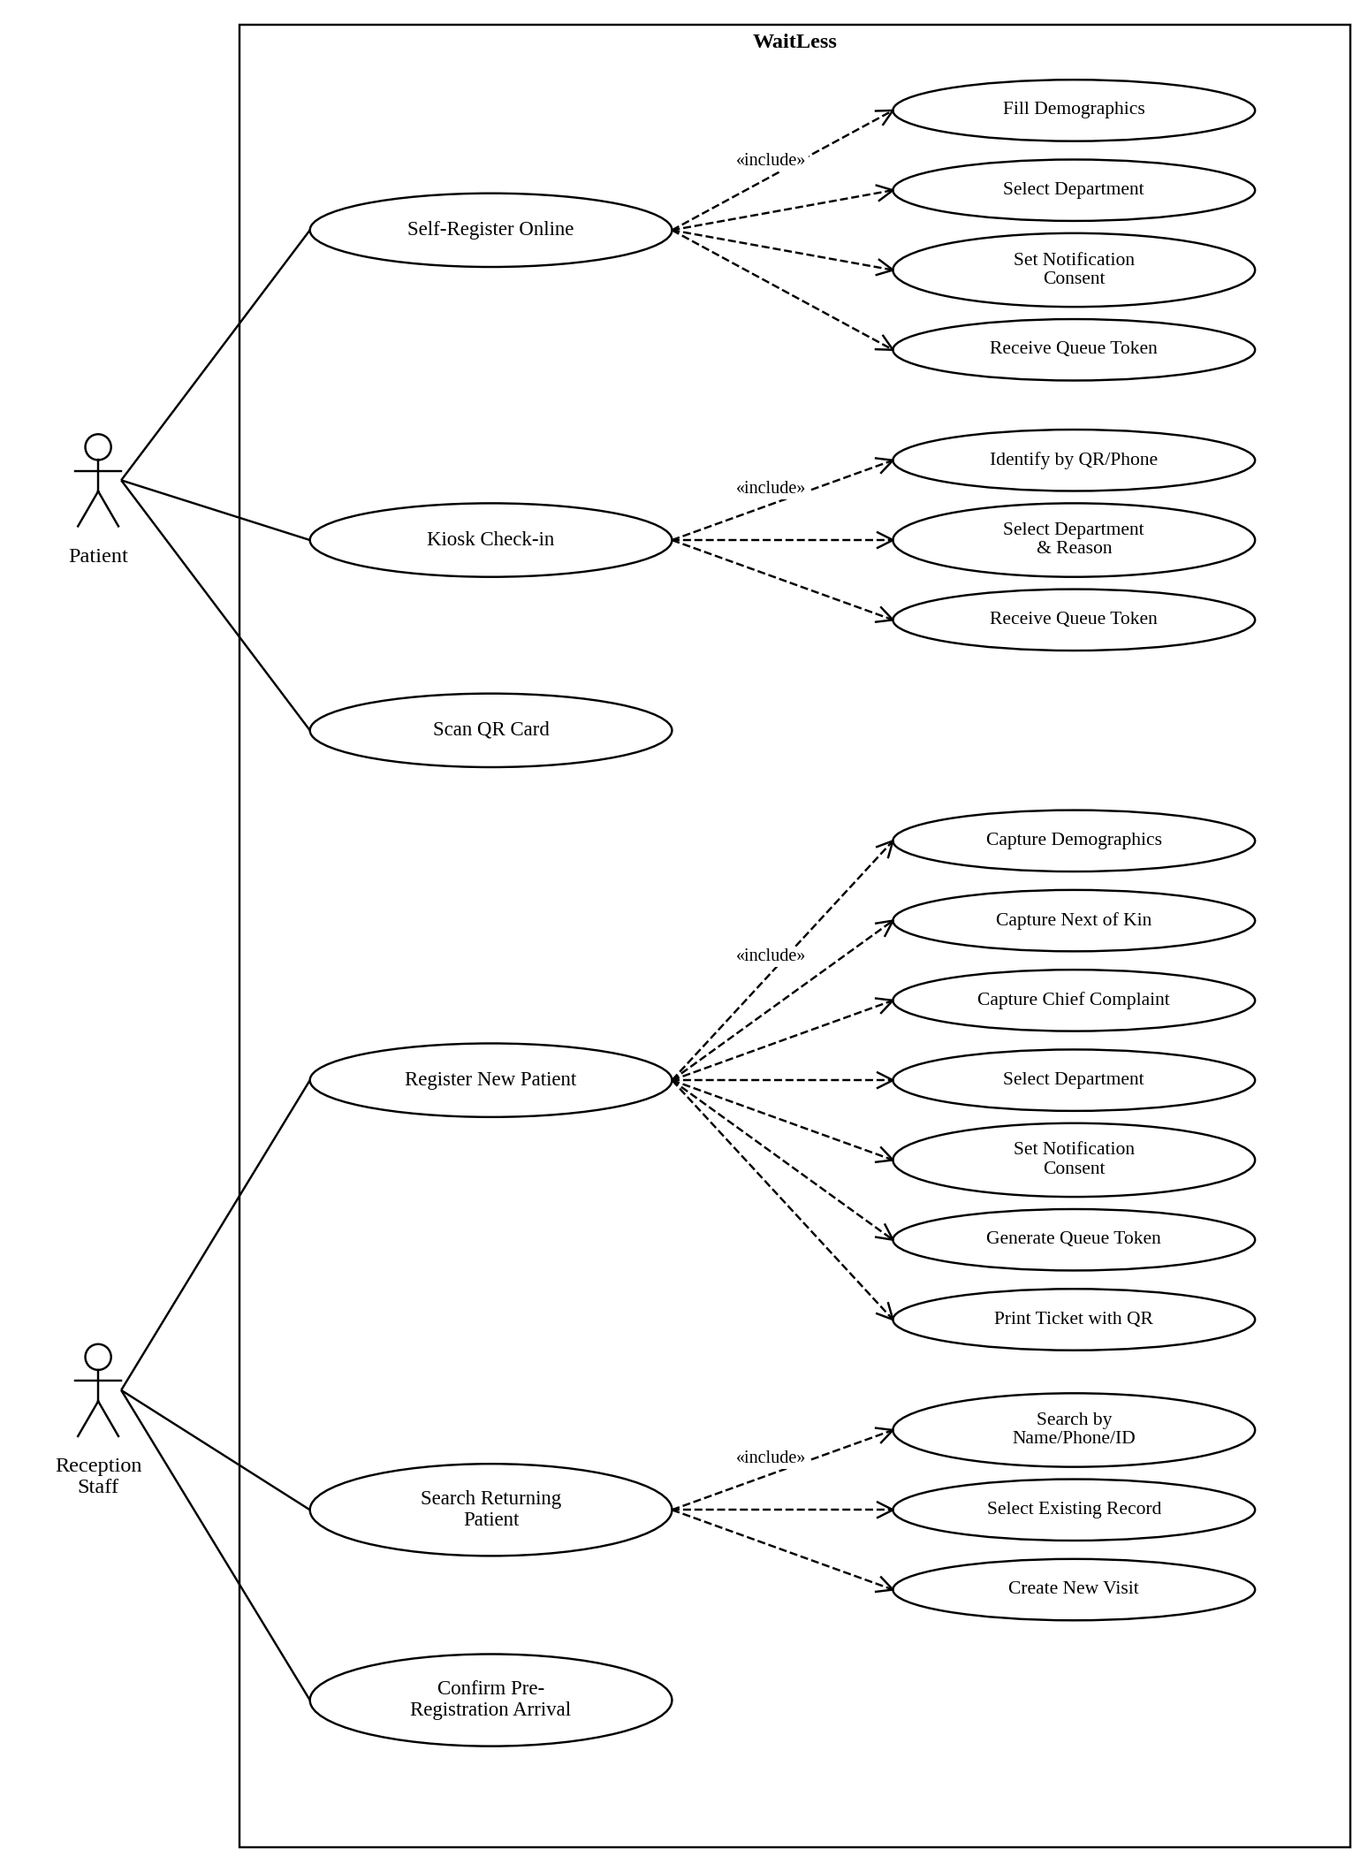
Figure 4.2: Patient Registration Use Case Diagram

4.2.3 Triage Use Case Diagram
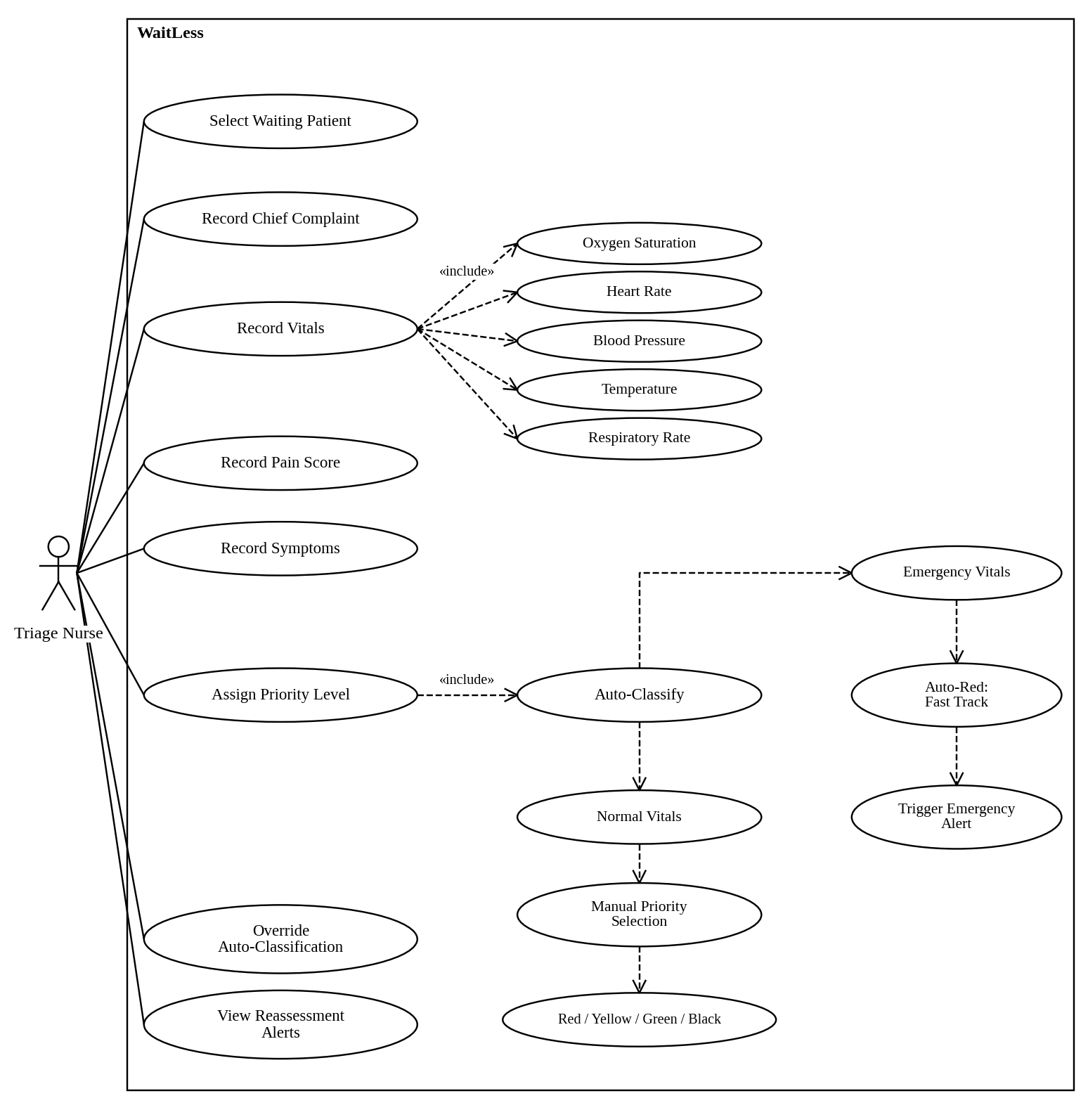
Figure 4.3: Triage Use Case Diagram

4.2.4 Queue Management Use Case Diagram
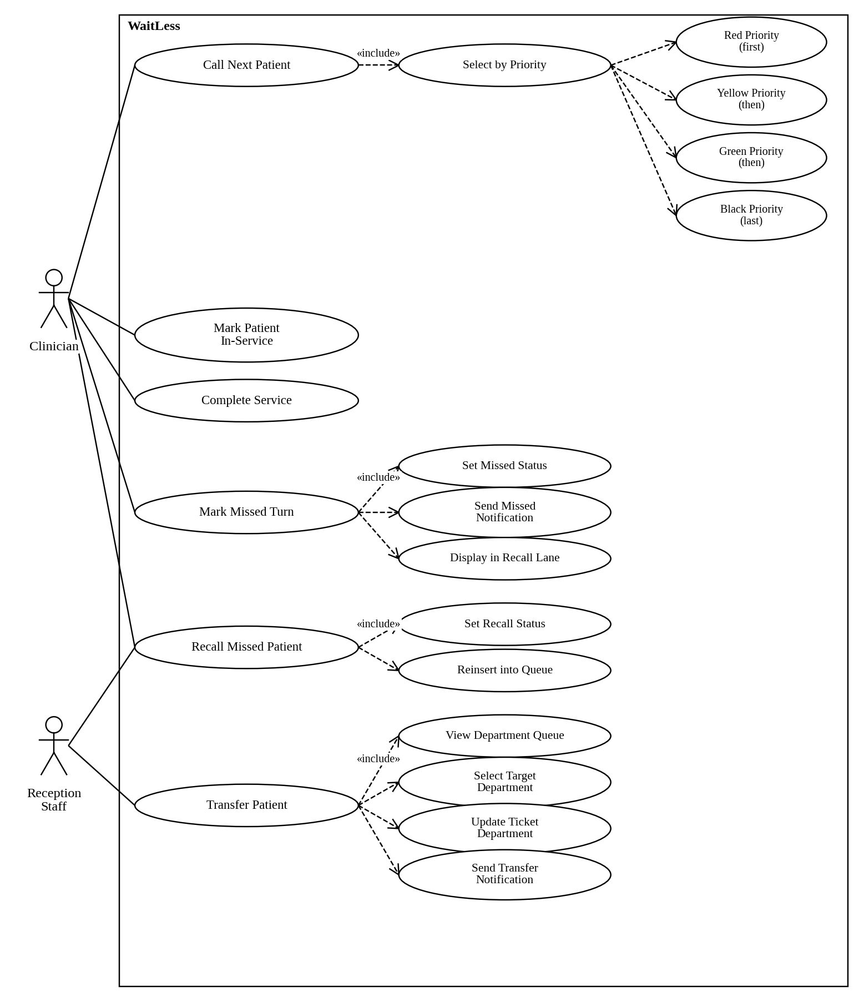
Figure 4.4: Queue Management Use Case Diagram

4.2.5 Notification Use Case Diagram
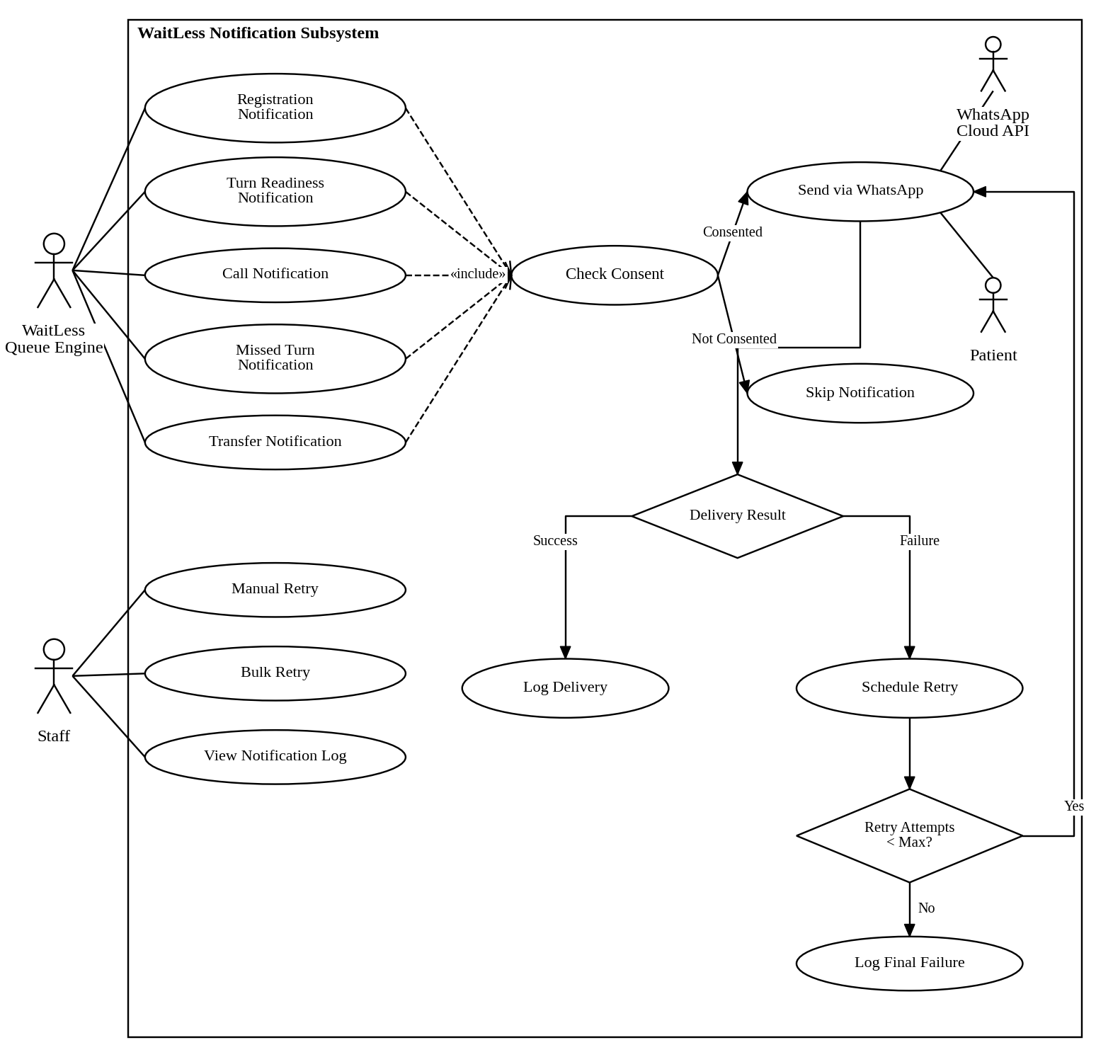
Figure 4.5: Notification Use Case Diagram

4.3 Use Case Descriptions

4.3.1 Use Case UC-01: Register New Patient
Table 4.16: Use Case UC-01: Register New Patient
Field | Description
Use Case ID | UC-01
Use Case Name | Register New Patient
Actor(s) | Reception Staff
Description | A reception staff member registers a new patient entering the hospital, capturing demographics, next of kin, chief complaint, and department selection. The system generates a unique queue token and prints a ticket.
Preconditions | Staff member is authenticated with reception role. Department queue is operational.
Postconditions | Patient is registered in the system. A queue ticket is created with a unique token. Patient appears in the department waiting queue.
Main Flow | 1. Staff selects “Register Patient” from the dashboard.  2. Staff enters patient demographics (name, national ID, DOB, gender, phone, address).  3. Staff selects patient category (walk-in, referred, emergency, etc.).  4. Staff enters next of kin details.  5. Staff enters chief complaint.  6. Staff selects destination department.  7. Staff sets notification consent (WhatsApp opt-in).  8. Staff submits the form.  9. System validates inputs.  10. System creates or links a patient profile.  11. System generates a department-specific queue token (e.g., OPD-205).  12. System creates a ticket with status “waiting” and priority “green”.  13. System broadcasts a queue update event via SSE.  14. System sends a registration WhatsApp notification if consented.  15. System displays the ticket with QR code for printing.
Alternate Flows | A1: Returning patient found. At step 10, if a matching patient profile is found by name, phone, or national ID, the system links to the existing profile instead of creating a new one.  A2: Validation error. At step 9, if required fields are missing or invalid, the system displays validation errors and the staff corrects the input.
Exceptions | E1: Database unavailable. If the database is unreachable, the system falls back to file-based storage (if configured) or displays an error message.
Business Rules | Queue tokens are immutable once generated. Token prefixes are department-specific (OPD, TRI, PHA, LAB, RAD, OIC). Sequence numbers are persistent and monotonic.
Frequency | High — performed many times daily.

4.3.2 Use Case UC-02: Triage Assessment
Table 4.17: Use Case UC-02: Triage Assessment
Field | Description
Use Case ID | UC-02
Use Case Name | Triage Assessment
Actor(s) | Triage Nurse
Description | A triage nurse conducts a structured assessment of a waiting patient, recording vitals, symptoms, pain score, and severity. The system auto-classifies priority based on emergency vital thresholds, with manual override capability.
Preconditions | Patient exists in the queue with status “waiting”. Triage nurse is authenticated with triage role.
Postconditions | Patient’s priority is updated. Triage assessment is recorded with assessor identity and timestamp. If Red priority, emergency fast-tracking is triggered. Queue order is updated.
Main Flow | 1. Nurse selects a waiting patient from the triage queue.  2. Nurse records chief complaint (if not already captured).  3. Nurse records vitals: oxygen saturation, heart rate, blood pressure (systolic/diastolic), temperature, respiratory rate.  4. Nurse records pain score (0–10).  5. Nurse records symptoms and severity notes.  6. System evaluates vitals against emergency thresholds.  7. If any vital exceeds emergency thresholds, system auto-assigns Red priority.  8. If no emergency thresholds are exceeded, nurse manually selects priority (Red/Yellow/Green/Black).  9. System saves the triage assessment with assessor ID and timestamp.  10. System updates the patient’s priority in the queue.  11. If Red priority, system triggers emergency fast-tracking (moves patient to front of queue).  12. System broadcasts a queue update event via SSE.  13. System records an audit event with before/after priority.
Alternate Flows | A1: Manual override. At step 8, the nurse may override an auto-Red classification if clinical judgement differs. The override is recorded with the original and new priority.  A2: Patient already triaged. If the patient has a prior triage assessment, the nurse can update it, and both the original and updated values are retained.
Exceptions | E1: Patient not found. If the selected patient no longer exists in the queue, the system displays an error and returns to the triage list.
Business Rules | Emergency vital thresholds: SpO2 < 90%, HR outside 40–130 bpm, systolic BP outside 80–180 mmHg, temperature >= 39.5°C, respiratory rate outside 8–30/min, pain score >= 9. Priority order: Red (0) > Yellow (1) > Green (2) > Black (3).
Frequency | High — performed for every Casualty/Triage patient.

4.3.3 Use Case UC-03: Call Next Patient
Table 4.18: Use Case UC-03: Call Next Patient
Field | Description
Use Case ID | UC-03
Use Case Name | Call Next Patient
Actor(s) | Clinician
Description | A clinician calls the next patient in their department queue. The system selects the highest-priority, longest-waiting patient and updates their status to “called”.
Preconditions | Clinician is authenticated. At least one patient is waiting in the department queue.
Postconditions | Selected patient’s status is “called”. Patient is removed from the waiting list. A call notification is sent if consented. Queue display boards update in real-time.
Main Flow | 1. Clinician clicks “Call Next” on the dashboard.  2. System retrieves all waiting tickets for the clinician’s department.  3. System sorts by priority rank (Red first), then by registration time (earliest first).  4. System selects the top ticket.  5. System updates the ticket status to “called” and records the called_at timestamp.  6. System broadcasts a “ticket.called” event via SSE.  7. System sends a WhatsApp call notification if the patient consented.  8. System dispatches turn- readiness notifications for remaining waiting patients.  9. System displays the called patient’s details to the clinician.
Alternate Flows | A1: No waiting patients. If no patients are waiting in the department, the system displays “No patients waiting” and no action is taken.
Exceptions | E1: Concurrent call. If two clinicians call next simultaneously, the system processes requests sequentially; the second clinician receives the next available patient.
Business Rules | Priority sorting: Red > Yellow > Green > Black. Within the same priority, earliest registration time is called first. Called patients have a configurable window before being marked missed.
Frequency | High — performed continuously during clinic hours.

4.3.4 Use Case UC-04: Missed Turn and Recall
Table 4.19: Use Case UC-04: Missed Turn and Recall
Field | Description
Use Case ID | UC-04
Use Case Name | Mark Missed Turn and Recall
Actor(s) | Clinician
Description | A clinician marks a called patient as missed when they do not present for service. The patient is moved to a recall lane. The clinician can later recall the patient, reinserting them into the queue.
Preconditions | Patient has status “called”.
Postconditions | Patient status is “missed”. Missed notification is sent. Patient appears in the recall lane. On recall, patient is reinserted into the waiting queue.
Main Flow | 1. Clinician selects a called patient and clicks “Mark Missed”.  2. System updates the ticket status to “missed” and records the missed_at timestamp.  3. System broadcasts a “ticket.missed” event via SSE.  4. System sends a missed-turn WhatsApp notification if consented.  5. Patient appears in the missed/recall lane on the dashboard and display board.  6. When the patient returns, clinician clicks “Recall”.  7. System updates the ticket status to “waiting” and records the recalled_at timestamp.  8. System increments the recall count.  9. System reinserts the patient into the waiting queue.  10. System broadcasts a “ticket.recalled” event via SSE.
Alternate Flows | A1: Configurable reinsertion. The reinsertion position can be configured (e.g., after 3 patients) to balance fairness with flow.
Business Rules | Recall count is tracked per ticket. Multiple recalls are allowed. The registration time may be reset on recall depending on configuration.
Frequency | Medium — occurs when patients step away during their turn.

4.3.5 Use Case UC-05: Queue Transfer
Table 4.20: Use Case UC-05: Queue Transfer
Field | Description
Use Case ID | UC-05
Use Case Name | Transfer Patient Between Departments
Actor(s) | Clinician, Reception Staff
Description | A staff member transfers a patient from one department queue to another, recording the previous department and notifying the patient.
Preconditions | Patient exists in the queue with a non-completed status. Target department is valid.
Postconditions | Patient’s department is updated. Previous department is recorded. Transfer notification is sent. Patient appears in the target department’s waiting queue.
Main Flow | 1. Staff selects a patient and clicks “Transfer”.  2. Staff selects the target department from the dropdown.  3. System validates the target department exists.  4. System records the previous department.  5. System updates the ticket’s department and sets transferred_at timestamp.  6. System broadcasts a “ticket.transferred” event via SSE.  7. System sends a transfer WhatsApp notification with the new department and directions.  8. System dispatches turn-readiness notifications for the updated queue.
Alternate Flows | None.
Exceptions | E1: Invalid department. If the target department is the same as the current department or does not exist, the system displays an error.
Business Rules | Only non-completed tickets can be transferred. The previous department is retained for audit and tracking purposes.
Frequency | Medium — occurs when patients need services in multiple departments.

4.3.6 Use Case UC-06: Patient Self-Tracking
Table 4.21: Use Case UC-06: Patient Self-Tracking
Field | Description
Use Case ID | UC-06
Use Case Name | Track Queue Status
Actor(s) | Patient
Description | A patient enters their queue token on the public tracking page to view their current queue position, estimated wait time, patients ahead, and notification history.
Preconditions | Patient has a valid queue token.
Postconditions | Patient views their current queue status. No state changes occur.
Main Flow | 1. Patient navigates to the tracking page (/track).  2. Patient enters their queue token (e.g., OPD-205).  3. System looks up the ticket by normalised token code.  4. System retrieves the ticket’s current status, department, priority, and position.  5. System calculates the estimated wait time based on historical service time and queue position.  6. System retrieves the patient’s notification history.  7. System displays: token, department, current status, position in queue, patients ahead, estimated wait time, progress indicator, and department directions.  8. Page updates in real-time via SSE when queue state changes.
Alternate Flows | A1: Token not found. If the token does not match any ticket, the system displays “Ticket not found” and prompts re- entry.
Exceptions | None.
Business Rules | Tracking is public and does not require authentication. Only the token code is needed. Patient name is not displayed on the tracking page for privacy.
Frequency | High — patients check frequently during their wait.

4.3.7 Use Case UC-07: Kiosk Self-Check-in
Table 4.22: Use Case UC-07: Kiosk Self-Check-in
Field | Description
Use Case ID | UC-07
Use Case Name | Kiosk Self-Check-in
Actor(s) | Patient
Description | A patient uses a self-service kiosk to check in by scanning a QR card or entering a phone number, selecting a department and visit reason, and receiving a queue token.
Preconditions | Kiosk device is operational and connected to the network.
Postconditions | Patient is checked in. A queue ticket is created. Patient receives a token and optional WhatsApp notifications.
Main Flow | 1. Patient approaches the kiosk and taps “Check In”.  2. Patient identifies themselves by scanning a QR card (camera- based) or entering a phone number.  3. System searches for an existing patient profile by QR payload or phone.  4. If found, system displays the patient’s name for confirmation.  5. If not found, patient enters basic demographics.  6. Patient selects the destination department.  7. Patient enters a visit reason / chief complaint.  8. Patient sets notification consent.  9. System creates a queue ticket with the next sequence number.  10. System displays the queue token and estimated wait time.  11. System broadcasts a queue update event via SSE.  12. System sends a registration notification if consented.
Alternate Flows | A1: QR scan failure. If the camera cannot read the QR code, the patient can manually enter their phone number or patient number.
Exceptions | E1: Network error. If the kiosk cannot reach the server, an error message is displayed and the patient is directed to reception.
Business Rules | Kiosk check-in creates a “waiting” ticket with “green” priority by default. Triage assessment can upgrade the priority later.
Frequency | Medium — used by walk-in patients at the hospital entrance.

4.3.8 Use Case UC-08: Send WhatsApp Notification
Table 4.23: Use Case UC-08: Send WhatsApp Notification
Field | Description
Use Case ID | UC-08
Use Case Name | Send WhatsApp Notification
Actor(s) | System (automated)
Description | The system sends a WhatsApp message to a patient for registration, turn readiness, call, missed turn, or transfer events, with automatic retry on failure.
Preconditions | Patient has notification consent enabled. Patient has a valid phone number. WhatsApp provider is configured (mock or Meta Cloud API).
Postconditions | Notification record is created with delivery status. If successful, message is delivered. If failed, retry is scheduled.
Main Flow | 1. A queue event triggers notification dispatch (registration, call, missed, transfer, turn readiness).  2. System checks the patient’s notification consent.  3. System creates a notification record with type, channel, recipient, and message content.  4. System resolves the WhatsApp template for the notification type.  5. System sends the message via the configured provider (mock or Meta Cloud API).  6. If delivery succeeds, system records the provider message ID and sets status to “sent”/“delivered”.  7. If delivery fails, system records the error code and message, and schedules a retry based on configured retry delays (15s, 60s, 300s).  8. System creates a notification attempt record for each attempt.  9. Retry continues until max attempts is reached or delivery succeeds.
Alternate Flows | A1: Manual retry. Staff can manually retry a failed notification from the dashboard.  A2: Bulk retry. Staff can retry multiple failed notifications simultaneously.
Exceptions | E1: Provider unavailable. If the WhatsApp API is unreachable, the notification is queued for retry.  E2: Invalid phone number. If the phone number is invalid, the notification is marked as failed with an error code.
Business Rules | Retry delays: 15 seconds, 60 seconds, 300 seconds (configurable). Max attempts: configurable per notification. Mock provider simulates delivery with configurable delay and failure rate for development.
Frequency | High — triggered by every queue event for consented patients.

4.3.9 Use Case UC-09: View Reports
Table 4.24: Use Case UC-09: View Reports
Field | Description
Use Case ID | UC-09
Use Case Name | View Operational Reports
Actor(s) | Administrator, Clinician
Description | A staff member views operational reports including average waiting time, department performance, no-show analysis, triage outcomes, and WhatsApp status, with date range filtering.
Preconditions | Staff member is authenticated.
Postconditions | Report data is displayed. No state changes occur.
Main Flow | 1. Staff navigates to the Reports page.  2. Staff selects a report tab (Overview, Average Wait Time, Department Performance, No-Show, Triage, WhatsApp Status).  3. Staff selects a date range (from/to).  4. System fetches report data from the API with date filters.  5. System displays the report with summary metrics, department breakdowns, and detailed tables.
Alternate Flows | None.
Exceptions | E1: No data. If no tickets exist in the selected date range, the system displays an empty state message.
Business Rules | Reports are read-only. Date filtering applies to ticket registration date. Department scoping applies to non-admin staff.
Frequency | Medium — used for daily/weekly operational review.

4.3.10 Use Case UC-10: View Audit Trail
Table 4.25: Use Case UC-10: View Audit Trail
Field | Description
Use Case ID | UC-10
Use Case Name | View Audit Trail
Actor(s) | Administrator
Description | An administrator views the immutable audit trail of all system actions, including actor, timestamp, action type, entity, before/after state, and hash chain verification.
Preconditions | Administrator is authenticated with admin role.
Postconditions | Audit events are displayed. No state changes occur (audit trail is read-only).
Main Flow | 1. Administrator navigates to the Audit Trail page.  2. System retrieves audit events from the database, ordered by occurrence time (most recent first).  3. System displays each event with: timestamp, actor name/role/department, action, entity type/ID, outcome, and before/after state.  4. Administrator can filter by action type, actor, or date range.  5. System displays the hash chain verification status.
Alternate Flows | None.
Exceptions | E1: Hash chain broken. If a tamper event is detected, the system flags the compromised event(s) in the audit display.
Business Rules | Audit events are append-only and cannot be modified or deleted. Each event’s hash incorporates the previous event’s hash, creating a verifiable chain. Sensitive data (passwords, tokens) is redacted in audit records. Only administrators can view the audit trail.
Frequency | Low — used for security review and compliance.

4.4 System Architecture

4.4.1 High-Level Architecture
The WaitLess system follows a client-server architecture with a React single-page application frontend, a Node.js backend with a custom HTTP router, a dual-mode data layer (MySQL or file-based JSON), and integration with the WhatsApp Cloud API for external notifications.
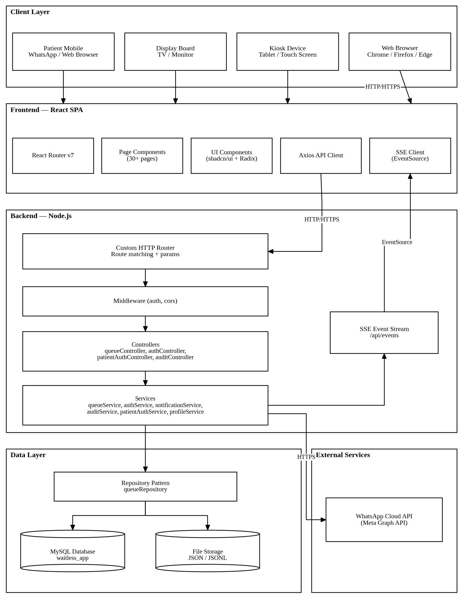
Figure 4.6: High-Level Architecture

4.4.2 Layered Architecture Description
The system follows a strict layered architecture with clear separation of concerns:
Table 4.26: Layered Architecture Description
Layer | Responsibility | Key Files
Presentation Layer | Renders UI, captures user input, displays real-time updates | frontend/src/pages/ ,  frontend/src/components/
API/Controller Layer | Receives HTTP requests, validates input, calls services, formats responses | backend/src/controllers/ ,  backend/src/index.js
Service/Business Logic Layer | Implements domain rules, queue algorithms, notification dispatch, authentication | backend/src/services/
Repository/Data Access Layer | Abstracts data persistence, supports MySQL and file-based modes | backend/src/repositories/
External Integration Layer | Communicates with WhatsApp Cloud API | backend/src/services/whatsAppProvider.js

4.4.3 Technology Architecture
Table 4.27: Technology Architecture
Component | Technology | Version
Frontend Framework | React | 19.2.0
Build Tool | Vite | 7.3.1
Routing | React Router DOM | 7.10.1
Styling | Tailwind CSS | 4.2.1
UI Components | Radix UI (shadcn/ui) | Various
Charts | Recharts | 2.15.4
HTTP Client | Axios | 1.7.9
Form Validation | Zod + react-hook-form | 3.24.2 / 7.71.2
Icons | Lucide React | 0.575.0
Toast Notifications | Sonner | 2.0.7
QR Code | qrcode | 1.5.4
QR Scanning | html5-qrcode | 2.3.8
Backend Runtime | Node.js | 18+ (ESM)
Database Driver | mysql2 | 3.6.0
Password Hashing | bcryptjs | 2.4.3
Environment Config | dotenv | 16.3.1
Real-time Protocol | Server-Sent Events (SSE) | Native
Notification Provider | WhatsApp Cloud API (Meta Graph) | v23.0

4.4.4 Deployment Architecture
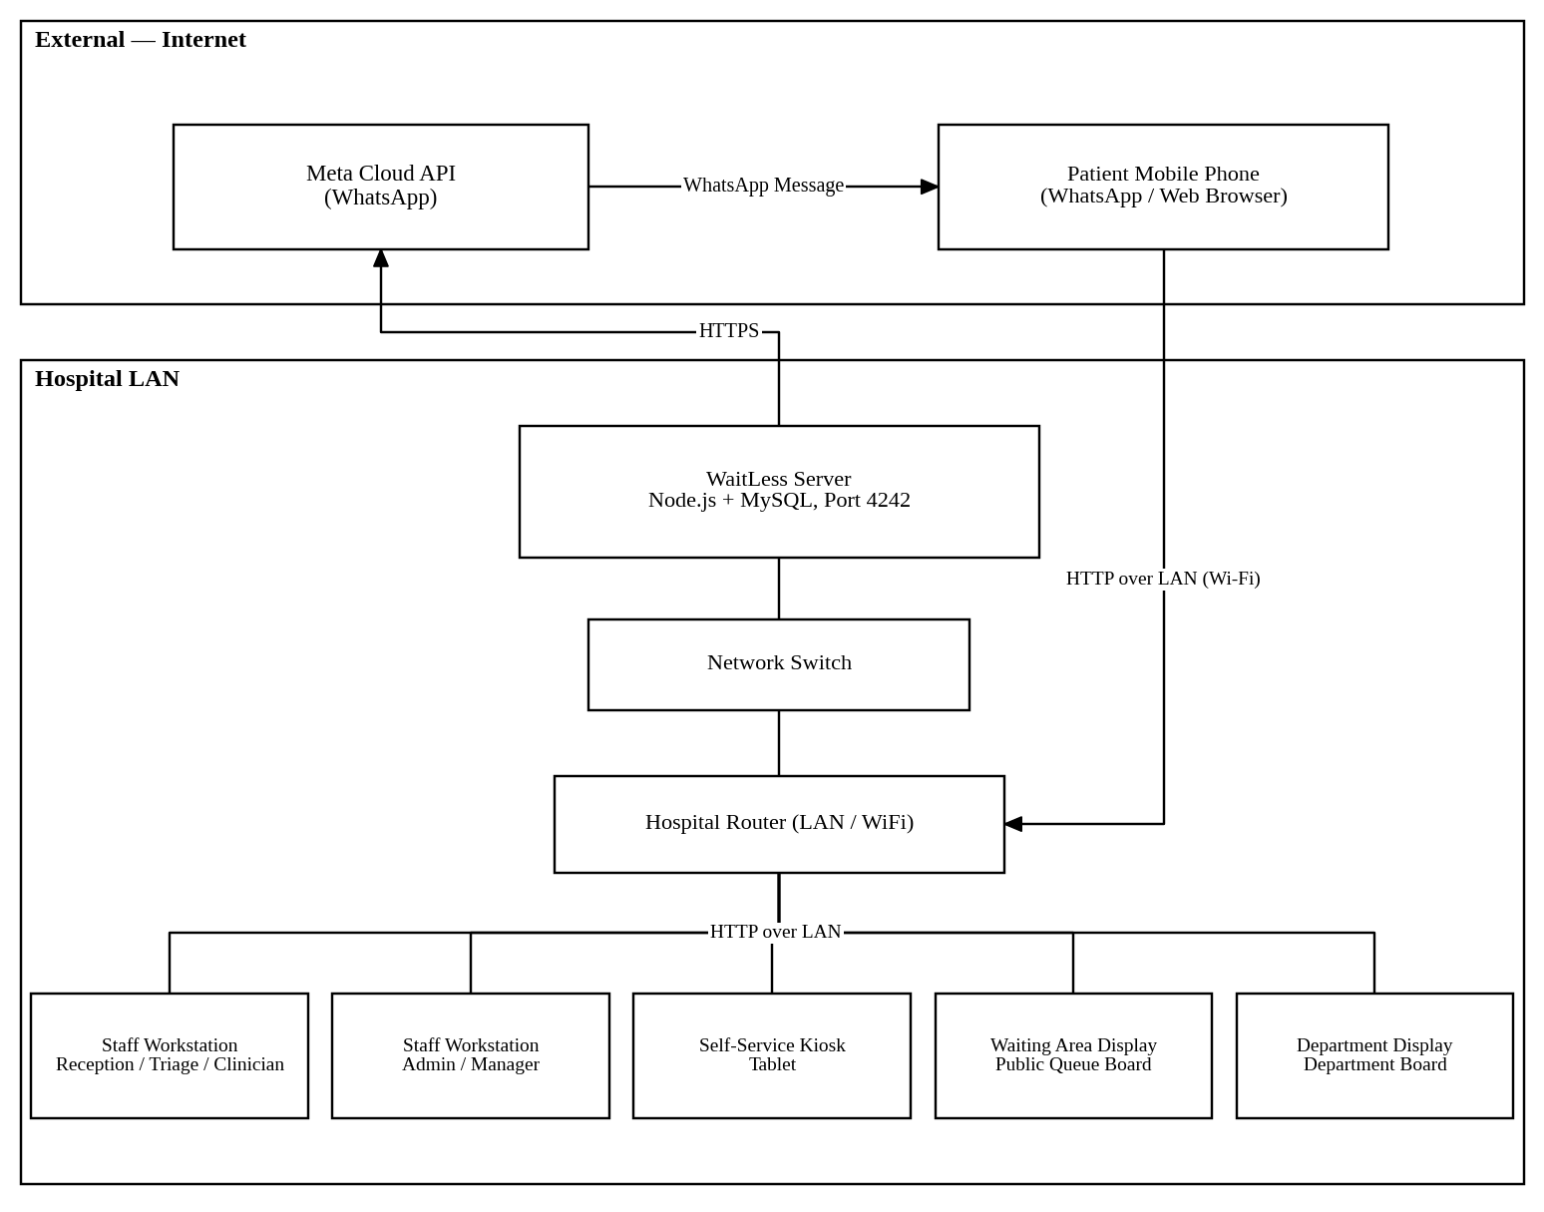
Figure 4.7: Deployment Architecture
The system is designed for primary deployment on a hospital local area network (LAN). The Node.js server and MySQL database run on a single machine or a small server within the hospital network. Staff workstations, kiosks, and display boards connect to the server over the LAN via standard HTTP. External WhatsApp notifications are sent via HTTPS to the Meta Cloud API, which requires internet connectivity. The system can operate in a reduced capacity (core queue management without notifications) when internet is unavailable.

4.5 Data Design

4.5.1 Entity-Relationship Diagram
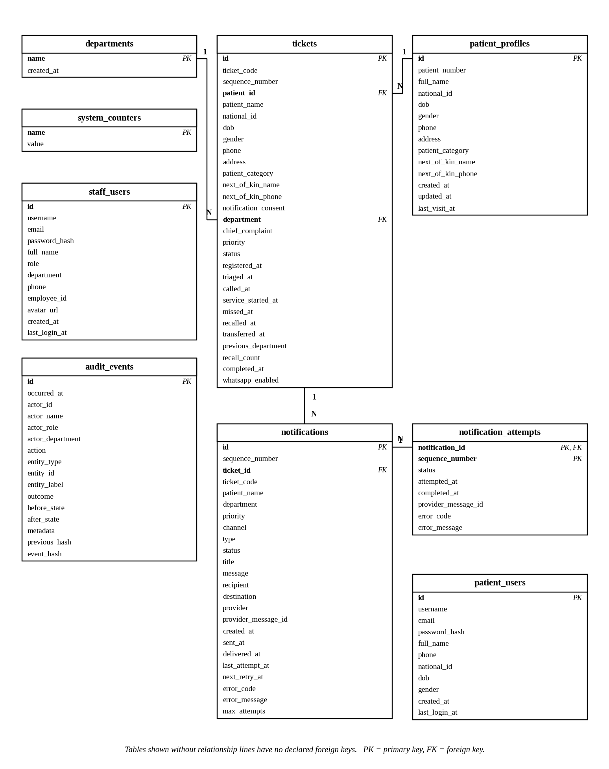
Figure 4.8: Entity-Relationship Diagram

4.5.2 Data Dictionary

Table: departments
Table 4.28: Table: departments
Column | Type | Constraints | Description
name | VARCHAR(80) | PRIMARY KEY | Department name (e.g., “OPD”, “Casualty / Triage”)
created_at | TIMESTAMP(3) | NOT NULL, DEFAULT CURRENT_TIMESTAMP | Record creation timestamp

Table: patient_profiles
Table 4.29: Table: patient_profiles
Column | Type | Constraints | Description
id | CHAR(36) | PRIMARY KEY | UUID identifier
patient_number | VARCHAR(24) | NOT NULL, UNIQUE | Permanent patient number (e.g., “PT-0001”)
full_name | VARCHAR(160) | NOT NULL | Patient’s full name
national_id | VARCHAR(80) | NULL | National ID number
dob | DATE | NULL | Date of birth
gender | VARCHAR(40) | NOT NULL, DEFAULT ‘unknown’ | Gender (male/female/unknown)
phone | VARCHAR(80) | NULL | Phone number for notifications
address | VARCHAR(255) | NOT NULL, DEFAULT ‘’ | Residential address
patient_category | VARCHAR(80) | NOT NULL, DEFAULT ‘walk-in’ | Category (walk-in, referred, emergency, etc.)
next_of_kin_name | VARCHAR(160) | NOT NULL, DEFAULT ‘’ | Next of kin full name
next_of_kin_phone | VARCHAR(80) | NOT NULL, DEFAULT ‘’ | Next of kin phone number
created_at | DATETIME(3) | NOT NULL | Profile creation timestamp
updated_at | DATETIME(3) | NOT NULL | Last update timestamp
last_visit_at | DATETIME(3) | NULL | Last visit timestamp

Indexes: idx_patient_profiles_name (full_name), idx_patient_profiles_national_id (national_id), idx_patient_profiles_phone (phone)

Table: tickets
Table 4.30: Table: tickets
Column | Type | Constraints | Description
id | CHAR(36) | PRIMARY KEY | UUID identifier
ticket_code | VARCHAR(20) | NOT NULL, UNIQUE | Queue token (e.g., “OPD-205”)
sequence_number | INT | NOT NULL | Department-specific sequence
patient_id | CHAR(36) | NULL, FK → patient_profiles(id) | Linked patient profile
patient_name | VARCHAR(160) | NOT NULL | Patient name (denormalised)
national_id | VARCHAR(80) | NOT NULL, DEFAULT ‘’ | National ID (denormalised)
dob | DATE | NULL | Date of birth (denormalised)
gender | VARCHAR(40) | NOT NULL, DEFAULT ‘unknown’ | Gender (denormalised)
phone | VARCHAR(80) | NOT NULL, DEFAULT ‘’ | Phone (denormalised)
address | VARCHAR(255) | NOT NULL, DEFAULT ‘’ | Address (denormalised)
patient_category | VARCHAR(80) | NOT NULL, DEFAULT ‘walk-in’ | Category (denormalised)
next_of_kin_name | VARCHAR(160) | NOT NULL, DEFAULT ‘’ | Next of kin name (denormalised)
next_of_kin_phone | VARCHAR(80) | NOT NULL, DEFAULT ‘’ | Next of kin phone (denormalised)
notification_consent | BOOLEAN | NOT NULL, DEFAULT FALSE | WhatsApp notification opt-in
department | VARCHAR(80) | NOT NULL, FK →  departments(name) | Current department
chief_complaint | TEXT | NULL | Patient’s chief complaint
priority | VARCHAR(20) | NOT NULL | Priority level (red/yellow/green/black)
status | VARCHAR(30) | NOT NULL | Ticket status (waiting/called/in- service/missed/completed)
registered_at | DATETIME(3) | NOT NULL | Registration timestamp
triaged_at | DATETIME(3) | NULL | Triage assessment timestamp
called_at | DATETIME(3) | NULL | When patient was called
service_started_at | DATETIME(3) | NULL | When service began
missed_at | DATETIME(3) | NULL | When marked missed
recalled_at | DATETIME(3) | NULL | When recalled
transferred_at | DATETIME(3) | NULL | When transferred
previous_department | VARCHAR(80) | NOT NULL, DEFAULT ‘’ | Previous department (for transfers)
recall_count | INT | NOT NULL, DEFAULT 0 | Number of recalls
completed_at | DATETIME(3) | NULL | Service completion timestamp
whatsapp_enabled | BOOLEAN | NOT NULL, DEFAULT FALSE | WhatsApp enabled flag

Indexes: idx_tickets_department_status (department, status), idx_tickets_priority_status (priority, status), idx_tickets_registered_at (registered_at), idx_tickets_patient_id (patient_id)

Table: notifications
Table 4.31: Table: notifications
Column | Type | Constraints | Description
id | CHAR(36) | PRIMARY KEY | UUID identifier
sequence_number | BIGINT | NOT NULL, UNIQUE | Monotonic sequence
ticket_id | CHAR(36) | NOT NULL, FK → tickets(id) | Related ticket
ticket_code | VARCHAR(20) | NOT NULL | Ticket code (denormalised)
patient_name | VARCHAR(160) | NOT NULL | Patient name (denormalised)
department | VARCHAR(80) | NOT NULL | Department (denormalised)
priority | VARCHAR(20) | NOT NULL | Priority (denormalised)
channel | VARCHAR(40) | NOT NULL | Notification channel (whatsapp, display-board)
type | VARCHAR(80) | NOT NULL | Notification type (queue.registered, queue.called, etc.)
status | VARCHAR(40) | NOT NULL | Delivery status (pending, sent, delivered, failed)
title | VARCHAR(255) | NOT NULL | Notification title
message | TEXT | NOT NULL | Message body
recipient | VARCHAR(160) | NOT NULL | Recipient phone number
destination | VARCHAR(160) | NULL | Destination department
provider | VARCHAR(80) | NULL | Provider name (mock, meta-cloud)
provider_message_id | VARCHAR(160) | NULL | Provider’s message ID
created_at | DATETIME(3) | NOT NULL | Creation timestamp
sent_at | DATETIME(3) | NULL | When sent to provider
delivered_at | DATETIME(3) | NULL | When delivered
last_attempt_at | DATETIME(3) | NULL | Last attempt timestamp
next_retry_at | DATETIME(3) | NULL | Next scheduled retry
error_code | VARCHAR(80) | NULL | Error code from provider
error_message | TEXT | NULL | Error message from provider
max_attempts | INT | NOT NULL, DEFAULT 1 | Maximum retry attempts

Indexes: idx_notifications_ticket_id, idx_notifications_status, idx_notifications_channel, idx_notifications_provider_message_id, idx_notifications_created_at

Table: notification_attempts
Table 4.32: Table: notification_attempts
Column | Type | Constraints | Description
notification_id | CHAR(36) | PK, FK → notifications(id) | Related notification
sequence_number | INT | PK | Attempt sequence
status | VARCHAR(40) | NOT NULL | Attempt status
attempted_at | DATETIME(3) | NOT NULL | Attempt timestamp
completed_at | DATETIME(3) | NULL | Completion timestamp
provider_message_id | VARCHAR(160) | NULL | Provider message ID
error_code | VARCHAR(80) | NULL | Error code
error_message | TEXT | NULL | Error message

Table: staff_users
Table 4.33: Table: staff_users
Column | Type | Constraints | Description
id | CHAR(36) | PRIMARY KEY | UUID identifier
username | VARCHAR(32) | NOT NULL, UNIQUE | Login username
email | VARCHAR(120) | NOT NULL, UNIQUE | Email address
password_hash | VARCHAR(255) | NOT NULL | bcrypt password hash
full_name | VARCHAR(160) | NOT NULL | Staff member’s full name
role | VARCHAR(40) | NOT NULL, DEFAULT ‘reception’ | Role (admin, reception, triage, clinician)
department | VARCHAR(80) | NOT NULL, DEFAULT ‘’ | Assigned department
phone | VARCHAR(80) | NULL | Phone number
employee_id | VARCHAR(80) | NULL | Employee ID
avatar_url | TEXT | NULL | Avatar image URL
created_at | DATETIME(3) | NOT NULL, DEFAULT CURRENT_TIMESTAMP | Creation timestamp
last_login_at | DATETIME(3) | NULL | Last login timestamp

Table: patient_users
Table 4.34: Table: patient_users
Column | Type | Constraints | Description
id | CHAR(36) | PRIMARY KEY | UUID identifier
username | VARCHAR(32) | NOT NULL, UNIQUE | Login username
email | VARCHAR(120) | NOT NULL, UNIQUE | Email address
password_hash | VARCHAR(255) | NOT NULL | bcrypt password hash
full_name | VARCHAR(160) | NOT NULL | Patient’s full name
phone | VARCHAR(80) | NOT NULL | Phone number
national_id | VARCHAR(80) | NULL | National ID
dob | DATE | NULL | Date of birth
gender | VARCHAR(40) | NOT NULL, DEFAULT ‘unknown’ | Gender
created_at | DATETIME(3) | NOT NULL, DEFAULT CURRENT_TIMESTAMP | Creation timestamp
last_login_at | DATETIME(3) | NULL | Last login timestamp

Table: audit_events
Table 4.35: Table: audit_events
Column | Type | Constraints | Description
id | CHAR(36) | PRIMARY KEY | UUID identifier
occurred_at | DATETIME(3) | NOT NULL | When the event occurred
actor_id | CHAR(36) | NULL | Staff user ID who performed the action
actor_name | VARCHAR(160) | NULL | Staff name (denormalised)
actor_role | VARCHAR(40) | NULL | Staff role (denormalised)
actor_department | VARCHAR(80) | NULL | Staff department (denormalised)
action | VARCHAR(100) | NOT NULL | Action type (e.g., “ticket.create”, “auth.login”)
entity_type | VARCHAR(80) | NOT NULL | Entity type (ticket, staff, notification)
entity_id | VARCHAR(80) | NULL | Entity ID
entity_label | VARCHAR(160) | NULL | Entity label (e.g., ticket code)
outcome | VARCHAR(40) | NOT NULL, DEFAULT ‘success’ | Outcome (success, failure)
before_state | JSON | NULL | State before the action
after_state | JSON | NULL | State after the action
metadata | JSON | NULL | Additional metadata
previous_hash | CHAR(64) | NULL | Hash of the previous audit event
event_hash | CHAR(64) | NOT NULL, UNIQUE | SHA-256 hash of this event

Indexes: idx_audit_events_occurred_at, idx_audit_events_actor_id, idx_audit_events_action, idx_audit_events_entity

Table: system_counters
Table 4.36: Table: system_counters
Column | Type | Constraints | Description
name | VARCHAR(80) | PRIMARY KEY | Counter name (e.g., “OPD”, “TRI”, “PHA”)
value | BIGINT | NOT NULL | Current counter value

4.5.3 Data Flow Diagrams

DFD Level 0 — Context Diagram
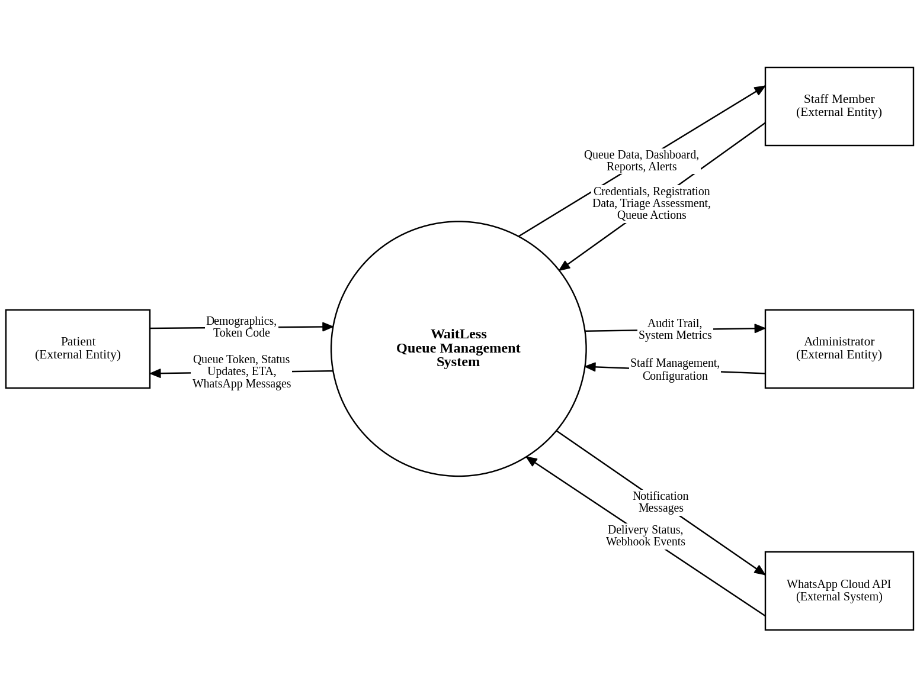
Figure 4.9: DFD Level 0 — Context Diagram

DFD Level 1 — Major Processes
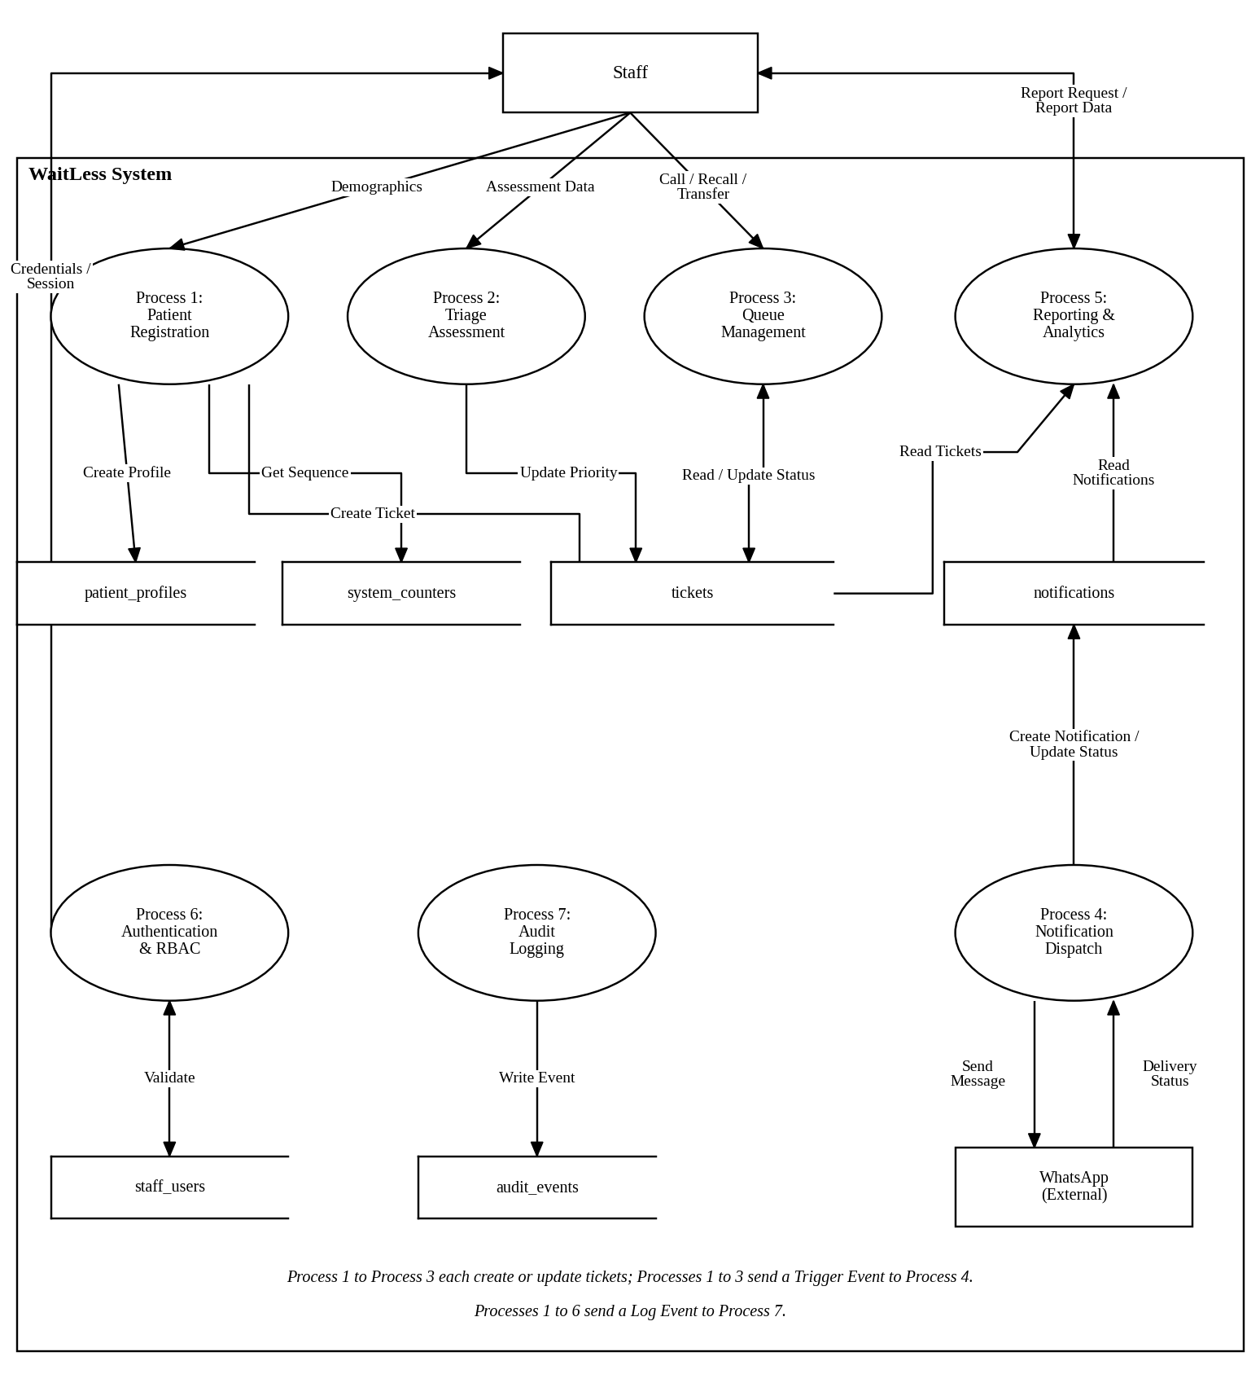
Figure 4.10: DFD Level 1 — Major Processes

DFD Level 2 — Patient Registration Detail
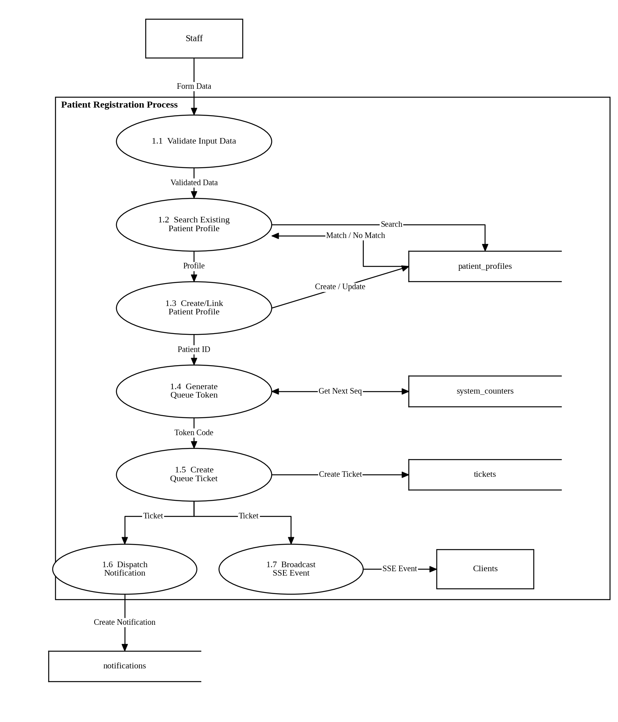
Figure 4.11: DFD Level 2 — Patient Registration Detail

4.6 Process Design

4.6.1 Sequence Diagram: Patient Registration
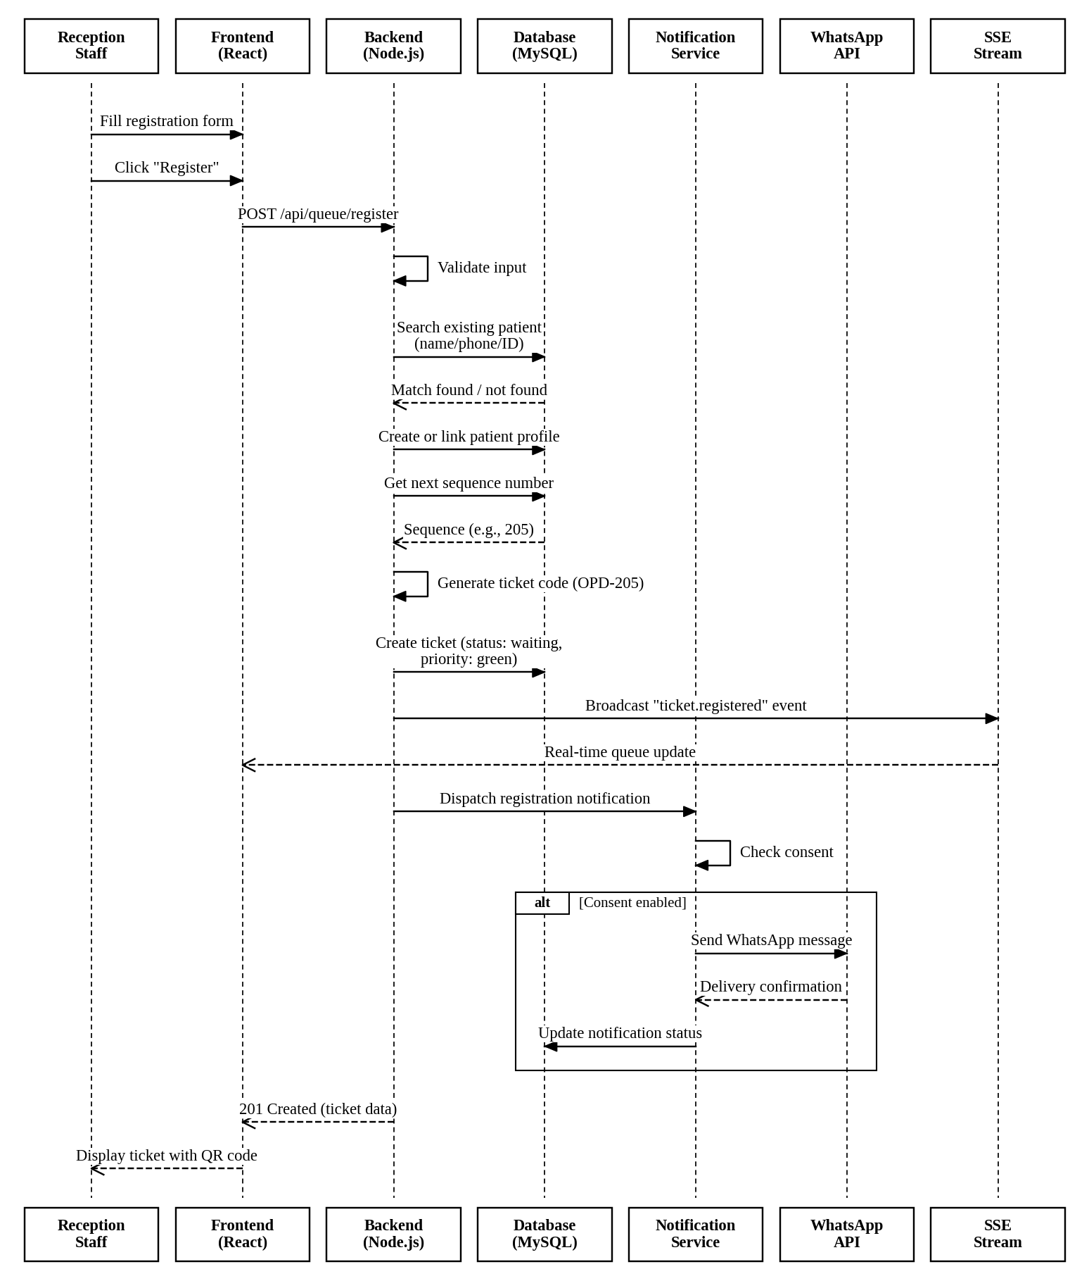
Figure 4.12: Sequence Diagram: Patient Registration

4.6.2 Sequence Diagram: Triage Assessment
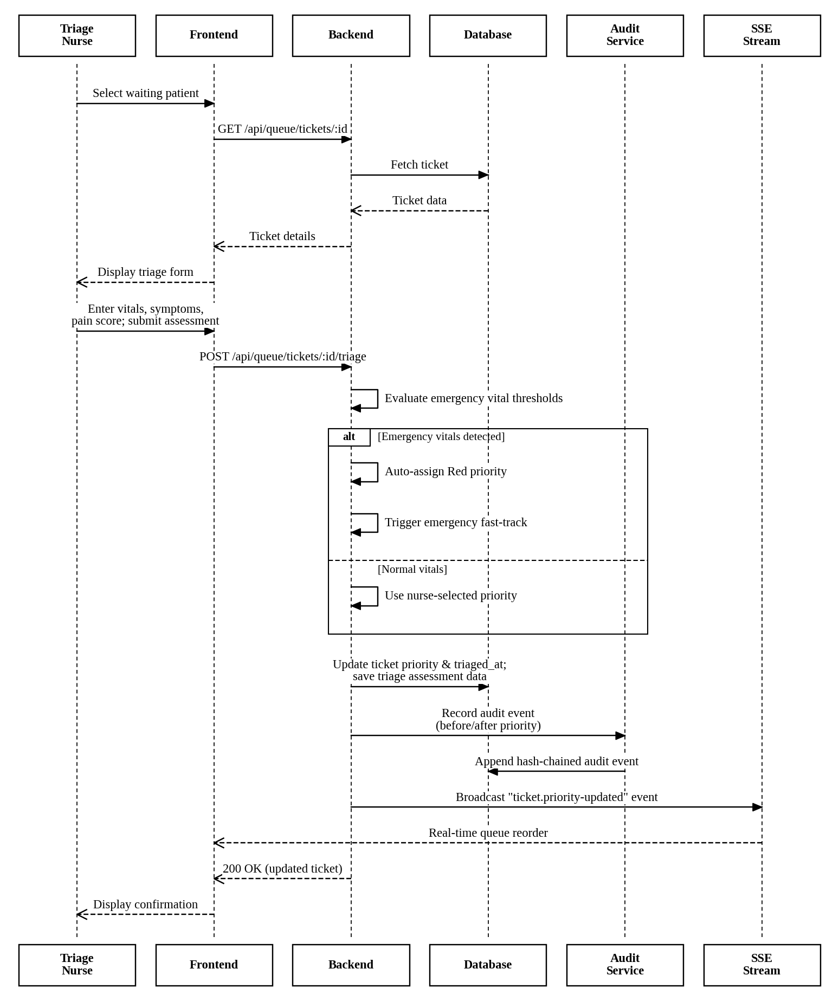
Figure 4.13: Sequence Diagram: Triage Assessment

4.6.3 Sequence Diagram: Call Next Patient
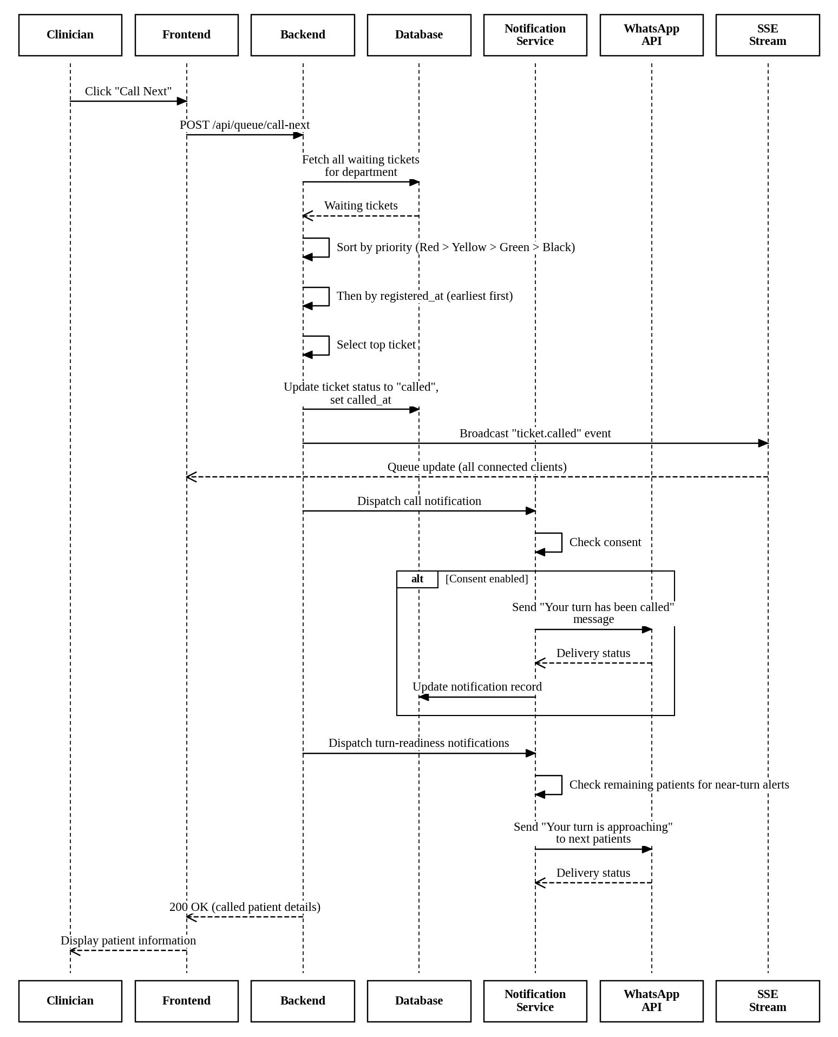
Figure 4.14: Sequence Diagram: Call Next Patient

4.6.4 Sequence Diagram: Notification Dispatch with Retry
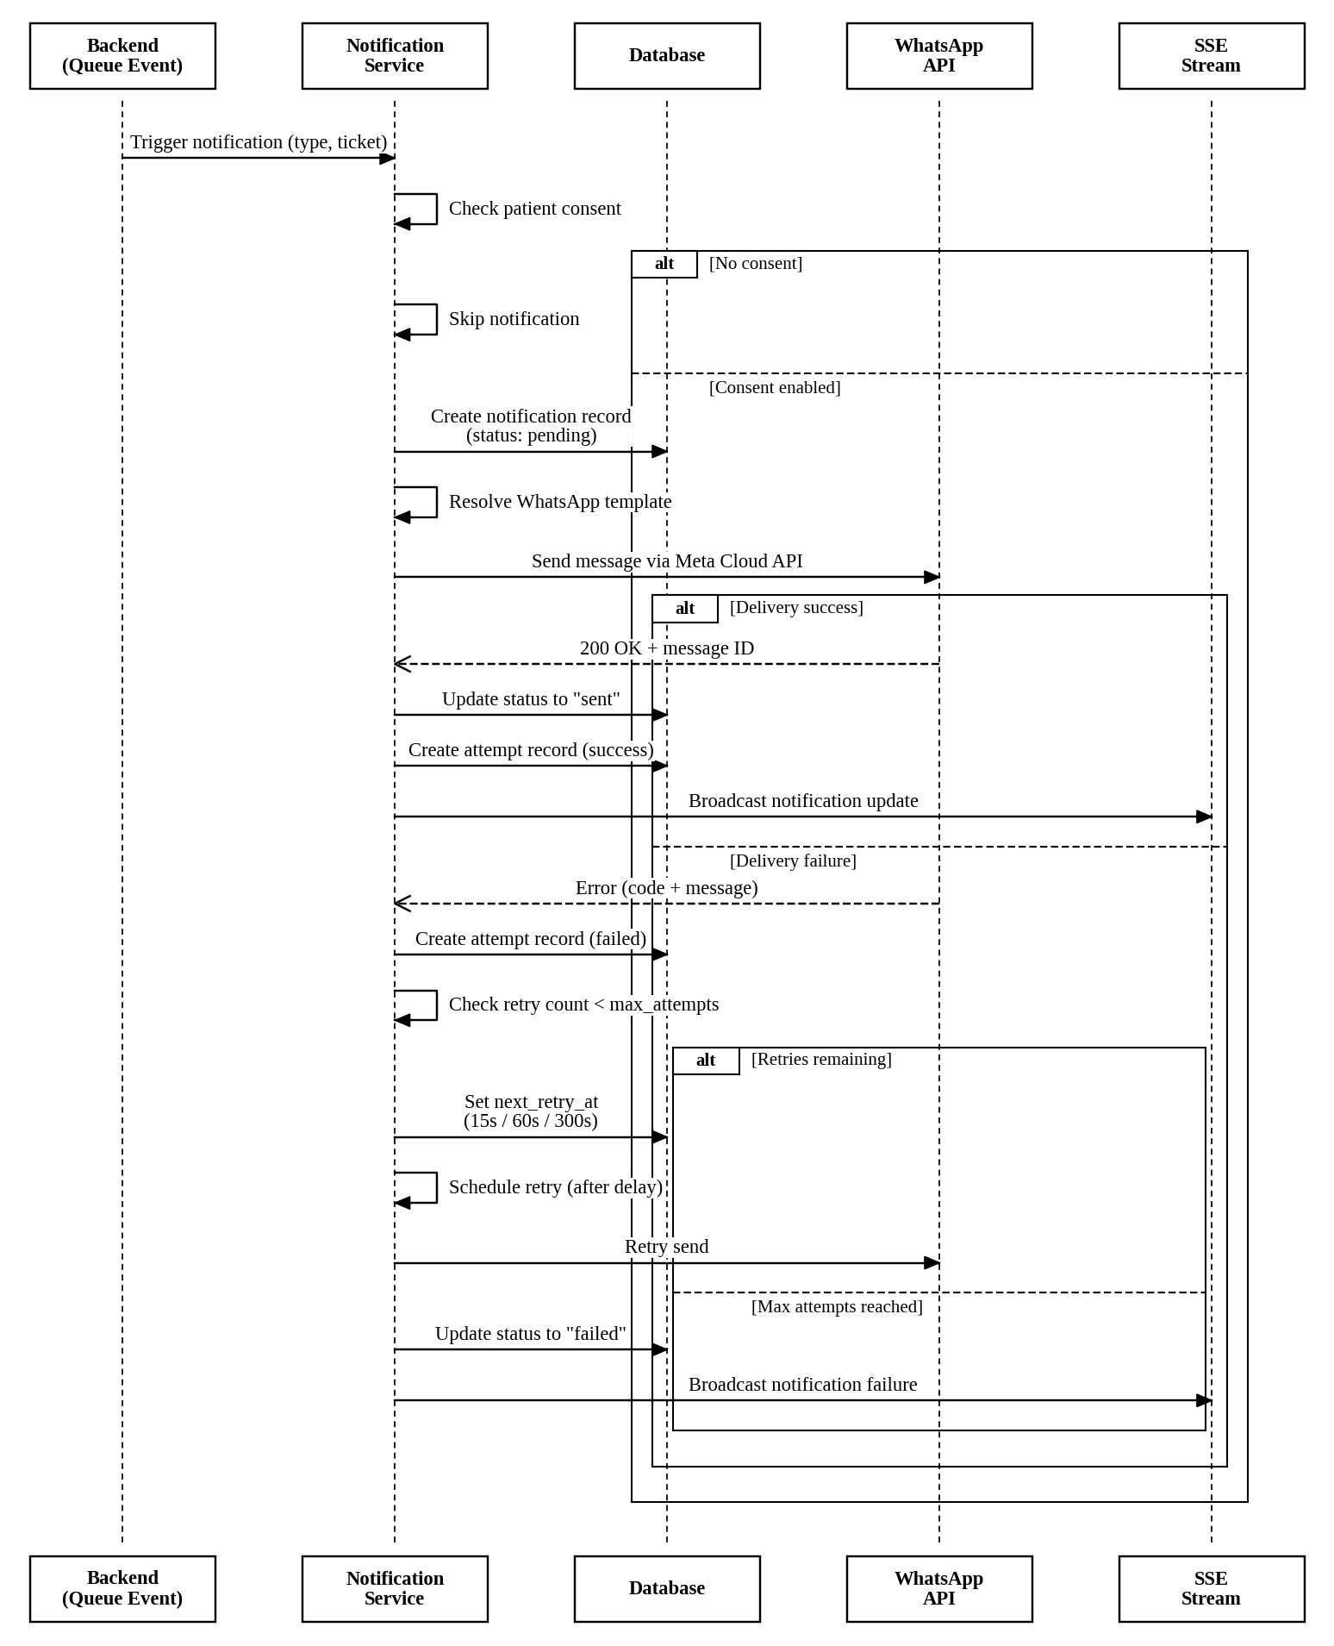
Figure 4.15: Sequence Diagram: Notification Dispatch with Retry

4.6.5 Activity Diagram: Patient Journey
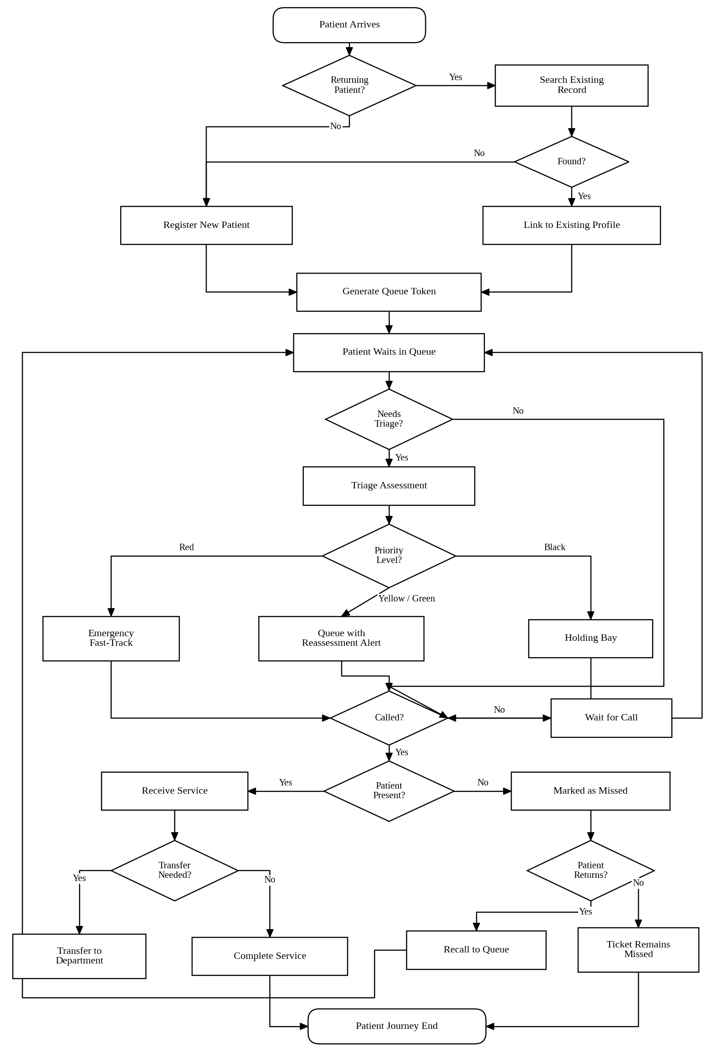
Figure 4.16: Activity Diagram: Patient Journey

4.6.6 Activity Diagram: Triage Workflow
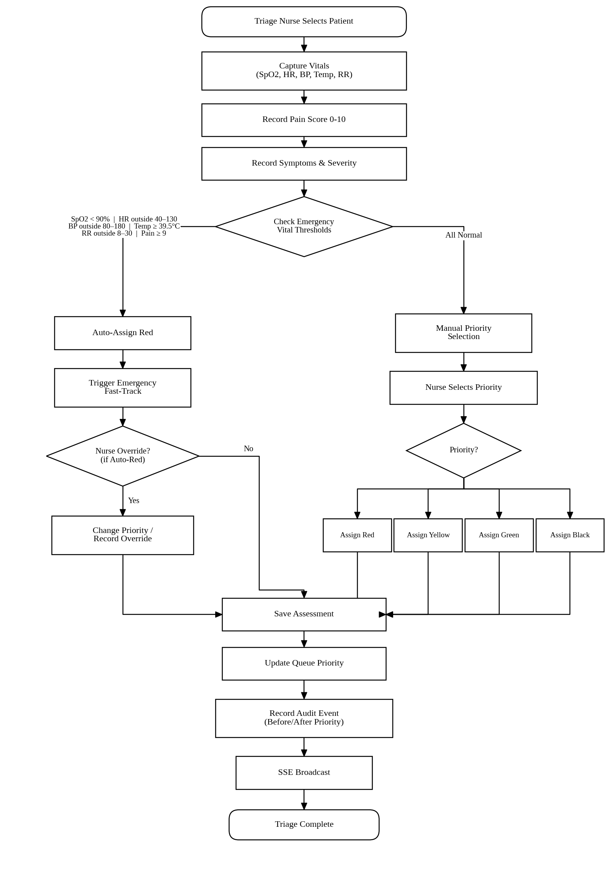
Figure 4.17: Activity Diagram: Triage Workflow

4.6.7 Activity Diagram: Notification Retry Lifecycle
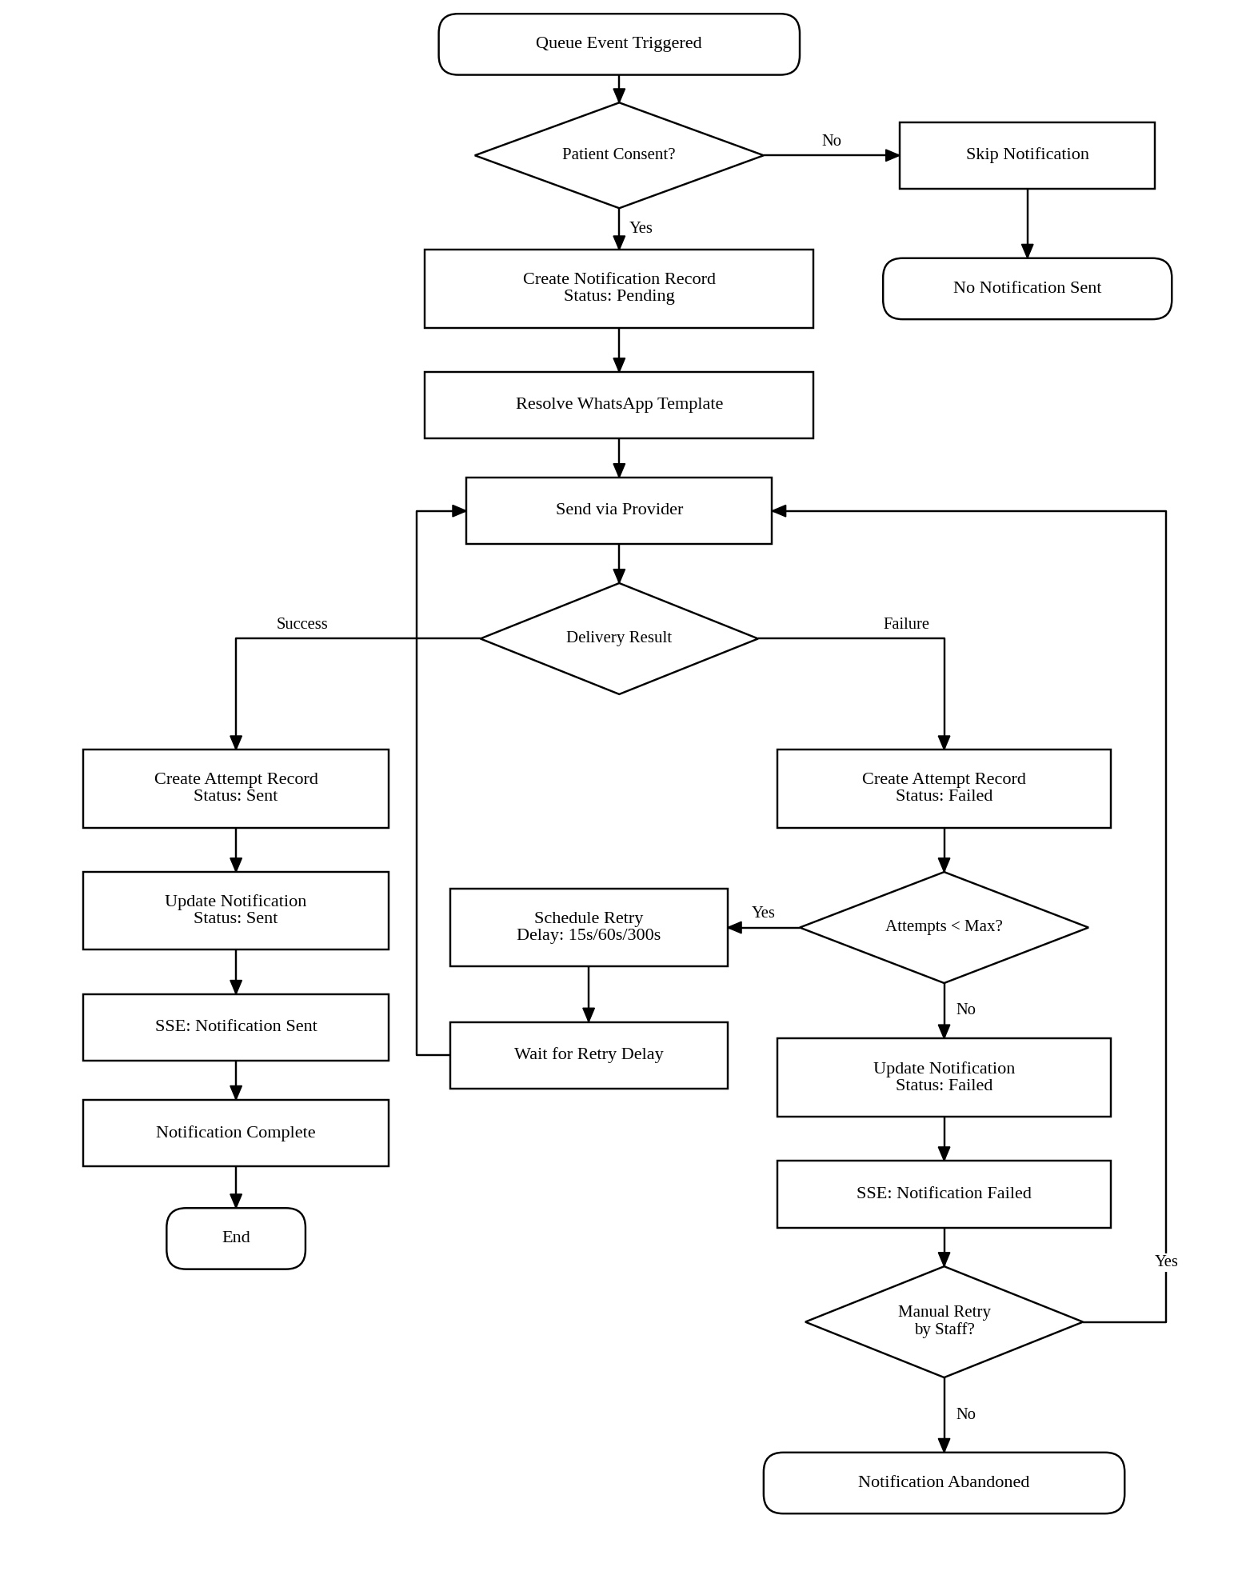
Figure 4.18: Activity Diagram: Notification Retry Lifecycle

4.7 User Interface Design

4.7.1 UI Design Principles
The WaitLess user interface is designed with the following principles:
- Medical Professional Aesthetic — A dark teal (#0F766E) and navy colour scheme conveys clinical professionalism while reducing eye strain in hospital environments with varied lighting conditions.
- Glassmorphism Design — Semi-transparent “glass” cards with backdrop blur create depth and visual hierarchy without overwhelming the user.
- Responsive Design — The interface adapts to desktop monitors, tablets, and mobile phones using Tailwind CSS responsive breakpoints.
- Real-Time Feedback — All queue updates are reflected instantly via Server-Sent Events, with visual indicators for connection status.
- Accessibility — High contrast text, keyboard navigation, ARIA labels, and semantic HTML ensure the system is usable by staff with varying abilities.
- Role-Based Navigation — Staff see only the navigation items and pages relevant to their role, reducing cognitive load.
- Privacy by Design — Public displays show only token numbers, never patient names. Patient-facing pages minimise exposed personal information.

4.7.2 Colour Palette
Table 4.37: Colour Palette
Purpose | Colour | Hex
Primary (Medical Teal) | Teal | #0F766E
Secondary (Hospital Blue) | Blue | #2563EB
Priority Red | Red | #DC2626
Priority Yellow | Amber | #F59E0B
Priority Green | Emerald | #10B981
Priority Black | Dark Grey | #1F2937
Background (Dark) | Navy/Black | #0A0F1A
Surface (Glass) | Semi-transparent | rgba(255,255,255,0.05)
Text Primary | White | #F8FAFC
Text Muted | Slate | #94A3B8

4.7.3 Typography
Table 4.38: Typography
Element | Font | Size | Weight
Headings | System sans-serif | 1.5rem – 2.25rem | 700
Body text | System sans-serif | 0.875rem – 1rem | 400
Labels | System sans-serif | 0.75rem | 500
Token numbers | Monospace | 2rem – 4rem | 700
Captions | System sans-serif | 0.75rem | 400

4.7.4 Navigation Structure
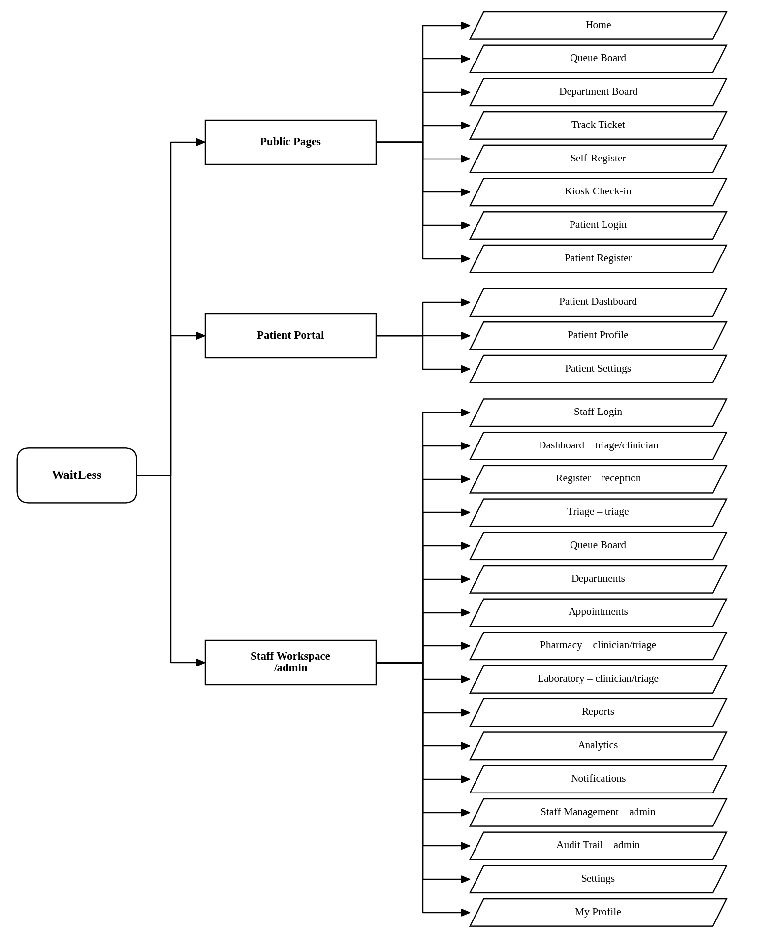
Figure 4.19: Navigation Structure

4.7.5 Key Page Descriptions

Landing Page (/)
- Hero section with WaitLess logo, tagline, and call-to-action buttons
- Live statistics display (patients served, current waiting, departments active)
- Feature highlights with icons
- Footer with hospital branding

Patient Registration (/admin/register)
- Multi-section form: demographics, next of kin, chief complaint, department selection
- Real-time form validation with inline error messages
- QR code scanner for returning patient lookup
- Patient category selector with visual icons
- Notification consent toggle
- On submit: ticket display with QR code, print button, and WhatsApp share

Triage Assessment (/admin/triage)
- Patient selector from waiting queue (sorted by priority)
- Vitals input form with range indicators and colour-coded warnings
- Pain score slider (0–10) with visual scale
- Symptoms and severity text areas
- Emergency vital threshold warnings (real-time as values are entered)
- Priority selection (auto-suggested based on vitals, manually overridable)
- Assessment history for previously triaged patients

Public Queue Board (/queue)
- Large-format display optimised for TV/monitor screens
- Three columns: “Now Serving”, “Waiting”, “Missed”
- Token numbers displayed in large monospace font
- Priority colour coding (red, yellow, green borders)
- Real-time updates via SSE (no page refresh)
- Department filter selector
- Animated transitions when tickets move between columns

Department Display Board (/department-board)
- Department-specific view (filtered by URL parameter)
- Shows only tickets for the selected department
- Larger token number display for waiting area visibility
- Real-time SSE updates
- Auto-refresh on connection loss

Staff Dashboard (/admin/dashboard)
- Live metrics cards: waiting count, in-service count, missed count, avg wait time
- Department-scoped queue table with sortable columns
- Patient action buttons: call next, mark missed, recall, transfer
- Operational alerts panel: reassessment alerts, notification failures, critical metrics
- Notification analytics with charts (delivery rate, retry trends)
- Real-time auto-refresh

Patient Tracking (/track)
- Token code input field with auto-lookup
- Progress indicator showing queue position
- Estimated wait time display
- Patients ahead count
- Department directions and current status
- Notification history timeline
- Real-time updates via SSE

Reports (/admin/reports)
- Tabbed interface: Overview, Average Wait Time, Department Performance, No-Show, Triage, WhatsApp Status
- Date range picker (from/to)
- Summary metric cards per report type
- Department breakdown tables
- Per-ticket notification correlation (no-show report)
- WhatsApp configuration checklist (status report)

Audit Trail (/admin/audit)
- Chronological list of audit events
- Filterable by action type, actor, date range
- Before/after state comparison view
- Hash chain verification indicator
- Actor details: name, role, department
- Redacted sensitive fields

4.8 Security Design

4.8.1 Authentication Model
The system implements two separate authentication flows:
Staff Authentication:
- Staff users log in with username/email and password
- Passwords are hashed using bcrypt with a cost factor of 12
- On successful login, a bearer token session is created (in-memory Map)
- Session token is included in the Authorization header for all API requests
- Sessions expire after 8 hours (configurable via AUTH_SESSION_TTL_MS)
- Password policy enforced: minimum 8 characters, at least 3 character groups (uppercase, lowercase, digits, special), common password rejection
Patient Authentication:
- Patient users register and log in with username/email and password
- Passwords are hashed using bcrypt
- Separate session management from staff authentication
- Patient sessions stored in localStorage with expiry tracking

4.8.2 Role-Based Access Control Matrix
Table 4.39: Role-Based Access Control Matrix
Resource/Action | Admin | Reception | Triage | Clinician | Patient | Anonymous
View public queue board | ✓ | ✓ | ✓ | ✓ | ✓ | ✓
Track ticket | ✓ | ✓ | ✓ | ✓ | ✓ | ✓
Self-register / kiosk | ✓ | ✓ | ✓ | ✓ | ✓ | ✓
Register patient | ✓ | ✓ | ✗ | ✗ | ✗ | ✗
Triage assessment | ✓ | ✗ | ✓ | ✗ | ✗ | ✗
Call next patient | ✓ | ✗ | ✓ | ✓ | ✗ | ✗
Mark missed/recall | ✓ | ✗ | ✓ | ✓ | ✗ | ✗
Transfer patient | ✓ | ✓ | ✓ | ✓ | ✗ | ✗
View dashboard | ✓ | ✗ | ✓ | ✓ | ✗ | ✗
View reports | ✓ | ✓ | ✓ | ✓ | ✗ | ✗
Manage staff | ✓ | ✗ | ✗ | ✗ | ✗ | ✗
View audit trail | ✓ | ✗ | ✗ | ✗ | ✗ | ✗
Configure settings | ✓ | ✓ | ✓ | ✓ | ✗ | ✗
Prescribe medication | ✓ | ✗ | ✓ | ✓ | ✗ | ✗
Order lab tests | ✓ | ✗ | ✓ | ✓ | ✗ | ✗
View patient portal | ✗ | ✗ | ✗ | ✗ | ✓ | ✗

4.8.3 Audit Trail Design
The audit trail provides a tamper-evident record of all system actions:
- Append-Only Storage — Audit events are written to the audit_events table (MySQL) or audit-events.jsonl file. No update or delete operations are supported.
- SHA-256 Hash Chaining — Each audit event includes:
  - previous_hash: The event_hash of the preceding event
  - event_hash: SHA-256 hash of the event’s content + previous_hash
  - This creates a cryptographic chain where modifying any event invalidates all subsequent hashes.
- Sensitive Data Redaction — Passwords, session tokens, and other sensitive fields are redacted in the before_state and after_state JSON before hashing.
- Actor Attribution — Every event records the actor’s ID, name, role, and department, providing full accountability.
- Tracked Actions — Login, staff creation, profile updates, ticket creation, triage assessment, priority changes, status updates, recalls, transfers, prescription and test order events, arrival confirmation, and notification retries.

4.8.4 Privacy Measures
Table 4.40: Privacy Measures
Measure | Implementation
Anonymous public displays | Queue board and department board show only token numbers, never patient names
Notification consent | Patients explicitly opt in to WhatsApp notifications during registration
Patient tracking privacy | Tracking page requires only a token code; no authentication needed, but no personal data is displayed
Audit redaction | Sensitive fields are redacted before storage in audit events
Department scoping | Non-admin staff see only their department’s data in dashboards, tickets, and notifications

4.9 Implementation Plan and Milestones
Implementation followed an incremental sequence so that each stage left a demonstrable patient-flow path. The first milestone established registration and ticket creation. The second added triage and priority-aware queue movement. The third introduced staff dashboards, public boards, and real-time updates. The fourth expanded notifications, patient self-service, departmental workflows, reporting, and administration. The final milestone concentrated on security corrections, controlled walkthroughs, documentation, and packaging. The detailed research and development sequence appears in Section 3.10, while the remaining deployment controls are listed in Appendix C.

4.10 Technology Stack

4.10.1 Frontend Technologies
Table 4.41: Frontend Technologies
Technology | Version | Purpose
React | 19.2.0 | UI framework with hooks, concurrent rendering
Vite | 7.3.1 | Build tool and development server
React Router DOM | 7.10.1 | Client-side routing with nested routes
Tailwind CSS | 4.2.1 | Utility-first CSS framework
Radix UI | Various | Accessible, unstyled headless UI primitives
shadcn/ui | — | Component library built on Radix UI
Recharts | 2.15.4 | Charts and data visualisation
Axios | 1.7.9 | HTTP client with interceptors
Zod | 3.24.2 | Schema validation
react-hook-form | 7.71.2 | Performant form management
Lucide React | 0.575.0 | Icon library
Sonner | 2.0.7 | Toast notifications
qrcode | 1.5.4 | QR code generation
html5-qrcode | 2.3.8 | Camera-based QR code scanning
Lottie React | 2.4.1 | Animations

4.10.2 Backend Technologies
Table 4.42: Backend Technologies
Technology | Version | Purpose
Node.js | 18+ (ESM) | JavaScript runtime
Custom HTTP Router | — | Route matching, parameter extraction, request handling
MySQL (mysql2) | 3.6.0 | Primary database driver
File-based JSON | — | Fallback storage mode
bcryptjs | 2.4.3 | Password hashing
dotenv | 16.3.1 | Environment variable management
Server-Sent Events | Native | Real-time queue updates

4.10.3 Development Tools
Table 4.43: Development Tools
Tool | Purpose
ESLint | Code linting and style enforcement
Prettier | Code formatting
Nodemon | Auto-restart backend during development
Git | Version control
Node.js native test runner | Backend unit testing

4.10.4 Architecture Decision Records
ADR-01: Custom HTTP Router instead of Express
The backend uses a lightweight custom HTTP router built on Node.js’s native http module rather than the Express framework. This decision was made to:
- Minimise dependencies and reduce the attack surface
- Maintain full control over request parsing, route matching, and error handling
- Reduce bundle size and startup time
- Provide a learning opportunity in understanding HTTP server fundamentals
The custom router (backend/src/utils/router.js) supports:
- HTTP method-based route registration
- Path parameter extraction (e.g., /api/tickets/:id)
- Query string parsing via URLSearchParams
- JSON body parsing with size limits (3 MB max)
- Automatic trailing slash normalisation
ADR-02: Server-Sent Events instead of WebSocket
Real-time updates are delivered via Server-Sent Events (SSE) rather than WebSocket. Rationale:
- SSE is simpler to implement and requires no additional libraries
- Unidirectional communication (server-to-client) is sufficient for queue updates
- SSE works over standard HTTP, simplifying proxy and firewall configuration
- Built-in reconnection with configurable retry interval
- Lower overhead for the hospital LAN environment
The SSE implementation (backend/src/sockets/queueEvents.js) provides:
- Persistent connections via text/event-stream content type
- Heartbeat pings every 25 seconds to keep connections alive
- Configurable retry interval (3 seconds) for client reconnection
- Event broadcasting for all queue state changes
ADR-03: Dual-Mode Storage (MySQL + File)
The system supports both MySQL and file-based JSON storage, controlled by the DB_PROVIDER environment variable. This provides:
- Production deployment with MySQL for data integrity and concurrent access
- Development and testing with file-based storage for zero-configuration setup
- Deployment flexibility for hospitals with varying infrastructure
The repository pattern (backend/src/repositories/queueRepository.js) abstracts the storage mode, exposing a unified interface that both implementations satisfy.

4.11 System Structure

4.11.1 Project Directory Structure
WAITLESS/
├── backend/
│ ├── package.json
│ ├── .env
│ ├── data/ # File-based storage (when DB_PROVIDER=file)
│ │ ├── queue-state.json
│ │ ├── audit-events.jsonl
│ │ └── staff-users.json
│ ├── test/ # Backend unit tests
│ │ ├── audit-service.test.js
│ │ ├── returning-patient.test.js
│ │ └── staff-auth-security.test.js
│ └── src/
│ ├── index.js # Server entry, route registration, startup
│ ├── config/
│ │ └── env.js # Environment variable parsing
│ ├── controllers/
│ │ ├── auditController.js
│ │ ├── authController.js
│ │ ├── patientAuthController.js
│ │ ├── profileController.js
│ │ └── queueController.js
│ ├── services/
│ │ ├── auditService.js # Hash-chained audit trail
│ │ ├── authService.js # Staff authentication & RBAC
│ │ ├── avatarService.js # Avatar image handling
│ │ ├── filePatientStore.js # File-based patient storage
│ │ ├── fileStaffStore.js # File-based staff storage
│ │ ├── notificationService.js # WhatsApp notification dispatch & retry
│ │ ├── patientAuthService.js # Patient authentication
│ │ ├── passwordSecurity.js # Password policy & hashing
│ │ ├── profileService.js # Staff profile management
│ │ ├── queueService.js # Core queue business logic (2234 lines)
│ │ ├── sessionService.js # Session token management
│ │ └── whatsAppProvider.js # WhatsApp Cloud API provider
│ ├── repositories/
│ │ ├── queueRepository.js # Repository abstraction layer
│ │ ├── fileQueueRepository.js # File-based implementation
│ │ └── mysqlQueueRepository.js # MySQL implementation
│ ├── middleware/
│ │ ├── auth.js # Staff authentication middleware
│ │ └── cors.js # CORS handling
│ ├── modules/
│ │ └── queue/
│ │ └── queue.constants.js # Domain constants & seed data
│ ├── db/
│ │ ├── db.js # MySQL connection pool
│ │ ├── initDb.js # Database initialisation
│ │ ├── schema.sql # DDL for all tables
│ │ ├── seedAdmin.js # Admin user seeding
│ │ ├── waitless_db.sql # Full database export
│ │ └── waitless_tables.sql # Table definitions
│ ├── sockets/
│ │ └── queueEvents.js # SSE event stream server
│ └── utils/
│ ├── http.js # HTTP utilities (errors, body parsing, JSON)
│ └── router.js # Custom HTTP router
├── frontend/
│ ├── package.json
│ ├── vite.config.js
│ ├── index.html
│ └── src/
│ ├── main.jsx # React entry point
│ ├── App.jsx # Route definitions
│ ├── App.css
│ ├── index.css # Tailwind CSS imports
│ ├── styles.css # Global styles
│ ├── assets/ # Images (BACKG.png, logos)
│ ├── auth/ # Authentication context
│ │ ├── AuthContext.jsx
│ │ ├── AuthProvider.jsx
│ │ └── PatientAuthProvider.jsx
│ ├── components/ # Reusable UI components
│ │ ├── ui/ # shadcn/ui components (40+ files)
│ │ ├── dashboard/
│ │ ├── AuthShell.jsx
│ │ ├── PatientAuthShell.jsx
│ │ ├── ProtectedRoute.jsx
│ │ ├── WaitLessLogo.jsx
│ │ └── ...
│ ├── context/
│ │ └── LiveRefreshContext.jsx # Global refresh trigger
│ ├── hooks/
│ │ ├── useApiResource.jsx # Data fetching hook
│ │ └── use-mobile.jsx
│ ├── layouts/
│ │ ├── AppLayout.jsx # Main layout (header, footer, routing)
│ │ ├── DashboardLayout.jsx
│ │ └── PatientPortalLayout.jsx
│ ├── pages/ # Page components (30+ files)
│ │ ├── index.jsx # Landing page
│ │ ├── register.jsx # Staff patient registration
│ │ ├── triage.jsx # Triage assessment
│ │ ├── queue.jsx # Public queue board
│ │ ├── department-board.jsx # Department-specific board
│ │ ├── track.jsx # Patient tracking
│ │ ├── dashboard.jsx # Staff dashboard
│ │ ├── staff-modules.jsx # Staff sub-pages (reports, analytics, etc.)
│ │ ├── patient-dashboard.jsx # Patient portal dashboard
│ │ ├── patient-login.jsx
│ │ ├── patient-register.jsx
│ │ ├── kiosk.jsx # Self-service kiosk
│ │ ├── self-register.jsx # Online self-registration
│ │ └── ...
│ ├── services/ # API and data services
│ │ ├── api.js # Axios client configuration
│ │ ├── authApi.js
│ │ ├── authSession.js
│ │ ├── patientAuthApi.js
│ │ ├── patientAuthSession.js
│ │ ├── queueApi.js # Queue API functions
│ │ ├── queueMeta.js # Frontend metadata constants
│ │ ├── queueTicketHandoff.js # Ticket handoff utilities
│ │ └── staffProfilePrefs.js
│ ├── sockets/
│ │ └── QueueRealtimeProvider.jsx # SSE client
│ ├── store/
│ └── utils/
└── docs/
└── world-class-system-roadmap.md

4.11.2 Backend Module Map
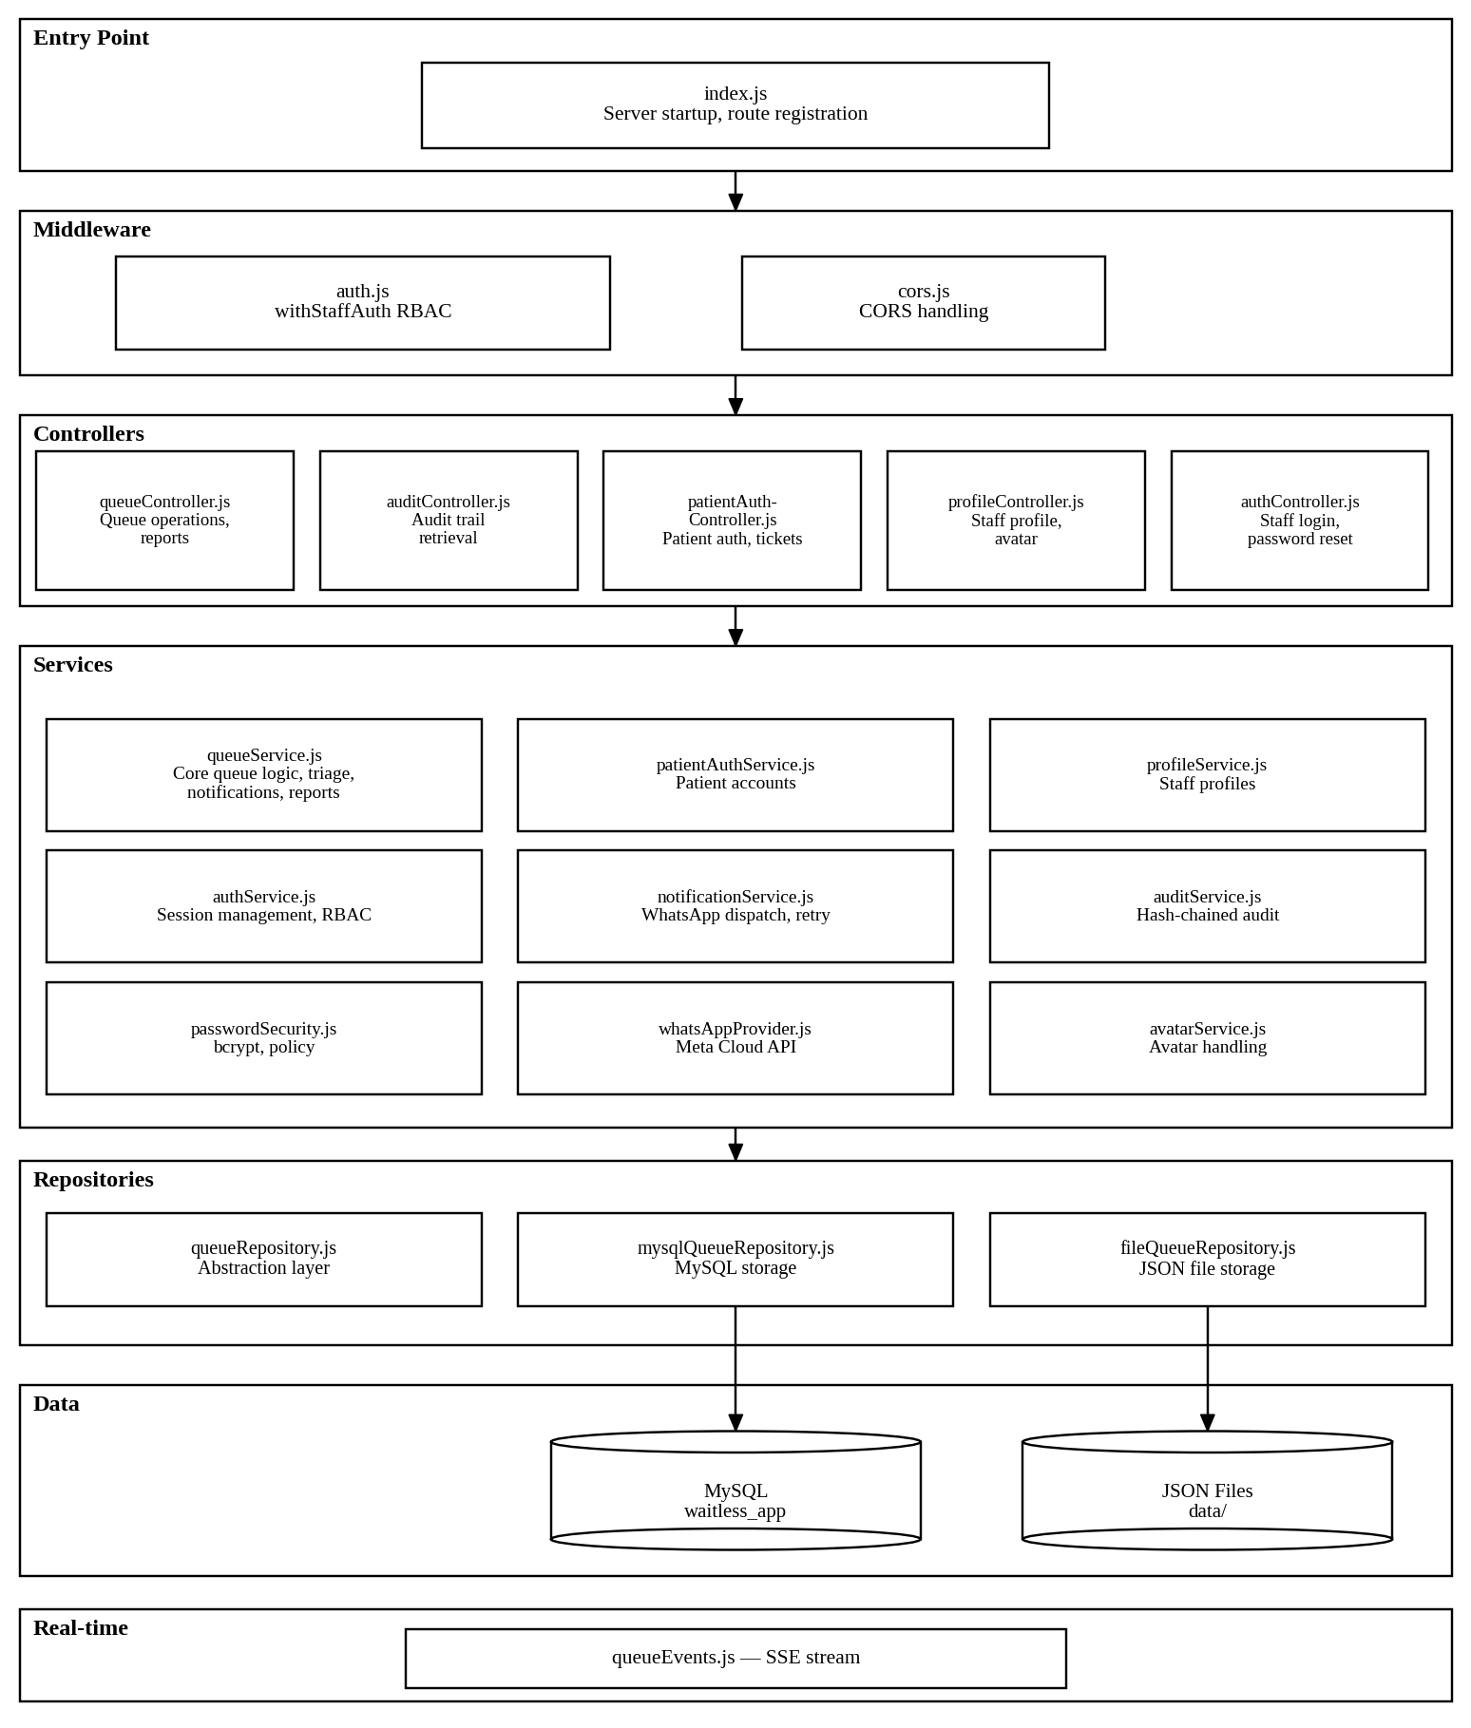
Figure 4.20: Backend Module Map

4.11.3 Frontend Component Hierarchy
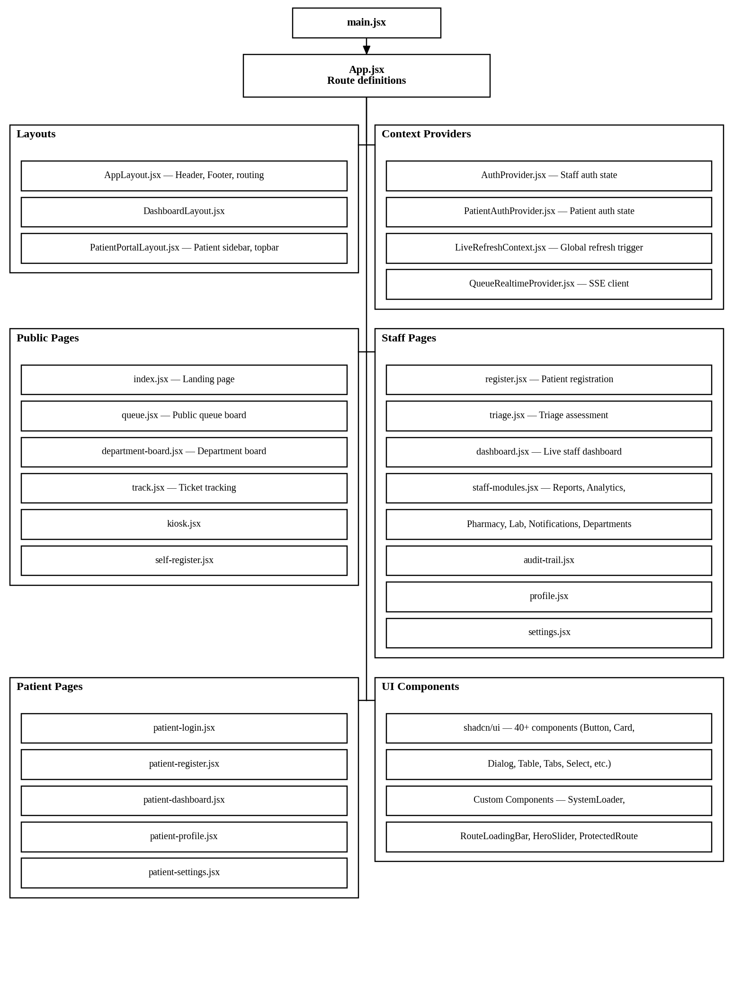
Figure 4.21: Frontend Component Hierarchy

4.12 Backend Implementation

4.12.1 Custom HTTP Router
The custom HTTP router is the backbone of the backend, handling all incoming HTTP requests. It is implemented in backend/src/utils/router.js.
Route Registration: Routes are registered with a method, URL pattern, and handler function. Patterns support path parameters using colon notation (e.g., /api/tickets/:id).
Request Handling: When a request arrives, the router iterates registered routes, matches by HTTP method and path pattern, extracts parameters, parses the JSON body (for POST/PATCH), and invokes the handler with a context object containing { req, res, url, params, query, body, rawBody }.
Key code — route matching with parameter extraction:
function matchRoute(pattern, pathname) {
const routeSegments = normalisePath(pattern).split("/").filter(Boolean);
const pathSegments = normalisePath(pathname).split("/").filter(Boolean);

if (routeSegments.length !== pathSegments.length) {
return null;
}

const params = {};
for (let index = 0; index < routeSegments.length; index += 1) {
const routeSegment = routeSegments[index];
const pathSegment = pathSegments[index];

if (routeSegment.startsWith(":")) {
params[routeSegment.slice(1)] = decodeURIComponent(pathSegment);
continue;
}
if (routeSegment !== pathSegment) {
return null;
}
}
return params;
}

Request body handling (backend/src/utils/http.js):
- Bodies are read as UTF-8 strings with a 3 MB size limit
- JSON parsing with error handling (returns 400 on invalid JSON)
- HttpError class for structured error responses with HTTP status codes
- sendJson helper for consistent JSON responses with correct content type

4.12.2 Repository Pattern — Dual-Mode Data Access
The repository pattern abstracts data persistence behind a unified interface, allowing the system to switch between MySQL and file-based storage via the DB_PROVIDER environment variable.
Repository abstraction (backend/src/repositories/queueRepository.js):
const repositories = {
file: fileRepository,
mysql: mysqlRepository,
};

function getRepository() {
const repository = repositories[env.databaseProvider];
if (!repository) {
throw new Error(`Unsupported DB_PROVIDER "${env.databaseProvider}".`);
}
return repository;
}

export function listTickets() {
return getRepository().listTickets();
}

export function createTicket(ticket) {
return getRepository().createTicket(ticket);
}

Both fileQueueRepository.js and mysqlQueueRepository.js implement the same interface:
- initializeQueueRepository() — initialise tables/files
- listTickets(), findTicketById(), createTicket(), updateTicket(), getNextSequence() — atomic sequence number generation
- findPatientById(), findPatientByPhone(), findPatientByPatientNumber(), listPatients(), createPatient(), updatePatient()
- listNotifications(), createNotification(), updateNotification(), listNotificationAttempts(), createNotificationAttempt()
- listAuditEvents(), createAuditEvent()
- listStaffUsers(), findStaffUserById(), findStaffUserByUsername(), createStaffUser(), updateStaffUser()

4.12.3 Queue Service — Core Business Logic
The queueService.js file (2,234 lines) is the central business logic module, implementing all queue operations.
Ticket Registration: When a patient is registered, the system:
- Validates input data (name, department, etc.)
- Searches for an existing patient profile by phone, national ID, or name
- Creates or links a patient profile with a permanent patient number
- Gets the next department-specific sequence number from system_counters
- Generates a ticket code using the department prefix (e.g., OPD-205)
- Creates a ticket with status “waiting” and priority “green”
- Broadcasts a “ticket.registered” SSE event
- Dispatches a registration notification if consented
- Records an audit event
Priority-Based Sorting: Tickets are sorted by priority rank, then by registration time within the same priority:
export function priorityRank(priority) {
return PRIORITY_ORDER.indexOf(priority); // red: 0, yellow: 1, green: 2, black: 3
}

function sortWaitingTickets(tickets) {
return [...tickets].sort((a, b) => {
const priorityDiff = priorityRank(a.priority) - priorityRank(b.priority);
if (priorityDiff !== 0) return priorityDiff;
return new Date(a.registeredAt) - new Date(b.registeredAt);
});
}

ETA Calculation: The system calculates estimated waiting times based on historical service time and queue position:
function calculateHistoricalServiceTime(tickets) {
const completed = tickets.filter(
(t) => t.serviceStartedAt && t.completedAt
);
if (!completed.length) return 8 * 60 * 1000; // default 8 minutes
const total = completed.reduce(
(sum, t) => sum + (new Date(t.completedAt) - new Date(t.serviceStartedAt)), 0
);
return total / completed.length;
}

Bottleneck Detection: The system identifies departments with excessive waiting loads:
function detectBottlenecks(tickets) {
const waiting = tickets.filter((t) => t.status === "waiting");
const byDept = {};
for (const t of waiting) {
byDept[t.department] = (byDept[t.department] || 0) + 1;
}
return Object.entries(byDept)
.filter(([_, count]) => count >= 5)
.map(([department, waitingCount]) => ({ department, waitingCount }));
}

Department Routing Rules: The system includes keyword-based routing rules that suggest departments based on chief complaint text:
export const DEPARTMENT_ROUTING_RULES = [
{
department: "Casualty / Triage",
keywords: ["chest pain", "breathing", "respiratory", "distress",
"unconscious", "bleeding", "trauma", "injury", ...],
},
{
department: "Pharmacy",
keywords: ["medication", "refill", "prescription", "pharmacy", ...],
},
// ... Laboratory, Radiology, OI Clinic
];

4.12.4 Triage Assessment
The triage assessment system captures structured clinical data and auto-classifies priority based on emergency vital thresholds.
Emergency Vital Thresholds:
export const EMERGENCY_VITAL_THRESHOLDS = {
oxygenSaturation: { min: 90, label: "SpO2 below 90%" },
heartRate: { max: 130, min: 40, label: "Heart rate outside 40-130 bpm" },
bloodPressureSystolic: { max: 180, min: 80, label: "Systolic BP outside 80-180 mmHg" },
temperature: { min: 39.5, label: "Temperature at or above 39.5°C" },
respiratoryRate: { max: 30, min: 8, label: "Respiratory rate outside 8-30 /min" },
painScore: { min: 9, label: "Pain score 9 or 10" },
};

Auto-Classification Logic: When a triage assessment is submitted, the system evaluates each vital against the emergency thresholds. If any vital exceeds a threshold, the patient is automatically classified as Red priority and fast-tracked to the front of the queue. The triage nurse can override this classification, with the override recorded in the audit trail.
Triage Assessment Data Captured:
- Chief complaint
- Symptoms and severity notes
- Vitals: oxygen saturation (%), heart rate (bpm), blood pressure systolic/diastolic (mmHg), temperature (°C), respiratory rate (/min)
- Pain score (0–10)
- Manual priority selection (if no auto-Red trigger)
- Assessor identity and timestamp

4.12.5 Notification System
The notification system (notificationService.js, 19,713 bytes) handles WhatsApp message dispatch with retry logic.
WhatsApp Provider Abstraction (whatsAppProvider.js): The system supports two providers:
- Mock provider (default for development): Simulates delivery with configurable delay and failure rate
- Meta Cloud API (production): Sends real WhatsApp messages via Meta’s Graph API
Provider selection is controlled by the WHATSAPP_PROVIDER environment variable.
Meta Cloud API Integration:
- API version: v23.0
- Base URL: https://graph.facebook.com
- Uses template-based messaging with configurable language
- Templates: queue-registered, queue-ready-soon, queue-called
- Request timeout: 10 seconds (configurable)
Notification Lifecycle:
- A queue event triggers notification creation (registration, call, missed, transfer, turn readiness)
- System checks patient consent
- Notification record created with status “pending”
- Message sent via the configured provider
- On success: status updated to “sent”, provider message ID recorded
- On failure: error details recorded, retry scheduled
- Retry delays: 15 seconds, 60 seconds, 300 seconds (configurable)
- Maximum attempts enforced per notification
- Each attempt creates a notification_attempts record
Retry Queue:
- Automatic retry with exponential back-off (15s → 60s → 300s)
- Manual retry by staff from the dashboard
- Bulk retry for multiple failed notifications
- Startup recovery: pending retries are processed when the server restarts

4.12.6 Authentication and Security
Staff Authentication (authService.js):
- Login with username/email and password
- Passwords hashed with bcrypt (cost factor 12)
- Password policy: minimum 8 characters, at least 3 character groups (uppercase, lowercase, digits, special), common password rejection
- Session tokens stored in an in-memory Map with 8-hour TTL
- Role-based access control with roles: admin, reception, triage, clinician
- Role mapping supports synonyms (reception → receptionist, triage → nurse, clinician → doctor)
RBAC Middleware (middleware/auth.js):
export function withStaffAuth(allowedRoles, handler) {
return (context) => {
const expandedRoles = [
...allowedRoles,
...allowedRoles.map((role) => roleMapping[role]).filter(Boolean),
];
const session = requireStaffSession(context.req, expandedRoles);
return handler({
...context,
staff: session.user,
session,
});
};
}

Patient Authentication (patientAuthService.js):
- Separate authentication flow from staff
- Registration with username, email, password, phone, national ID
- bcrypt password hashing
- Session stored in localStorage with expiry tracking
Audit Trail (auditService.js):
- Append-only event log (MySQL table or JSONL file)
- SHA-256 hash chaining: each event’s hash incorporates the previous event’s hash
- Sensitive data redaction before hashing
- Actor attribution: user ID, name, role, department
- Tracked actions: login, staff creation, profile updates, ticket operations, triage, prescriptions, test orders, notifications, arrivals

4.12.7 Real-Time Updates (SSE)
The SSE implementation consists of a server-side event stream and a client-side EventSource consumer.
Server-side (sockets/queueEvents.js):
- Clients connect to GET /api/events
- Response headers: Content-Type: text/event-stream, Cache-Control: no-cache, Connection: keep-alive
- Heartbeat every 25 seconds to maintain connection
- Client retry interval: 3 seconds (sent as retry: field)
- Events are broadcast via a broadcastQueueEvent function that writes to all connected clients
Event Types:
- connected — initial connection confirmation
- ticket.registered — new patient registered
- ticket.called — patient called to service
- ticket.missed — patient marked missed
- ticket.recalled — patient recalled to queue
- ticket.transferred — patient transferred between departments
- ticket.priority-updated — triage priority changed
- ticket.completed — service completed
- notification.sent — notification delivered
- notification.failed — notification delivery failed

4.12.8 Reporting Endpoints
The system implements five report endpoints, each with date range filtering:
Table 4.44: Reporting Endpoints
Endpoint | Method | Description
/api/reports/average-wait | GET | Average wait and service time by department
/api/reports/department-performance | GET | Throughput, missed rate, priority breakdown per department
/api/reports/no-show | GET | No-show rate with per-ticket notification correlation
/api/reports/triage | GET | Triage rate, timing, outcomes, overrides, emergency triggers
/api/whatsapp/status | GET | WhatsApp configuration and credential status

All report endpoints require staff authentication (triage, clinician, or admin roles) and accept from and to query parameters for date filtering.

4.13 Frontend Implementation

4.13.1 Application Architecture
The frontend is a React single-page application built with Vite. The application architecture follows these patterns:
Routing: React Router v7 with nested routes. All routes are defined in App.jsx and wrapped in a single AppLayout component that provides the header, footer, and context providers.
Protected Routes: The ProtectedRoute component wraps routes that require authentication, checking the user’s authentication status and role before rendering. Unauthenticated users are redirected to the login page; unauthorised users see an access denied message.
Layout Strategy:
- AppLayout — main layout with conditional header/footer based on route type
- PatientPortalLayout — sidebar navigation for patient portal pages
- DashboardLayout — staff dashboard wrapper
- Routes are classified as auth paths, patient portal paths, staff workspace paths, or public paths

4.13.2 State Management
The system uses React Context for global state management:
Table 4.45: State Management
Context | Purpose
AuthContext | Staff authentication state (user, token, login, logout)
PatientAuthProvider | Patient authentication state (user, token, login, logout)
LiveRefreshContext | Global refresh trigger — increments a counter to signal data re-fetch
QueueRealtimeProvider | SSE connection status and event handling

Live Refresh Mechanism: The LiveRefreshContext provides a refreshLiveData function that increments a refreshToken counter. Components using the useApiResource hook watch this counter and re-fetch data when it changes. This allows the SSE event handler to trigger global data refresh by calling refreshLiveData().

4.13.3 API Layer
The API layer is built on Axios with a centralised client configuration (services/api.js):
const apiClient = axios.create({
baseURL: import.meta.env.VITE_API_URL || "http://localhost:4242",
});

apiClient.interceptors.request.use((config) => {
const token = getStoredToken();
if (token) {
config.headers.Authorization = `Bearer ${token}`;
}
return config;
});

- Base URL configurable via VITE_API_URL environment variable
- Request interceptor automatically attaches the auth token
- apiRequest helper function for consistent error handling
- Patient API uses a separate Axios client with patient-specific token
Queue API Functions (services/queueApi.js): The file contains 30+ API functions covering:
- Queue metadata and ticket fetching
- Patient registration (staff, self, kiosk, pre-registration)
- Triage assessment submission
- Queue operations (call next, recall, transfer, status update)
- Prescription and test order management
- ETA estimates and ticket tracking
- Notification retry (single and bulk)
- Dashboard summary
- Reports (average wait, department performance, no-show, triage, WhatsApp status)
- Department-specific queue board

4.13.4 Real-Time Integration
The QueueRealtimeProvider (sockets/QueueRealtimeProvider.jsx) manages the SSE connection:
- On mount, it creates an EventSource connection to /api/events
- On successful connection, status is set to “connected”
- On error, status is set to “reconnecting” (EventSource auto-reconnects)
- On message, the event payload is parsed and refreshLiveData() is called
- If EventSource is not supported, falls back to polling every 10 seconds
- An additional auto-refresh timer runs every 10 seconds (configurable) to refresh wait times
- Settings are loaded from localStorage (live sync enabled, polling fallback, refresh interval)

4.13.5 Key Page Implementations

Patient Registration (register.jsx — 44,592 bytes)
- Multi-section form with react-hook-form and Zod validation
- QR code scanner for returning patient lookup (html5-qrcode)
- Patient category selector with visual icons
- Department dropdown populated from API metadata
- Notification consent toggle
- On submit: displays ticket with QR code, print button, and WhatsApp share option
- Real-time form validation with inline error messages

Triage Assessment (triage.jsx — 51,594 bytes)
- Patient selector from waiting queue (sorted by priority, then wait time)
- Vitals input form with range indicators
- Real-time emergency vital threshold warnings as values are entered
- Pain score slider (0–10) with visual colour scale
- Symptoms and severity text areas
- Auto-suggested priority based on vitals (manually overridable)
- Assessment history for previously triaged patients

Public Queue Board (queue.jsx — 35,047 bytes)
- Three-column layout: “Now Serving”, “Waiting”, “Missed”
- Large-format token numbers in monospace font
- Priority colour coding (red, yellow, green borders)
- Animated transitions when tickets move between columns
- Real-time updates via SSE (no page refresh required)
- Department filter selector
- Particle background animation
- Connection status indicator

Department Display Board (department-board.jsx — 17,834 bytes)
- Department-specific view filtered by URL query parameter (?dept=OPD)
- Shows only tickets for the selected department
- Larger token number display for waiting area visibility
- Real-time SSE updates
- Dark teal theme matching the main queue board
- Auto-refresh on connection loss

Staff Dashboard (dashboard.jsx — 46,343 bytes)
- Live metrics cards: waiting count, in-service count, missed count, average wait time
- Department-scoped queue table with sortable columns
- Patient action buttons: call next, mark missed, recall, transfer
- Operational alerts panel: reassessment alerts, notification failures, critical metrics
- Notification analytics with Recharts visualisations
- Real-time auto-refresh via SSE and LiveRefreshContext
- Search functionality for patient lookup

Patient Tracking (track.jsx — 66,903 bytes)
- Token code input with auto-lookup
- Progress indicator showing queue position
- Estimated wait time display
- Patients ahead count
- Department directions and current status
- Notification history timeline
- Real-time updates via SSE
- Dark teal themed UI with glassmorphism cards

Reports Page (staff-modules.jsx — 57,232 bytes)
- Tabbed interface with 6 tabs: Overview, Average Wait Time, Department Performance, No-Show, Triage, WhatsApp Status
- Date range picker (from/to) for all report types
- Summary metric cards per report type
- Department breakdown tables
- Per-ticket notification correlation (no-show report)
- WhatsApp configuration checklist (status report)
- Loading states with LoadingPanel component

Patient Portal (patient-dashboard.jsx — 29,933 bytes)
- Patient welcome card with time-based greeting
- Active tickets display with status badges
- QR patient card with download and print functionality
- Quick action buttons (track ticket, view queue)
- Visit history with timeline
- Prescriptions and test orders sections
- Feedback section
- Theme toggle (dark/light) with localStorage persistence
- Profile avatar with initials fallback

4.13.6 UI Component Library
The system uses shadcn/ui, a component library built on Radix UI primitives. The following components are implemented in components/ui/:
Table 4.46: UI Component Library
Component | File | Purpose
Accordion | accordion.jsx | Collapsible content sections
Alert Dialog | alert-dialog.jsx | Confirmation dialogs
Avatar | avatar.jsx | User profile images
Badge | badge.jsx | Status and priority indicators
Button | button.jsx | Action buttons with variants
Calendar | calendar.jsx | Date selection
Card | card.jsx | Content containers
Chart | chart.jsx | Recharts wrapper
Command | command.jsx | Searchable command palette
Dialog | dialog.jsx | Modal dialogs
Dropdown Menu | dropdown-menu.jsx | Context menus
Form | form.jsx | Form integration with react-hook-form
Input | input.jsx | Text inputs
Label | label.jsx | Form labels
Popover | popover.jsx | Floating content
Progress | progress.jsx | Progress bars
Select | select.jsx | Dropdown selection
Separator | separator.jsx | Visual dividers
Sheet | sheet.jsx | Slide-out panels
Skeleton | skeleton.jsx | Loading placeholders
Sonner | sonner.jsx | Toast notifications
Switch | switch.jsx | Toggle switches
Table | table.jsx | Data tables
Tabs | tabs.jsx | Tabbed navigation
Textarea | textarea.jsx | Multi-line text input
Tooltip | tooltip.jsx | Hover information

Custom Components:
- SystemLoader / LoadingPanel — animated 3D cube loading indicator
- RouteLoadingBar — top-of-page loading bar for route transitions
- HeroSlider — auto-rotating hero section for the landing page
- ProtectedRoute — authentication and role-based route guard
- WaitLessLogo — SVG logo component
- AuthShell / PatientAuthShell — branded shell for authentication pages

4.14 Database Implementation

4.14.1 Schema Implementation
The database schema is defined in backend/src/db/schema.sql and contains 10 tables:
- departments — Department reference data (6 departments)
- system_counters — Monotonic sequence counters per department
- patient_profiles — Persistent patient records with permanent patient numbers
- tickets — Queue tickets with full lifecycle timestamps
- notifications — Notification records with delivery tracking
- notification_attempts — Per-attempt delivery records
- staff_users — Staff accounts with roles and department assignments
- patient_users — Patient portal accounts
- audit_events — Immutable, hash-chained audit trail
- system_counters — Department sequence counters

4.14.2 Indexing Strategy
The schema uses strategic composite and single-column indexes to optimise query performance:
Table 4.47: Indexing Strategy
Index | Table | Columns | Purpose
idx_tickets_department_status | tickets | department, status | Queue queries by department and status
idx_tickets_priority_status | tickets | priority, status | Priority-based queue sorting
idx_tickets_registered_at | tickets | registered_at | Date-range reports and sorting
idx_tickets_patient_id | tickets | patient_id | Patient history lookup
idx_notifications_ticket_id | notifications | ticket_id | Notification lookup by ticket
idx_notifications_status | notifications | status | Pending/failed notification queries
idx_notifications_created_at | notifications | created_at | Notification history by date
idx_audit_events_occurred_at | audit_events | occurred_at | Chronological audit display
idx_audit_events_actor_id | audit_events | actor_id | Audit filter by staff member
idx_audit_events_action | audit_events | action | Audit filter by action type
idx_patient_profiles_name | patient_profiles | full_name | Patient search by name
idx_patient_profiles_phone | patient_profiles | phone | Patient search by phone
idx_patient_profiles_national_id | patient_profiles | national_id | Patient search by national ID

4.14.3 Initialisation and Seeding
Database Initialisation (db/initDb.js):
- Creates all tables if they do not exist
- Seeds the 6 default departments (OPD, Casualty/Triage, Pharmacy, Laboratory, Radiology, OI Clinic)
- Initialises department sequence counters to 100
- Seeds demo tickets for development (12 sample patients across departments)
Admin Seeding (db/seedAdmin.js):
- Creates an initial administrator account from environment variables
- INITIAL_ADMIN_USERNAME, INITIAL_ADMIN_EMAIL, INITIAL_ADMIN_PASSWORD
- Refuses to create admin with a weak password
- Only runs when DB_PROVIDER=mysql

4.14.4 Dual-Mode Storage
MySQL Mode (mysqlQueueRepository.js):
- Uses mysql2 connection pool (configurable limit, default 10)
- All operations use parameterised queries (SQL injection prevention)
- Atomic sequence generation using UPDATE ... SET value = value + 1 and SELECT
- JSON columns for audit event before/after state
File Mode (fileQueueRepository.js):
- JSON file at data/queue-state.json
- In-memory array with file write-back on each mutation
- Atomic file writes using write-then-rename pattern
- Suitable for development and single-user testing

4.15 Integration Implementation

4.15.1 WhatsApp Cloud API Integration
The WhatsApp integration (whatsAppProvider.js) supports two modes:
Mock Provider (Development):
- Simulates message delivery with configurable delay (WHATSAPP_MOCK_DELAY_MS, default 250ms)
- Configurable failure rate for testing retry logic (WHATSAPP_MOCK_FAILURE_RATE, default 0)
- No external API calls required
Meta Cloud API (Production):
- Sends messages to https://graph.facebook.com/v23.0/{phone_number_id}/messages
- Uses template-based messaging with configurable template names and language
- Authentication via bearer token (WHATSAPP_ACCESS_TOKEN)
- Request timeout: 10 seconds (WHATSAPP_REQUEST_TIMEOUT_MS)
- Webhook verification support (WHATSAPP_WEBHOOK_VERIFY_TOKEN)
- Webhook event handling for delivery status updates
Phone Number Sanitisation: Phone numbers are sanitised to international format (removing spaces, dashes, leading zeros) before sending.
Template Resolution: The system resolves template names based on notification type:
- queue_registered — Registration confirmation
- queue_ready_soon — Turn approaching
- queue_called — Turn called

4.15.2 QR Code Generation and Scanning
Generation: The qrcode library generates QR codes as data URLs for:
- Patient registration tickets (tracking QR)
- Patient profile cards (patient portal)
- Kiosk check-in tokens
Scanning: The html5-qrcode library provides camera-based QR scanning for:
- Kiosk self-check-in (scan patient QR card)
- Reception returning patient lookup (scan QR to find existing record)

4.15.3 Audit Trail Implementation
The audit service (auditService.js) implements:
Hash Chain Computation:
function computeEventHash(event, previousHash) {
const payload = JSON.stringify({
occurredAt: event.occurredAt,
actorId: event.actorId,
action: event.action,
entityType: event.entityType,
entityId: event.entityId,
outcome: event.outcome,
beforeState: event.beforeState,
afterState: event.afterState,
previousHash: previousHash,
});
return crypto.createHash("sha256").update(payload).digest("hex");
}

Redaction: Sensitive fields (passwords, tokens, phone numbers in certain contexts) are replaced with [REDACTED] before being included in the hash computation and stored in the database.
Tamper Detection: The system can verify the integrity of the audit chain by recomputing each event’s hash from its stored content and comparing it to the stored hash. Any mismatch indicates tampering.

4.16 Deployment Configuration

4.16.1 Environment Variables
The system is configured through environment variables in a .env file:
Table 4.48: Environment Variables
Variable | Default | Description
PORT | 4242 | Backend server port
CORS_ORIGIN | * | Allowed CORS origins (restrict in production)
PUBLIC_APP_URL | http://localhost:5173 | Frontend public URL
DB_PROVIDER | mysql | Storage mode: “mysql” or “file”
DB_HOST | 127.0.0.1 | MySQL host
DB_PORT | 3306 | MySQL port
DB_NAME | waitless | MySQL database name
DB_USER | root | MySQL username
DB_PASSWORD | — | MySQL password
DB_CONNECTION_LIMIT | 10 | MySQL connection pool size
DB_SEED_DEMO_DATA | true | Seed demo tickets on init
AUTH_SESSION_TTL_MS | 28800000 | Session TTL (8 hours)
INITIAL_ADMIN_USERNAME | admin | Initial admin username
INITIAL_ADMIN_EMAIL | admin@waitless.local | Initial admin email
INITIAL_ADMIN_PASSWORD | — | Initial admin password (required for first run)
WHATSAPP_PROVIDER | mock | WhatsApp provider: “mock” or “meta-cloud”
WHATSAPP_API_BASE_URL | https://graph.facebook.com | Meta API base URL
WHATSAPP_API_VERSION | v23.0 | Meta API version
WHATSAPP_PHONE_NUMBER_ID | — | Meta phone number ID
WHATSAPP_ACCESS_TOKEN | — | Meta access token
WHATSAPP_APP_SECRET | — | Meta app secret for webhook verification
WHATSAPP_WEBHOOK_VERIFY_TOKEN | — | Webhook verification token
WHATSAPP_REQUEST_TIMEOUT_MS | 10000 | API request timeout
WHATSAPP_RETRY_DELAYS_MS | 15000,60000,300000 | Retry delay schedule
WHATSAPP_MOCK_DELAY_MS | 250 | Mock provider delay
WHATSAPP_MOCK_FAILURE_RATE | 0 | Mock provider failure rate (0–1)
WHATSAPP_TEMPLATE_LANGUAGE | en_US | Template language code
VITE_API_URL | http://localhost:4242 | Frontend API base URL

4.16.2 Backend Startup
The server startup sequence (index.js):
- Load environment variables from .env
- Verify the configured port is available (probe and release)
- Initialise the queue repository (create tables, seed data)
- Initialise the notification delivery service (process pending retries)
- If MySQL mode: seed the default admin account
- Start the HTTP server on the configured port
- Log the server URL
Error handling:
- EADDRINUSE — port already in use, display helpful message
- Other errors — log and exit with code 1

4.16.3 Frontend Build
Development:
cd WAITLESS/frontend
npm install
npm run dev # Vite dev server at http://localhost:5173

Production:
cd WAITLESS/frontend
npm run build # Output to dist/
npm run preview # Preview production build

The production build verified on 10 August 2026:
- Transformed 2,633 modules
- Output: dist/ + dist/assets/ (CSS, JS, images)
- CSS: 290.2 KB (42.2 KB gzipped)
- JavaScript: 2,440.6 KB across 65 lazy-loaded files (660.6 KB gzipped in total)
- Assets: Logo images, background images (BACKG.png, etc.)

4.16.4 LAN Deployment
For hospital LAN deployment:
- Install Node.js 18+ and MySQL on a server machine
- Create the waitless database and run schema.sql
- Configure .env with MySQL credentials and WHATSAPP_PROVIDER=meta-cloud (if using real WhatsApp)
- Set CORS_ORIGIN to the hospital LAN IP range
- Set VITE_API_URL to the server’s LAN IP address
- Run npm install in both backend/ and frontend/
- Build the frontend: npm run build in frontend/
- Serve the frontend static build files (via nginx, Apache, or a simple static server)
- Start the backend: npm start in backend/
- Access from any device on the LAN via the server’s IP address
The system operates on the hospital LAN without internet for all core queue functions. WhatsApp notifications require internet connectivity to reach the Meta Cloud API, but are queued for retry when connectivity returns.

4.17 Summary
This chapter has detailed the implementation of the WaitLess Digital Queue Management System. The technology stack combines React 19 with Vite for the frontend and Node.js with a custom HTTP router for the backend, supported by MySQL for data persistence and SSE for real-time updates. The system structure follows a clean layered architecture with controllers, services, and repositories, while the frontend uses a component-based design with context providers for state management.
Key implementation achievements include the priority-based queue sorting algorithm, emergency vital threshold detection for triage, WhatsApp Cloud API integration with retry logic, SHA-256 hash-chained audit trail, dual-mode storage abstraction, and real-time SSE updates. The deployment configuration supports both development and hospital LAN production environments.
The next chapter, Chapter 5: Testing and Evaluation, presents the testing strategy, test cases, results, and system evaluation.

